UNITED STATES
SECURITIES AND EXCHANGE COMMISSION
WASHINGTON, D.C. 20549
FORM 8-K
CURRENT REPORT
Pursuant to Section 13 or 15(d) of the Securities Exchange Act of 1934
Date of Report (Date of earliest event reported): August 4, 2026
ContextLogic Holdings Inc.
(Exact name of Registrant as Specified in Its Charter)
Delaware |  |  | 000-56773 | 27-2930953
(State or Other Jurisdiction  of Incorporation) |  |  | (Commission File Number) | (IRS Employer  Identification No.)
2648 International Blvd., Ste 301
Oakland, California |  |  |  | 94601
(Address of Principal Executive Offices) |  |  |  | (Zip Code)
Registrant’s Telephone Number, Including Area Code: (415) 965-8476
N/A
(Former Name or Former Address, if Changed Since Last Report)
Check the appropriate box below if the Form 8-K filing is intended to simultaneously satisfy the filing obligation of the registrant under any of the following provisions:
☐Written communications pursuant to Rule 425 under the Securities Act (17 CFR 230.425)
☐Soliciting material pursuant to Rule 14a-12 under the Exchange Act (17 CFR 240.14a-12)
☐Pre-commencement communications pursuant to Rule 14d-2(b) under the Exchange Act (17 CFR 240.14d-2(b))
☐Pre-commencement communications pursuant to Rule 13e-4(c) under the Exchange Act (17 CFR 240.13e-4(c))
Securities registered pursuant to Section 12(b) of the Act:
Securities registered pursuant to Section 12(g) of the Act:
Title of each class | Trading Symbol(s) | Name of each exchange on which registered
Common Stock, $0.0001 par value | LOGC | OTCQB
Indicate by check mark whether the registrant is an emerging growth company as defined in Rule 405 of the Securities Act of 1933 (§ 230.405 of this chapter) or Rule 12b-2 of the Securities Exchange Act of 1934 (§ 240.12b-2 of this chapter).
Emerging growth company ☐
If an emerging growth company, indicate by check mark if the registrant has elected not to use the extended transition period for complying with any new or revised financial accounting standards provided pursuant to Section 13(a) of the Exchange Act. ☐

Item 1.01. Entry into a Material Definitive Agreement.
Purchase Agreement
On August 4, 2026, ContextLogic Holdings, LLC, a Delaware limited liability company (“Holdings”), of which ContextLogic Holdings Inc. (OTCQB: LOGC) (“ContextLogic,” or the “Company”) is the managing member, entered into a Stock Purchase Agreement (the “Purchase Agreement”) with EagleTree-Gaylord Management Investment, L.P., a Delaware limited partnership (“Seller”), EagleTree-Gaylord Holdings Corp., a Delaware corporation (the “Target Company”), and GCH Buyer, Inc., a Delaware corporation and indirect, wholly-owned subsidiary of Holdings (“Buyer”). The Purchase Agreement provides that, following satisfaction or waiver of certain conditions, Buyer will purchase from Seller all of the outstanding shares (other than certain rollover shares) of the Target Company (the “Transaction”) for $850 million in cash, subject to customary adjustments.
The consummation of the Transaction is subject to the satisfaction of certain customary closing conditions, including expiration or termination of the waiting period under the Hart-Scott-Rodino Antitrust Improvements Act of 1976 (the “HSR Act”) and the absence of certain legal restraints on completion of the transaction. Each of Buyer’s and Seller’s obligations to complete the Transaction are subject to certain customary conditions, including: (i) the accuracy of the representations and warranties of the other party, subject to applicable materiality or material adverse effect standards; (ii) compliance of the other party with its covenants in all material respects; (iii) the absence of a material adverse effect on the Target Company; and (iv) execution of certain ancillary agreements in accordance with the Purchase Agreement. The Purchase Agreement contains representations, warranties and other covenants made by each of Buyer and Seller that are customary for transactions of this nature.
The Purchase Agreement may be terminated prior to the consummation of the Transaction by the mutual written consent of Buyer and Seller and in certain other circumstances, including if closing has not occurred on or prior to May 1, 2027 (the “Outside Date”), subject to an automatic extension to June 30, 2027, as of the Outside Date, if HSR clearance has not yet been obtained and the other closing conditions have been satisfied or are capable of being satisfied at closing.
The foregoing description of the Purchase Agreement and the Transactions is only a summary of the material terms, does not purport to be complete, and is qualified in its entirety by reference to the Purchase Agreement, which is filed herewith as Exhibit 2.1 to this Current Report on Form 8-K and is hereby incorporated by reference herein. It is not intended to provide any other factual information about Buyer, Seller, the Target Company, the Company, their respective businesses, or the actual conduct of their respective businesses during the period prior to the consummation of the Transaction. The Purchase Agreement contains representations, warranties and covenants that the parties made to each other as of the date of the Purchase Agreement or other specific dates. The representations, warranties, covenants and agreements contained in the Purchase Agreement, which were made only for purposes of the Purchase Agreement and as of specific dates, were solely for the benefit of the parties to the Purchase Agreement, may be subject to limitations agreed upon by the contracting parties (including being qualified by confidential disclosures made for the purposes of allocating contractual risk between the parties to the Purchase Agreement instead of establishing these matters as facts) and may be subject to standards of materiality applicable to the contracting parties that differ from those applicable to investors and reports and documents filed with the Securities and Exchange Commission (the “SEC”). Investors should not rely on the representations, warranties, covenants and agreements, or any descriptions thereof, as characterizations of the actual state of facts or condition of any party to the Purchase Agreement. In addition, the representations, warranties, covenants and agreements and other terms of the Purchase Agreement may be subject to subsequent waiver or modification. Moreover, information concerning the subject matter of the representations and warranties and other terms may change after the date of the Purchase Agreement, which subsequent information may or may not be fully reflected in the Company’s public disclosures.
Financing of the Transaction
In connection with its entry into the Purchase Agreement, Holdings obtained (i) equity financing commitments from certain investors, including BCP Special Opportunities Fund III Originations LP, Abrams Capital Partners I, L.P., Abrams Capital Partners II, L.P. and Whitecrest Partners, LP, for an aggregate of $870 million and (ii) a debt financing commitment led by Blackstone Credit & Insurance, comprising a $250 million term loan and a $25 million revolving credit facility, which will be used to finance the consideration due under the Purchase Agreement and related fees and expenses, subject to the terms and conditions set forth in the related equity and debt commitment letters.
A portion of the equity financing is expected to be provided by, and the equity financing commitments may be offset by, a proposed rights offering by the Company (the “Rights Offering”). The record date, subscription ratio, expiration date and other terms of the Rights Offering will be described in a registration statement, including a prospectus, to be filed with the SEC. Any offer of the subscription rights or the securities issuable upon exercise of the subscription rights will be made only by means of the prospectus forming part of the registration statement, once such registration statement is declared effective.
In addition, the Transaction includes a rollover of Target Company shares, directly or indirectly into Holdings equity, by MFR Holdings, L.L.C., an entity affiliated with the Target Company’s chief executive officer.

Item 2.02. Results of Operations and Financial Condition.
The Company has presented below certain preliminary estimated financial information as of and for the three months ended June 30, 2026 based on currently available information. The Company has not finalized its results for the periods presented below. The preliminary estimated financial information presented below as of and for the three months ended June 30, 2026 is unaudited. Neither the Company's independent accountants, nor any other independent accountants, have compiled, examined, or performed any procedures with respect to the preliminary second quarter financial information contained herein, nor have they expressed any opinion or any other form of assurance on such information, and assume no responsibility for, and disclaim any association with, the preliminary second quarter financial information. These preliminary estimates should not be regarded as a representation by the Company as to its actual financial results for the periods presented below as of and for the three months ended June 30, 2026. The preliminary estimated financial information presented below is inherently uncertain, is subject to change as the Company completes its closing procedures and review, and the Company’s actual financial results may materially differ from such preliminary estimates.
Revenue: Preliminary estimated revenue for the three months ended June 30, 2026 was $33.6 million, essentially flat compared to $33.8 million for the three months ended June 30, 2025. We experienced lower sales volume in the quarter, partially offset by higher average sales prices. The average sales price for the three months ended June 30, 2026 was 7.7% higher than that of same period in the prior year, which generated approximately $2.4 million of additional revenue. Overall volume during the three months ended June 30, 2026 decreased 8.8 thousand tons, or 8.0%, compared with same period in 2025, resulting in an approximately $2.6 million reduction in revenue. The decrease in tons sold was primarily attributable to a planned maintenance shutdown in the second quarter of 2026 that was not performed in the prior year and transportation constraints related to limited trucking availability that limited shipments during the quarter.
Gross Profit: Gross profit for the three months ended June 30, 2026 was $12.5 million, a decrease of $1.2 million compared to the three months ended June 30, 2025. The decrease is primarily attributable to lower sales volumes and fixed cost absorption, offset by higher average sales prices. The Gross profit figures include $2.7 million and $3.2 million of non-cash depreciation in the three months ended June 30, 2026 and 2025 periods, respectively.

 |  | Successor |  |  |  | Predecessor
 |  | Three Months Ended June 30, 2026 |  |  |  | Three Months Ended June 30, 2025
 |  | (in millions) |  |  |  | (in millions)
Net Sales |  | $ | 33.6 |  |  | $ | 33.8
Gross Profit |  | 12.5 |  |  |  | 13.7
Gross Margin |  |  | 37 | % |  |  | 41 | %

Item 7.01. Regulation FD Disclosure.
On August 5, 2026, ContextLogic issued a press release announcing the Transaction. A copy of the press release announcing the Transactions is furnished as Exhibit 99.1 hereto.
On August 5, 2026, ContextLogic, together with representatives from Seller and the Target Company, conducted an investor call and investor presentation to discuss the Transaction (the “Investor Presentation”). A copy of the investor presentation is furnished as Exhibit 99.2 and is incorporated by reference into this Item 7.01.
The information in this Item 7.01 of this Current Report on Form 8-K (including Exhibits 99.1 and 99.2) is being furnished pursuant to Item 7.01 and will not be deemed to be “filed” for purposes of Section 18 of the Securities and Exchange Act of 1934, as amended (the “Exchange Act”), or otherwise be subject to the liabilities of that section, nor will it be deemed to be incorporated by reference in any filing under the Securities Act or the Exchange Act.

Item 8.01. Other Events.
US Salt Parent Holdings LLC (“US Salt”) is conducting an investigation associated with a confirmed report of contaminant in a production lot of salt shipped in February 2026. Although not legally required to do so, US Salt has self-reported this matter to the U.S. Food and Drug Administration. US Salt has implemented additional measures to further reduce the risk of contamination, has enhanced in-process testing, and has retained third party consultants to support its root cause investigation and advise on best practices. There have been no reported adverse events associated with this matter. There also have been no positive tests of contamination detected in US Salt’s expanded testing of both its historic and current retained lots. It is possible that US Salt may issue a partial or full recall of one or more lots of its salt. Any recalls by US Salt or US Salt customers could have a material adverse effect on US Salt’s business and financial performance, including due to direct and indirect costs of a recall, the destruction of product inventory and production delays

to investigate, identify, and address the underlying cause of a recall, liability to customers related to a recall, reduced sales of US Salt’s products, and adverse publicity that harms US Salt’s brand and reputation.

Forward-looking Statements
This communication includes forward-looking statements, including statements relating to the potential transaction, such as the expected funding and time period to consummate the potential transaction and the anticipated benefits of the potential transaction, the impact of the contaminant in US Salt’s lot of pharmaceutical salt and future recalls and preliminary estimates of certain financial information, including revenue and gross profit, for the three months ended June 30, 2026. All statements other than statements of historical fact are, or may be deemed to be, forward-looking statements. In some cases, forward-looking statements can be identified by the use of forward-looking terms such as “anticipate,” “estimate,” “believe,” “continue,” “could,” “intend,” “may,” “plan,” “predict,” “should,” “will,” “expect,” “potential,” “project,” “proposed,” “forecast,” “goal,” “target,” or the negative of these terms or other comparable terms. However, the absence of these words does not mean that the statements are not forward-looking. These forward-looking statements are based on certain assumptions and analyses made by us in light of our experience and our perception of historical trends, current conditions and expected future developments, as well as other factors we believe are appropriate in the circumstances.
These forward-looking statements are subject to known and unknown risks, uncertainties and assumptions that may cause actual results, levels of activity, performance, or achievements to be materially different from any future results, levels of activity, performance or achievements expressed or implied by such forward-looking statements. Factors that might cause or contribute to a material difference include the risks discussed in our filings with the SEC and the following: the risk that regulatory approvals are not obtained or are obtained subject to conditions that are not anticipated; potential delays in consummating the potential transaction, including as a result of regulatory approvals; ContextLogic’s ability to integrate the operations of the Target Company’s business in a successful manner and in the expected time period; the possibility that any of the anticipated benefits of the potential transaction will not be realized or will not be realized on the anticipated terms and within the expected time period; the occurrence of any event, change or other circumstance that could give rise to the termination of the Purchase Agreement; risks that the anticipated tax treatment of the potential transaction is not obtained; unforeseen or unknown liabilities; customer, regulatory and other stakeholder approvals and support; unexpected future capital expenditures; potential litigation relating to the potential transaction that could be instituted against ContextLogic or its directors; the possibility that the potential transaction may be more expensive to complete than anticipated, including as a result of unexpected factors or events; the effect of the announcement, pendency or completion of the potential transaction on the parties’ business relationships and business generally; risks that the potential transaction disrupts current plans and operations of ContextLogic and potential difficulties in employee retention and hiring as a result of the potential transaction, as well as the risk of disruption of ContextLogic’s or the Target Company’s management, including the diversion of management’s time and attention to completion of the potential transaction and integration matters, and business disruption during the pendency of, or following, the potential transaction; certain restrictions during the pendency of the potential transaction that may impact ContextLogic’s and the Target Company’s ability to pursue certain business opportunities or strategic transactions; negative effects of this announcement, and the pendency or completion of the potential transaction on the market price of ContextLogic’s common stock and/or operating results; rating agency actions and ContextLogic’s ability to access short- and long-term debt and equity markets on a timely and affordable basis; the risk that actual results of the Target Company’s business may differ materially from preliminary results; the cost and reputational impact caused by any US Salt product recalls; future financial performance; future liquidity and operating expenditures; financial condition and results of operations; the risk that the actual results for the quarter ended June 30, 2026 may differ materially from our preliminary estimates as a result of changes to assumptions and estimates, the completion of review of internal controls over financial reporting or other quarter-end and year-end procedures; and the risks described in Part I, Item 1A “Risk Factors” of ContextLogic’s Annual Report on Form 10-K for the year ended December 31, 2025 and in its subsequent filings with the SEC. All forward-looking statements set forth in this communication are qualified by these cautionary statements and there can be no assurance that the actual results or developments anticipated by us will be realized or, even if substantially realized, that they will have the expected consequences to or effects on us or our business or operations. Forward-looking statements set forth in this communication speak only as of the date hereof, and we do not undertake any obligation to update forward-looking statements to reflect subsequent events or circumstances, changes in expectations or the occurrence of unanticipated events, except to the extent required by law.

Item 9.01 Financial Statements and Exhibits.
(d) Exhibits.

Exhibit  Number |  | Description
2.1* |  | Stock Purchase Agreement, dated August 4, 2026, by and among ContextLogic Holdings, LLC, EagleTree-Gaylord Management Investment, L.P., EagleTree-Gaylord Holdings Corp. and GCH Buyer, Inc.
99.1 |  | ContextLogic Press Release Announcing Transaction, dated August 5, 2026

99.2 |  | Investor Presentation, dated August 5, 2026
104 |  | Cover Page Interactive Data File (embedded within the Inline XBRL document)
* Certain schedules, exhibits and similar attachments have been omitted pursuant to Item 601(a)(5) of Regulation S-K. The Company will provide a copy of such omitted materials to the SEC or its staff upon request.

SIGNATURES
Pursuant to the requirements of the Securities Exchange Act of 1934, as amended, the registrant has duly caused this report to be signed on its behalf by the undersigned hereunto duly authorized.
 |  |  | ContextLogic Holdings Inc.
Date: | August 5, 2026 | By: | /s/ Mark Ward
Mark Ward
President
Principal Executive Officer

Exhibit 2.1

STOCK PURCHASE AGREEMENT
BY AND AMONG
EAGLETREE-GAYLORD MANAGEMENT INVESTMENT, L.P.,
EAGLETREE-GAYLORD HOLDINGS CORP.
GCH BUYER, Inc.
and
SOLELY FOR THE PURPOSES OF ARTICLE VIII and the defined terms used therein,

CONTEXTLOGIC HOLDINGS, LLC

Dated as of August 4, 2026

Table Of Contents
Page

ARTICLE I PURCHASE AND SALE |  | 2
1.1. | Purchase and Sale of Shares | 2
1.2. | Closing | 2
1.3. | Estimated Closing Statement | 3
1.4. | Closing Payments | 3
1.5. | Closing Deliveries | 4
1.6. | Purchase Price Adjustment | 5
1.7. | Escrow Accounts | 9
1.8. | Withholding | 9
ARTICLE II REPRESENTATIONS AND WARRANTIES OF SELLER |  | 10
2.1. | Organization and Good Standing | 10
2.2. | Authorization | 10
2.3. | Non-Contravention | 10
2.4. | Ownership of the Shares | 11
2.5. | Litigation and Claims | 11
2.6. | Financial Advisors | 11
2.7. | Governmental Consents and Approvals | 11
2.8. | Solvency | 11
2.9. | No Other Representations or Warranties | 12
ARTICLE III REPRESENTATIONS AND WARRANTIES OF THE COMPANY |  | 12
3.1. | Organization and Good Standing | 12
3.2. | Authorization | 13
3.3. | Capitalization | 13
3.4. | Governmental Consents and Approvals | 15
3.5. | Non-Contravention | 15
3.6. | Financial Statements; Undisclosed Liabilities | 15
3.7. | Litigation and Claims | 16
3.8. | Compliance with Laws; Permits | 17
3.9. | Absence of Changes | 17
3.10. | Taxes | 17
i

Table Of Contents
Page
3.11. | Title; Sufficiency of Assets; Real Property | 20
3.12. | Intellectual Property | 21
3.13. | Material Contracts | 23
3.14. | Employee Benefits Plans | 25
3.15. | Labor | 28
3.16. | Environmental Matters | 29
3.17. | Medical Regulatory Matters | 30
3.18. | Customers and Suppliers | 31
3.19. | Anti-Bribery; Anti-Corruption | 31
3.20. | International Trade; Import/Export Control | 32
3.21. | Data Privacy and Security | 32
3.22. | Financial Advisors | 33
3.23. | Transactions with Affiliates | 33
3.24. | Insurance | 33
3.25. | Books and Records | 34
3.26. | Bank Accounts | 34
3.27. | Critical Technology | 34
3.28. | No Other Representations or Warranties | 34
ARTICLE IV REPRESENTATIONS AND WARRANTIES OF BUYER |  | 34
4.1. | Organization and Qualification | 34
4.2. | Authorization | 35
4.3. | Governmental Consents and Approvals | 35
4.4. | Non-Contravention | 35
4.5. | Litigation and Claims | 35
4.6. | Financial Advisors | 36
4.7. | Financing | 36
4.8. | Solvency | 37
4.9. | Investment Representation | 37
4.10. | CFIUS | 37
4.11. | No Other Representations and Warranties; Disclaimer of Reliance | 37
ARTICLE V COVENANTS |  | 38
ii

Table Of Contents
Page
5.1. | Access to Information | 38
5.2. | Conduct of the Business Pending the Closing | 39
5.3. | Regulatory Approvals | 42
5.4. | Reasonable Best Efforts | 44
5.5. | Confidentiality | 44
5.6. | Indemnification and Insurance | 45
5.7. | Preservation of Records | 46
5.8. | Publicity | 46
5.9. | Employment and Employee Benefits | 47
5.10. | Financing Assistance | 49
5.11. | No Shop | 51
5.12. | Tax Matters | 52
5.13. | RWI Policy | 54
5.14. | Termination of Certain Agreements | 55
5.15. | Payment of Transaction Bonuses | 55
5.16. | Use of Names | 55
5.17. | Cooperation on Securities Act Filings | 55
5.18. | Section 280G; Other Matters. | 59
5.19. | DLA Contract and DLA CapEx | 60
5.20. | IP Registrations | 62
5.21. | IP Assignments | 63
5.22. | Specified Matter. | 63
ARTICLE VI CONDITIONS TO CLOSING |  | 66
6.1. | Conditions to the Obligations of All Parties | 66
6.2. | Conditions to the Obligations of Buyer | 66
6.3. | Conditions to the Obligations of Seller and the Company | 67
6.4. | Frustration of Closing Conditions | 68
ARTICLE VII TERMINATION |  | 68
7.1. | Termination of Agreement | 68
7.2. | Effect of Termination | 69
ARTICLE VIII MISCELLANEOUS |  | 70
iii

Table Of Contents
Page
8.1. | Limitations on Liability | 70
8.2. | Company Disclosure Schedules | 71
8.3. | Remedies | 72
8.4. | Expenses | 73
8.5. | Jurisdiction; Consent to Service of Process | 73
8.6. | Entire Agreement; Amendments and Waivers | 73
8.7. | Governing Law | 73
8.8. | Notices | 74
8.9. | Waiver of Jury Trial | 75
8.10. | Severability | 75
8.11. | No Third-Party Beneficiaries; No Assignment | 75
8.12. | Non-Recourse | 75
8.13. | Counterparts | 76
8.14. | Legal Representation | 76
8.15. | Joint Drafting | 77
8.16. | Debt Financing Matters | 77
8.17. | LOGC Guarantee | 78
ARTICLE IX DEFINITIONS AND CONSTRUCTION |  | 79
9.1. | Certain Definitions | 79

Exhibits
Exhibit A Accounting Principles
Exhibit B Escrow Agreement
Exhibit C Net Working Capital
Exhibit D Form of IP Assignment

iv

Stock Purchase Agreement
This Stock Purchase Agreement, dated as of August 4, 2026 (this “Agreement”), is entered into by and among EagleTree-Gaylord Management Investment, L.P., a Delaware limited partnership (“Seller”), EagleTree-Gaylord Holdings Corp., a Delaware corporation (the “Company”), GCH Buyer, Inc., a Delaware corporation (“Buyer”), and, solely for purposes of ARTICLE VIII and the defined terms used therein, ContextLogic Holdings, LLC, a Delaware limited liability company (“LOGC Guarantor”). Buyer, the Company, Seller and, solely for the applicable specified sections, LOGC Guarantor, are collectively referred to herein as the “Parties,” and each individually referred to herein as a “Party.”
Recitals
A. As of the date hereof, Seller owns all of the issued and outstanding shares of Company Common Stock (collectively, the “Shares”).
B. Upon the terms and subject to the conditions set forth in this Agreement, effective as of the Closing, Buyer wishes to purchase from Seller, and Seller wishes to sell and transfer to Buyer, all of the Shares other than the Rollover Shares (the “Purchased Shares”).
C. Concurrently with the execution and delivery of this Agreement, and as a condition and material inducement to Buyer’s execution and delivery of this Agreement, each of GCC and each Key Executive has executed and delivered an Employment Agreement, which shall become effective at, and is conditioned upon the occurrence of, the Closing.
D. Concurrently with the execution and delivery of this Agreement, and as a condition and material inducement to Buyer’s execution and delivery of this Agreement, each Selling Sponsor and each Key Person has executed and delivered a Restrictive Covenant Agreement, which shall become effective at, and is conditioned upon the occurrence of, the Closing.
E. Concurrently with the execution and delivery of this Agreement, and as a condition and material inducement to Buyer’s execution and delivery of this Agreement:
(i) Seller and the Rollover Shareholder have executed and delivered the Redemption and Distribution Agreement, pursuant to which, on the Closing Date prior to the Closing, Seller will distribute to the Rollover Shareholder certain Shares as specified in the Redemption and Distribution Agreement (the “Rollover Shares”), with a monetary value of $2,000,000 (the “Rollover Amount”), in redemption of a portion of the Rollover Shareholder’s limited partnership units of Seller as specified in the Redemption and Distribution Agreement (such transactions contemplated by this clause (i), the “Redemption and Distribution”);
(ii) the Rollover Shareholder has executed and delivered the Exchange Agreement, pursuant to which, immediately following the Redemption and Distribution and prior to the Closing: (x) the Rollover Shareholder will contribute the Rollover Shares to GCH Holdings, Inc., a Delaware corporation and indirect parent of Buyer (“Parent”), in exchange for (1) shares of Parent as specified in the Exchange Agreement (the “Parent Shares”) and (2) the right to receive the portion of any amounts otherwise payable to Seller
1

under this Agreement after the Closing (including pursuant to Section 1.6(c)) related to the Rollover Shares; (y) immediately thereafter, the Rollover Shareholder will contribute the Parent Shares to LOGC Guarantor in exchange for the issuance to the Rollover Shareholder of units of LOGC Guarantor as specified in the Exchange Agreement (the “LOGC Guarantor Units”); and (z) immediately thereafter, the Rollover Shareholder will contribute the LOGC Guarantor Units to CLI Management Aggregator, LLC, a Delaware limited liability company (“Management Aggregator”), in exchange for the issuance to the Rollover Shareholder of units of Management Aggregator as specified in the Exchange Agreement (such transactions contemplated by this clause (ii), collectively, the “Rollover”); and
(iii) the parties thereto have executed and delivered the Contribution Agreement, pursuant to which, immediately following the Rollover, Parent will contribute and cause its applicable subsidiary to contribute the Rollover Shares to Buyer as a contribution to capital, such that, as of immediately following the Closing, Buyer will hold all of the Shares (such transactions contemplated by this clause (iii), “Rollover Share Contribution” and together with the Redemption and Distribution and the Rollover, collectively, the “Rollover Transactions”).
In consideration of the representations, warranties and covenants contained in this Agreement, the Parties agree as follows:
ARTICLE I
PURCHASE AND SALE
1.1. Purchase and Sale of Shares.
(a) On the Closing Date, immediately prior to the Closing, the Rollover Transactions will occur in the sequence set forth in Recital (E).
(b) Upon the terms and subject to the conditions set forth in this Agreement, at the Closing, Buyer will purchase and acquire from Seller, and Seller will sell, assign and transfer to Buyer, all of the Purchased Shares, free and clear of all Liens (other than Liens of a nature described in clauses (vi), (vii) and (viii) of the definition of Permitted Liens), in exchange for the Estimated Purchase Price.
1.2. Closing. The closing of the Transactions (the “Closing”) will take place remotely via the electronic exchange of documents and executed signature pages on a date to be specified by the Parties, which will be no later than the third Business Day after satisfaction or waiver of the conditions set forth in ARTICLE VI (other than those conditions that by their terms are to be satisfied at the Closing, but subject to the satisfaction or waiver of those conditions), or at such other place and/or time as Buyer and Seller may mutually agree in writing; provided, however, that, notwithstanding anything to the contrary, in no event shall Buyer be obligated to consummate the Closing prior to the Inside Date, without the written consent of Buyer. The date on which the Closing actually occurs is the “Closing Date.” Except as otherwise specified herein, all actions to be taken and all documents to be executed and delivered by the Parties at the Closing will be deemed to have been taken and executed simultaneously, and no proceedings will be deemed to
2

have been taken, nor documents executed or delivered, until all have been taken, executed and delivered.
1.3. Estimated Closing Statement. No later than five Business Days prior to the Closing Date, Seller will deliver to Buyer a written statement (the “Estimated Closing Statement”) setting forth Seller’s good faith estimate of (i) the amount of Cash held by the Company and the Company Subsidiaries as of the Calculation Time (the “Estimated Cash”), (ii) the amount of Indebtedness of the Company and the Company Subsidiaries as of immediately prior to the Closing (the “Estimated Indebtedness”), (iii) the Net Working Capital of the Company and the Company Subsidiaries as of the Calculation Time (the “Estimated Net Working Capital”), (iv) the amount of Transaction Expenses (the “Estimated Transaction Expenses”) and (v) the amount of Reimbursed DLA CapEx as of the Calculation Time (the “Estimated Reimbursed DLA CapEx”), together with Seller’s calculation of (A) the Estimated Purchase Price resulting therefrom (which shall, for the avoidance of doubt, subtract the Aggregate Escrow Amount and the Rollover Amount in accordance with the definition of “Estimated Purchase Price”) and (B) DLA CapEx as of the Calculation Time (the “Estimated DLA CapEx”). All such estimates will be prepared in accordance with the Accounting Principles and the applicable definitions of this Agreement and will be accompanied by reasonable backup and supporting calculations (including, with respect to the Estimated DLA CapEx, a copy of the DLA CapEx Ledger as of the delivery date of the Estimated Closing Statement). Buyer and its representatives will have the opportunity to review the materials and information used by Seller in preparing such estimates, and Seller will use its commercially reasonable efforts to make available such of the Company’s and the Company Subsidiaries’ personnel as are reasonably necessary to assist Buyer in its review of the Estimated Closing Statement and discuss in good faith any modifications thereto proposed by Buyer. Seller will consider in good faith any comments of Buyer with respect to the Estimated Closing Statement prior to the Closing; provided, however, that in no event shall Seller’s acceptance of any of Buyer’s comments to the Estimated Closing Statement be a condition to Closing. If Seller and Buyer are unable to agree on any amount set forth on the Estimated Closing Statement prior to the Closing, the applicable value proposed by Seller will be utilized for purposes of the cash payments made at the Closing pursuant to Section 1.4, but in no event will the determination of the amounts set forth in the Estimated Closing Statement prejudice or limit Buyer’s rights under Section 1.6 or constitute an acknowledgement by Buyer of the accuracy thereof.
1.4. Closing Payments. At the Closing:
(a) Buyer will pay (or cause to be paid) in cash to Seller, by wire transfer of immediately available funds to such account as Seller indicates in writing to Buyer not less than three Business Days prior to the Closing Date, an aggregate amount equal to the Estimated Purchase Price;
(b) Buyer will pay (or cause to be paid) to the Persons specified in the Pay-Off Letters, by wire transfer of immediately available funds, on behalf of the Company and any Company Subsidiary, as applicable, all amounts set forth in such Pay-Off Letters in accordance with the instructions set forth therein;
(c) Buyer will pay (or cause to be paid) on behalf of the Company, to such account or accounts as Seller indicates in writing to Buyer not less than three Business Days prior
3

to the Closing Date, the amount payable to each Person to which Transaction Expenses are due and payable at the Closing; provided, however, that Buyer will deposit the aggregate amount of the Transaction Bonus Payments to the Company at the Closing for payment in accordance with Section 5.15;
(d) Buyer will deposit (or cause to be deposited) with the Escrow Agent, by wire transfer of immediately available funds, (i) the Adjustment Escrow Amount in the account specified in writing by the Escrow Agent (the “Adjustment Escrow Account”) and (ii) if required pursuant to Section 5.22, the Specified Matter Escrow Amount in the account specified in writing by the Escrow Agent (the “Specified Matter Escrow Account”); and
(e) the Company will, if required pursuant to Section 5.12(e)(i), deposit, or cause to be deposited, with the Escrow Agent, by wire transfer of immediately available funds any Tax Overpayments received following the date hereof and prior to the Closing in the account specified in writing by the Escrow Agent (the “Tax Overpayment Escrow Account”).
1.5. Closing Deliveries.
(a) Deliveries by Seller. By no later than the Closing, Seller will deliver, or cause to be delivered, to Buyer:
(i) each of (A) a stock transfer power or other appropriate instrument of assignment and transfer in substantially the same form as set forth in Exhibit A to the Exchange Agreement that represents all of the Purchased Shares, duly executed by Seller in proper form for transfer on the books of the Company, and (B) a stock transfer power or other appropriate instrument of assignment and transfer in substantially the form as set forth in Exhibit A to the Exchange Agreement that represents all of the Rollover Shares, duly executed by the Rollover Shareholder in proper form for transfer on the books of the Company;
(ii) the Pay-Off Letter(s), in each case duly executed by the holder (or the agent or representative of such holder) of the applicable Indebtedness;
(iii) resignations of (A) each Person listed on Section 1.5(a)(iii) of the Company Disclosure Schedules and (B) each other Person who serves as an officer or director (or in a comparable capacity) of the Company or the Company Subsidiaries in his or her capacity as such, to the extent Buyer requests such resignation in writing, in the case of this clause (B), at least five Business Days prior to the Closing Date;
(iv) the Escrow Agreement, duly executed by Seller and the Escrow Agent;
(v) a duly executed statement issued by the Company, in form and substance prescribed by Treasury Regulations Sections 1.897-2(h) and 1.1445-2(c)(3) and dated as of the Closing Date, certifying that no interest in the Company is a United States real property interest as defined in Section 897(c) of the Code (including a notice to the IRS as prescribed by Treasury Regulations Section 1.897-2(h)(2)) (the “FIRPTA Certificate”);
4

(vi) an IRS Form W-9, duly executed by Seller; and
(vii) evidence, in form and substance reasonably satisfactory to Buyer, of the termination of each Terminated Contract as of, and contingent upon, the Closing, without further liability or obligations of the Company or any Company Subsidiary, except as may exist pursuant to any indemnification and exculpation provisions included in such Terminated Contract as in effect as of the date hereof.
(b) Deliveries by Buyer. At the Closing, in addition to the payments set forth in Section 1.4, Buyer will deliver, or cause to be delivered, to Seller, the Escrow Agreement, duly executed by Buyer and the Escrow Agent.
(c) Other Deliveries. At the Closing, the closing certificates and other documents required to be delivered pursuant to ARTICLE VI with respect to the Closing will be exchanged.
1.6. Purchase Price Adjustment.
(a) Closing Statement. No later than 90 days after the Closing Date, Buyer will cause to be prepared and delivered to Seller a closing statement (the “Closing Statement”) setting forth Buyer’s good faith calculation of (i) the amount of Cash held by the Company and the Company Subsidiaries as of the Calculation Time (the “Closing Cash”), (ii) the amount of Indebtedness of the Company and the Company Subsidiaries as of immediately prior to the Closing (the “Closing Indebtedness”), (iii) the Net Working Capital of the Company and the Company Subsidiaries as of the Calculation Time (the “Closing Net Working Capital”), (iv) the amount of Transaction Expenses (the “Closing Transaction Expenses”), and (v) the amount of Reimbursed DLA CapEx as of the last Business Day prior to delivery of the Closing Statement (the “Closing Reimbursed DLA CapEx”), together with Buyer’s calculation of (A) the Final Purchase Price resulting therefrom (which shall, for the avoidance of doubt, subtract the Aggregate Escrow Amount and the Rollover Amount in accordance with the definition of “Final Purchase Price”) and (B) DLA CapEx as of the Calculation Time (“Closing DLA CapEx”). All such calculations will be prepared in accordance with the Accounting Principles and the applicable definitions of this Agreement and will be accompanied by reasonable backup and supporting calculations (including, with respect to Closing DLA CapEx, a revised draft of the DLA CapEx Ledger supporting such calculation). If for any reason, Buyer fails to deliver the Closing Statement by the deadline set forth above in this Section 1.6(a), then the Estimated Closing Statement delivered by Seller to Buyer prior to the Closing will be deemed the Closing Statement (with respect to which Buyer and Seller will have all dispute rights under Section 1.6(b)). During the Review Period, Seller and its representatives will be permitted, upon reasonable written request and subject to customary confidentiality protections, to have reasonable access during normal business hours to (i) the books and records of the Company and the Company Subsidiaries solely to the extent used by Buyer or its representatives in the preparation of the Closing Statement and the calculation of the Purchase Price Components and Closing DLA CapEx, and (ii) the personnel of Buyer, the Company, the Company Subsidiaries and/or their respective accountants who are knowledgeable about, and were involved in the preparation of, the Closing Statement.
(b) Disputes.
5

(i) If (A) Seller disagrees with Buyer’s calculation of any Purchase Price Components or Closing DLA CapEx set forth in the Closing Statement or (B) Buyer fails to deliver the Closing Statement within the applicable time period required by Section 1.6(a), Seller may, within 45 days after the earlier to occur of the actual delivery date of the Closing Statement or the deadline for having delivered the Closing Statement under Section 1.6(a), as applicable (the “Review Period”), deliver a notice (the “Notice of Disagreement”) to Buyer providing reasonable detail of the reason for any disagreement with any amount in the Closing Statement (which may include a lack of information requested by Seller and not provided by Buyer) and setting forth Seller’s calculation of each such disputed amount, together with reasonable supporting documentation. Any item or amount not specifically identified in a Notice of Disagreement delivered before the expiration of the Review Period will be deemed accepted by Seller and will become final and binding upon the Parties. If no Notice of Disagreement is received by Buyer on or prior to the expiration of the Review Period, then the Closing Statement and the amounts of the Purchase Price Components and Closing DLA CapEx set forth therein will be deemed to have been accepted by Seller and will become final and binding upon the Parties. Buyer and Seller each acknowledge and agree that all discussions related to any Notice of Disagreement are, without prejudice, communications made in confidence with the intent of attempting to resolve a potential litigious dispute and are subject to settlement privilege, and all such negotiations, including any written material exchanged in connection with such negotiations, will be governed by Rule 408 of the Federal Rules of Evidence and any other similar Law of any other applicable jurisdiction.
(ii) If a Notice of Disagreement has been delivered pursuant to Section 1.6(b)(i), Seller and Buyer will, during the 30 days following the delivery of such Notice of Disagreement (the “Negotiation Period”), negotiate in good faith to reach an agreement on the disputed items or amounts in order to determine, as may be required, the amount of such disputed Purchase Price Components and disputed Closing DLA CapEx. If, during the Negotiation Period, Seller and Buyer are unable to reach such an agreement, they will promptly thereafter cause KPMG, or, if KPMG is unable to serve, a nationally recognized accounting firm that is not currently engaged in a substantial manner with Buyer or Seller and their respective Affiliates and is reasonably agreed to by Seller and Buyer; provided, however, that if Seller and Buyer cannot agree on such a firm, Seller and Buyer will each appoint a firm to elect a third firm (such firm, the “Independent Accountant”), to review the relevant portions of this Agreement and the disputed items or amounts for the purpose of calculating such disputed Purchase Price Components and disputed Closing DLA CapEx. Such calculation will be made by the Independent Accountant in accordance with this Agreement, including the Accounting Principles and the applicable definitions contained herein. In making such calculation, the Independent Accountant will function as an expert and not an arbitrator and will consider only those items or amounts in the Closing Statement and the calculation of the Purchase Price Components and Closing DLA CapEx as to which Seller has validly disagreed in accordance with the terms hereof. The Independent Accountant will make its determination based solely on presentations and supporting material provided by Buyer and Seller and not pursuant to any independent audit or review. Neither Buyer nor Seller will disclose to the Independent Accountant, and the Independent Accountant will not consider for any purpose, the fact or content of any settlement discussions or settlement offer made by or on behalf of Buyer or Seller, whether
6

during the Negotiation Period or otherwise, unless otherwise agreed by Buyer and Seller in writing. Neither Buyer nor Seller may submit a written presentation that contains a proposal as to any Purchase Price Component or Closing DLA CapEx that, in the case of Buyer, is more adverse to Seller as compared to the Closing Statement or, in the case of Seller, is more adverse to Buyer as compared to the Notice of Disagreement. The scope of the disputes to be resolved by the Independent Accountant shall be limited to resolving the disputed items, fixing mathematical errors and determining whether such disputed items were determined in accordance with this Agreement (including the definitions herein) and the Accounting Principles, and the Independent Accountant is not to make any other determination. The Independent Accountant will deliver to Seller and Buyer, as promptly as practicable (and Buyer and Seller will use their respective reasonable best efforts to cause the Independent Accountant to deliver such report no later than 30 days from the date of engagement of the Independent Accountant), a report setting forth its calculation of the items in dispute; provided, however, that the Independent Accountant may not assign a value to any item greater than the greatest value for such item claimed by either Party or less than the smallest value for such item claimed by either Party. Such report will be final and binding upon the Parties, absent fraud or manifest mathematical error. Notwithstanding anything herein to the contrary, the dispute resolution mechanism contained in this Section ‎1.6(b) shall be the exclusive mechanism for resolving disputes regarding the Purchase Price Components and Closing DLA CapEx, and the determination of the Independent Accountant shall not be deemed an award subject to review under the Federal Arbitration Act or any other similar statute. The cost of any such review and report by the Independent Accountant will be paid on a proportionate basis by Buyer, on the one hand, and Seller, on the other hand, based on the percentage which the portion of the contested amount not awarded to such Party bears to the amount contested, as finally determined by the Independent Accountant. For example, if Seller claims the Final Purchase Price and Closing DLA CapEx is $1,000 greater than the amount determined by Buyer, and Buyer contests only $500 of the amount claimed by Seller, and if the Independent Accountant ultimately resolves the dispute by awarding Seller $300 of the $500 contested, then the costs and expenses of the Independent Accountant’s review will be allocated 60% (i.e., 300 ÷ 500) to Buyer and 40% (i.e., 200 ÷ 500) to Seller.
(c) Net Adjustment Amount.
(i) If the Net Adjustment Amount is positive or zero, (A) Buyer will promptly deliver, or cause to be delivered, to Seller (or its designee(s)) an amount equal to the lesser of the (x) Net Adjustment Amount (if any) and (y) an amount equal to the Adjustment Escrow Amount plus any interest or other investment proceeds thereon (such lesser amount, the “Positive Adjustment Funds”), and (B) Buyer and Seller will cause the Escrow Agent to promptly deliver to Seller (or its designee(s)) the Adjustment Escrow Amount, plus any interest or other investment proceeds thereon. For the avoidance of doubt, (1) Seller acknowledges and agrees that the Positive Adjustment Funds will be limited to and will not exceed in the aggregate (and Seller’s recovery of any Net Adjustment Amount payable to it under this Section 1.6(c) will be capped at) an amount equal to the Adjustment Escrow Amount plus any interest or other investment proceeds thereon, and (2) the Rollover Shareholder will be entitled to receive its pro rata share (based on the Rollover Amount relative to the Estimated Purchase Price) of any amounts
7

payable to Seller pursuant to this Section 1.6(c)(i), and Seller will cause such pro rata share to be paid to the Rollover Shareholder.
(ii) If the Net Adjustment Amount is negative, Buyer and Seller will cause the Escrow Agent to promptly deliver to Buyer from the Adjustment Escrow Account the absolute value of the Net Adjustment Amount. If the absolute value of the Net Adjustment Amount does not exceed the Adjustment Escrow Amount plus any interest or other investment proceeds thereon, any amount thereafter remaining in the Adjustment Escrow Account will be promptly released to Seller (or its designee(s)). Buyer’s sole source of recovery of any Net Adjustment Amount payable to it under this Section 1.6(c) will be limited to, and will not exceed in the aggregate, the Adjustment Escrow Amount plus any interest or other investment proceeds thereon. For the avoidance of doubt, the Rollover Shareholder will bear out of the Adjustment Escrow Account its pro rata share (based on the Rollover Amount relative to the Estimated Purchase Price) of any negative Net Adjustment Amount, and the Rollover Shareholder will be entitled to receive its pro rata share of any amounts released to Seller from the Adjustment Escrow Account pursuant to this Section 1.6(c)(ii).
(iii) For purposes of this Agreement, the “Net Adjustment Amount” means an amount equal to (A) the amount, if any, by which Estimated Net Working Capital is less than the Final Net Working Capital, minus (B) the amount, if any, by which Estimated Net Working Capital is greater than Final Net Working Capital, plus (C) the amount, if any, by which Estimated Cash is less than the Final Cash, minus (D) the amount, if any, by which Estimated Cash is greater than the Final Cash, minus (E) the amount, if any, by which Estimated Indebtedness is less than the Final Indebtedness, plus (F) the amount, if any, by which Estimated Indebtedness is greater than the Final Indebtedness, minus (G) the amount, if any, by which Estimated Transaction Expenses are less than the Final Transaction Expenses, plus (H) the amount, if any, by which Estimated Transaction Expenses are greater than the Final Transaction Expenses, plus (I) the amount, if any, by which Estimated Reimbursed DLA CapEx is less than the Final Reimbursed DLA CapEx, minus (J) the amount, if any, by which Estimated Reimbursed DLA CapEx is greater than the Final Reimbursed DLA CapEx.
(iv) Any payment pursuant to this Section 1.6(c) will be made promptly, but in no event more than five Business Days after Final Cash, Final Indebtedness, Final Net Working Capital, Final Transaction Expenses, Final Reimbursed DLA CapEx and Final DLA CapEx have been determined in accordance with the terms hereof (such date, the “Final Determination Date”), by wire transfer of immediately available funds to the account(s) designated in writing by Seller or Buyer, as applicable.
(v) The Parties agree that any payment pursuant to this Section 1.6(c) will be treated as an adjustment to the Estimated Purchase Price for U.S. federal income (and other applicable) Tax purposes, unless, and then only to the extent, otherwise required by applicable Tax Law.
8

(vi) Any disputes between the Parties regarding the adjustments contemplated by this Section 1.6 will be governed exclusively by the terms of this Section 1.6.
1.7. Escrow Accounts. The Escrow Agent will hold (a) the Adjustment Escrow Amount delivered to it pursuant to Section 1.4(d)(i) to support any obligations pursuant to Section 1.6‎, (b) if deposited in accordance with Section 1.4(d)(ii) and Section 5.22, the Specified Matter Escrow Amount delivered to it pursuant to Section 1.4(d)(ii) to support any obligations pursuant to Section 5.22, and (c) if deposited in accordance with Section 1.4(e) and/or Section 5.12(e)(ii), the Tax Overpayment Escrow Amount delivered to it pursuant to Section 1.4(e) and/or Section 5.12(e)(ii) to support any obligations pursuant to Section 5.12(e). The Adjustment Escrow Amount, Specified Matter Escrow Amount and the Tax Overpayment Escrow Amount will be retained by the Escrow Agent in accordance with the terms of this Agreement and the Escrow Agreement. Upon the final determination of the Net Adjustment Amount pursuant to Section 1.6, each of Buyer and Seller will execute joint written instructions instructing the Escrow Agent to disburse the funds in the Adjustment Escrow Account in accordance with Section 1.6(c).
1.8. Withholding. Buyer, the Company, any Company Subsidiary and any other applicable withholding agent shall be entitled to deduct and withhold, or cause to be deducted and withheld, from any amounts payable pursuant to or as contemplated by this Agreement, any Taxes or other amounts required under the Code or any applicable Tax Law to be deducted and withheld. To the extent that any such amounts are deducted and withheld in accordance with this Section 1.8 and are timely remitted to the applicable Taxing Authority, such amounts shall be treated for all purposes of this Agreement as having been paid to the Person in respect of which such deduction and withholding was made. Notwithstanding anything to the contrary in this Agreement, any compensatory amounts pursuant to or as contemplated by this Agreement shall be remitted by the applicable payor to the Company or applicable Company Subsidiary for payment through the appropriate payroll procedure in accordance with applicable Law. Other than (i) any withholding in respect of the Transaction Bonus Payments, (ii) any withholding as a result of Seller’s failure to deliver a valid IRS Form W-9 establishing an exemption from backup withholding, and (iii) any withholding pursuant to Section 1445 of the Code as a result of Seller’s failure to deliver the FIRPTA Certificate, and subject to the foregoing, Buyer does not intend to deduct any U.S. federal withholding with respect to payments under this Agreement absent a change in applicable Law after the date hereof. If, notwithstanding the foregoing intention, any payor determines that it is required to deduct or withhold amounts from any payment pursuant to this Agreement, such payor shall (1) use reasonable best efforts to notify the payee at least ten days prior to such payment, (2) discuss and cooperate, and cause its Affiliates to discuss and cooperate, to determine whether any potential deduction or withholding applies and to eliminate or reduce any such deduction or withholding to the extent permitted by applicable Law, and (3) provide the payee with receipts from the appropriate Taxing Authority evidencing the timely receipt of any deducted or withheld amount.
9

ARTICLE II
REPRESENTATIONS AND WARRANTIES OF SELLER
Seller represents and warrants to Buyer, as of the date hereof and as of the Closing (except for any such representations and warranties that are made as of a specific date, which representations and warranties are made as of such specific date), that:
2.1. Organization and Good Standing. Seller is duly formed, validly existing and in good standing under the Laws of the State of Delaware and has all requisite limited partnership or similar power and authority to own, lease and operate all of its properties and assets and to carry on its business as currently conducted.
2.2. Authorization. Seller has full power and authority to execute and deliver this Agreement and each Ancillary Agreement to which it is or will be a party and to perform its obligations hereunder and thereunder. The execution, delivery and performance of this Agreement by Seller and each Ancillary Agreement to which it is or will be a party, as applicable, have been duly and validly authorized, and no additional authorization or consent is required under the Organizational Documents of Seller or its Affiliates in connection with its execution, delivery and performance of this Agreement and the Ancillary Agreements to which it is or will be a party. This Agreement and each of the Ancillary Agreements, when executed and delivered by Buyer and the other parties hereto and thereto, will constitute valid and legally binding obligations of Seller, enforceable against Seller in accordance with their respective terms, subject to applicable bankruptcy, insolvency, fraudulent conveyance, reorganization, moratorium and similar laws affecting or relating to creditors’ rights and remedies generally and the availability of injunctive relief and other equitable remedies (the “Enforceability Exception”).
2.3. Non-Contravention. The execution, delivery and performance by Seller of this Agreement and the Ancillary Agreements to which it is or will be a party, as applicable, and the consummation of the Transactions, do not and will not (a) violate any provision of the Organizational Documents of Seller, (b) conflict with, or result in the breach of, or constitute a default under, or result in the termination, cancellation, modification or acceleration (whether after the filing of notice or the lapse of time, or both) of any right or obligation of Seller, or result in a loss of any benefit to which Seller is entitled, under any material Contract of Seller, or (c) assuming the receipt of all consents, approvals, waivers, exemptions and authorizations and the making of notices and filings required to be made or obtained by Buyer, violate or result in a breach of or constitute a default under any Law to which Seller is subject, or under any Governmental Authorization, other than, in the cases of clauses (b) and (c), conflicts, breaches, terminations, defaults, cancellations, accelerations, losses or violations that would not reasonably be expected to have a material adverse effect on Seller’s ability to perform its obligations under this Agreement or consummate the Transactions.
2.4. Ownership of the Shares. As of the date hereof and as of immediately prior to the Redemption and Distribution, Seller is the record and beneficial owner of the Shares, free and clear of all Liens (other than Liens of a nature described in clauses (vi), (vii) and (viii) of the definition of Permitted Liens). As of immediately prior to the Closing (and following the consummation of the Redemption and Distribution), Seller is the record and beneficial owner of the Purchased Shares, free and clear of all Liens (other than Liens of a nature described in clauses (vi), (vii) and
10

(viii) of the definition of Permitted Liens). Upon consummation of the Transactions (including the Rollover Transactions), Buyer will acquire good and valid title to the Shares, free and clear of all Liens (other than Liens of a nature described in clauses (vi), (vii) and (viii) of the definition of Permitted Liens).
2.5. Litigation and Claims. As of the date hereof, there is no Legal Proceeding pending or threatened in writing against Seller or to the actual knowledge of Seller, otherwise threatened against Seller, that would materially delay or impair Seller’s ability to effect the Closing or that seeks to prevent, enjoin or materially delay the consummation of any of the Transactions.
2.6. Financial Advisors. Other than the Banker, no agent, broker, investment banker, financial advisor, intermediary, finder, consultant or other firm acting on behalf of Seller will be entitled to any broker’s, finder’s, financial advisor’s or other similar fee or commission, directly or indirectly, in connection with any of the Transactions, for which the Company or any Company Subsidiary could be liable (except to the extent included in Transaction Expenses).
2.7. Governmental Consents and Approvals. Assuming the accuracy of the representation and warranty set forth in Section 4.10 and except in connection, or in compliance, with the notification and waiting period requirements of the HSR Act, no consent, approval, waiver, authorization, notice, exemption or filing is required to be obtained by Seller from, or to be given by Seller to, or be made by Seller with, any Governmental Body in connection with the execution, delivery and performance by Seller of this Agreement and the Ancillary Agreements to which it is or will be a party, except for those the failure of which to obtain, give or make would not reasonably be expected to materially impair or delay the ability of Seller to perform its obligations under this Agreement or consummate the Transactions.
2.8. Solvency. Seller is not insolvent as of the date hereof and will not be rendered insolvent by the Transactions. For purposes of this Section 2.8, “insolvent” means that the sum of the debts and other probable liabilities of Seller exceeds the present fair saleable value of Seller’s assets. Immediately after giving effect to the consummation of the Transactions, (a) Seller will be able to pay its liabilities as they become absolute and mature in the ordinary course of its business consistent with past practice, (b) Seller will not have an unreasonably small amount of capital with which to conduct its present business, and (c) Seller reasonably anticipates to have assets (calculated at fair market value) that exceed its liabilities. The cash available to Seller, after taking into account all other reasonably anticipated uses of the cash and the effect of the Transactions (including receipt of the Estimated Purchase Price), will be sufficient to pay all such debts and judgments of Seller in accordance with their terms as they become absolute and mature. No transfer of property is being made and no obligation is being incurred in connection with the Transactions with the intent to hinder, delay, or defraud either present or future creditors of Seller.
2.9. No Other Representations or Warranties. Except for the representations and warranties contained in this ARTICLE II and ARTICLE III, in any Ancillary Agreement and in the certificate delivered pursuant to Section 6.2(d), (a) none of the Company, any Company Subsidiary, Seller or any other Person is making, or has made, any representation or warranty, either written or oral, express or implied, at law or in equity, in respect of Seller, the Company, any Company Subsidiary or any of its or their respective businesses, assets, liabilities, operations, prospects or condition (financial or otherwise), including with respect to the merchantability or
11

fitness for any particular purpose of any assets, the nature or extent of any liabilities, the prospects of the business, the effectiveness or the success of any operations or the accuracy or completeness of any confidential information memoranda, management presentations, projections, documents, material or other information (financial or otherwise) regarding Seller, the Company and the Company Subsidiaries furnished or made available to Buyer or any of its representatives in any data room (including the Data Room), confidential information memorandum, management presentation, functional “break-out” discussions or in any other manner or form in expectation of, or in connection with, the Transactions, and (b) Seller disclaims any other representation and warranty made by any other Person in respect of Seller, the Company, any Company Subsidiary or any of its or their respective businesses, assets, liabilities, operations, prospects or condition (financial or otherwise), as well as any and all liabilities relating to or resulting from the use of information, documents or materials referenced in clause (a) of this Section 2.9. Notwithstanding the foregoing, nothing in this Section 2.9 shall limit any claim by Buyer or LOGC Guarantor for Fraud.
ARTICLE III
REPRESENTATIONS AND WARRANTIES OF THE COMPANY
Except as set forth in the Company Disclosure Schedules (interpreted in accordance with Section 8.2), the Company represents and warrants to Buyer, as of the date hereof and as of the Closing (except for any such representations and warranties that are made as of a specific date, which representations and warranties are made as of such specific date), that:
3.1. Organization and Good Standing.
(a) The Company and each Company Subsidiary is duly incorporated or organized, as applicable, validly existing and in good standing (with respect to jurisdictions that recognize the concept of good standing) under the Laws of its jurisdiction of its incorporation or formation, as applicable. Each of the Company and each Company Subsidiary has all requisite corporate, limited liability company or similar power and authority to own, lease and operate all of its properties and assets and to carry on its business as currently conducted, and is duly qualified to do business and is in good standing (with respect to jurisdictions that recognize the concept of good standing) as a foreign corporation or foreign limited liability company, as applicable, in each jurisdiction where the ownership or leasing of its properties and assets or the conduct of its business requires such qualification, except for failures to be so qualified or in good standing, as the case may be, that would not reasonably be expected to be material to the Company and the Company Subsidiaries, taken as a whole. Complete copies of the Organizational Documents of the Company and each Company Subsidiary as in effect on the date of this Agreement have been made available to Buyer.
(b) Section 3.1(b) of the Company Disclosure Schedules sets forth each jurisdiction in which the Company and each Company Subsidiary is qualified to do business.
3.2. Authorization. The Company has full power and authority to execute and deliver this Agreement and each Ancillary Agreement to which it is or will be a party and to perform its obligations hereunder and thereunder. The execution, delivery and performance of this Agreement by the Company and each Ancillary Agreement to which the Company is or will be a party, as
12

applicable, has been duly and validly authorized, and no additional authorization or consent is required under the Organizational Documents of the Company or its Affiliates in connection with its execution, delivery and performance of this Agreement and the Ancillary Agreements to which it is or will be a party. This Agreement and each of the Ancillary Agreements, when executed and delivered by Buyer and the other parties hereto and thereto, will constitute valid and legally binding obligations of the Company, enforceable against the Company in accordance with their respective terms, subject to the Enforceability Exception.
3.3. Capitalization.
(a) Neither the Company nor any Company Subsidiary has any obligation to make any loan, capital contribution or other investment in any Person (other than by the Company or any Company Subsidiary in any other Company Subsidiary).
(b) The Shares constitute all of the issued and outstanding equity interests of the Company. The Shares (i) have been duly authorized and validly issued and are fully paid and non-assessable, (ii) were issued without violation of any preemptive or similar rights and in compliance with all applicable state and federal securities Laws, and (iii) are held of record and beneficially by Seller (other than the Rollover Shares, which are held of record and beneficially by Seller as of the date hereof and will be held of record and beneficially by the Rollover Shareholder immediately following the Redemption and Distribution), free and clear of all Liens (other than Liens of a nature described in clauses (vi), (vii) and (viii) of the definition of Permitted Liens). There are no declared or accrued but unpaid dividends with respect to any Shares.
(c) Section 3.3(c) of the Company Disclosure Schedules sets forth a list of (i) each Company Subsidiary, (ii) each Company Subsidiary’s jurisdiction of incorporation or organization, as applicable, (iii) the entire authorized stock or other equity interests of such Company Subsidiary, and (iv) the record and beneficial owner of all of the issued and outstanding shares of such stock or other equity interests of such Company Subsidiary. All of the outstanding equity interests of the Company Subsidiaries have been duly authorized and validly issued and are fully paid and non-assessable (where such concepts are applicable in the applicable jurisdictions), and were not issued in violation of any Contract to which any Company Subsidiary is a party or subject to or in violation of any preemptive or similar rights. The equity interests set forth on Section 3.3(c) of the Company Disclosure Schedules constitute all the issued and outstanding equity interests of the Company Subsidiaries and are directly or indirectly owned of record and beneficially by the Company, free and clear of all Liens (other than Liens of a nature described in clauses (vi), (vii) and (viii) of the definition of Permitted Liens). Except for the Company Subsidiaries, the Company does not own, directly or indirectly, any capital stock or other equity interest of any Person.
(d) There are no preemptive or other outstanding rights, options, warrants, conversion rights, stock appreciation rights, redemption rights, repurchase rights, agreements, arrangements or commitments under which the Company or any Company Subsidiary is or may become obligated to issue or sell, or giving any Person a right to subscribe for or acquire, or dispose of, any equity interests, or any securities or obligations exercisable or exchangeable for or convertible into any equity interests, of the Company or any Company Subsidiary, and no securities or obligations evidencing such rights are authorized, issued or outstanding. There are no
13

bonds, debentures, notes or other Indebtedness of the Company or any Company Subsidiary having the right to vote (or convertible into, or exchangeable for, securities having the right to vote) on any matters on which stockholders or members, as applicable, of the Company or any Company Subsidiary may vote.
(e) Other than pursuant to the Redemption and Distribution Agreement, there are no outstanding obligations of the Company or any Company Subsidiary to repurchase, redeem or otherwise acquire any equity interest or other securities of the Company or any Company Subsidiary, and such equity interests are not subject to any voting trust agreement, stockholders’ agreement, registration rights agreement, proxy or similar arrangement relating to the voting, registration or disposition of such equity interests.
(f) Section 3.3(f) of the Company Disclosure Schedules sets forth a schedule of each outstanding incentive equity or equity-based award issued by Seller, the Company or any Company Subsidiary to any employee or service provider of the Company or any Company Subsidiary (each, an “Equity Award”), including (i) the type of award (e.g., stock option, restricted stock, restricted stock unit, stock appreciation right, phantom equity, profits interest, or other equity-based award), (ii) the name of the holder thereof, (iii) the number and class of equity interests underlying such award, (iv) the grant date, and (v) the exercise price, base price, or distribution threshold, as applicable. Each outstanding Equity Award (A) was granted in compliance with all applicable Laws and the terms and conditions of the applicable equity plan and award agreement under which it was granted, (B) has a per share exercise price or base value equal to or greater than the fair market value of a share of common stock of the Company on the date of grant as determined in accordance with Section 409A and Section 422 of the Code, as applicable, and (C) has continuously since grant met all requirements for exemption from Section 409A of the Code, to the extent applicable. Except as would not result in liability to the Company or any Company Subsidiary, all recipients of Equity Awards that were subject to a substantial risk of forfeiture at the time of grant have filed timely and valid elections under Section 83(b) of the Code with respect to such equity interests. Each outstanding Equity Award that is intended to constitute a profits interest (A) constitutes a “profits interest” for U.S. federal income tax purposes and complies with the requirements of Rev. Proc. 93-27 and any other applicable provision of the Code and (B) was granted with a distribution threshold or similar economic term equal to or greater than the liquidation value of the issuing entity on the date of grant. There is no agreement or arrangement (whether in writing or otherwise) to which the Company is a party or with respect to which the Company has or could reasonably be expected to have any liability that contains a promise or commitment to grant any Equity Award that has not been satisfied by the Company as of the date hereof. As of the Closing, no former holder of any Equity Award will have any rights with respect to such Equity Award other than the rights, if any, contemplated by this Agreement.
3.4. Governmental Consents and Approvals. Assuming the accuracy of the representation and warranty set forth in Section 4.10 and except in connection, or in compliance, with the notification and waiting period requirements of the HSR Act, no consent, approval, waiver, authorization, notice, exemption or filing is required to be obtained by the Company or any Company Subsidiary from, or to be given by the Company or any Company Subsidiary to, or be made by the Company or any Company Subsidiary with, any Governmental Body, in connection with the execution, delivery and performance by the Company of this Agreement and the Ancillary Agreements to which it is or will be a party, as applicable, except for those the failure
14

to obtain, give or make would not reasonably be expected to be material to the Company and the Company Subsidiaries, taken as a whole, and would not reasonably be expected to materially impair or delay the ability of the Company to perform its obligations under this Agreement or consummate the Transactions.
3.5. Non-Contravention. Assuming the receipt of all consents, approvals, waivers, exemptions and authorizations and the making of all notices and filings contemplated by Section 3.4 of the Company Disclosure Schedules, the execution, delivery and performance by the Company of this Agreement and the Ancillary Agreements to which it is or will be a party, as applicable, and the consummation of the Transactions, do not and will not (a) violate any provision of the Organizational Documents of the Company or any Company Subsidiary, (b) conflict with, or result in the breach of, or constitute a default under, or result in the termination, cancellation, modification or acceleration (whether after the filing of notice or the lapse of time or both) of any right or obligation of the Company or any Company Subsidiary, or result in a loss of any benefit to which the Company or any Company Subsidiary is entitled, under any Material Contract, or (c) assuming the receipt of all consents, approvals, waivers, exemptions and authorizations and the making of notices and filings required to be made or obtained by Buyer, violate or result in a breach of or constitute a default under any Law to which the Company or any Company Subsidiary is subject, or under any Governmental Authorization, other than in the cases of clauses (b) and (c), conflicts, breaches, terminations, defaults, cancellations, accelerations, losses or violations that would not reasonably be expected to be material to the Company and the Company Subsidiaries, taken as a whole, and would not reasonably be expected to materially impair or delay the ability of the Company to perform its obligations under this Agreement or consummate the Transactions.
3.6. Financial Statements; Undisclosed Liabilities.
(a) Section 3.6(a) of the Company Disclosure Schedules includes copies of (i) the audited consolidated balance sheet of the Company and the Company Subsidiaries as of December 31, 2024 and December 31, 2025 and the related audited consolidated statements of income, cash flows and changes in stockholders’ equity for the fiscal years then ended (the “Audited Financial Statements”) and (ii) the unaudited consolidated balance sheet of the Company and the Company Subsidiaries as of June 30, 2026 (the “Interim Balance Sheet”) and the related unaudited consolidated statements of income, cash flows and changes in stockholder’s equity for the six-month period then ended (together with the materials described in the preceding clause (ii), the “Interim Financial Statements” and, collectively with the Audited Financial Statements, the “Financial Statements”). Except as described in the notes thereto, the Financial Statements (A) were derived from the books and records of the Company, (B) have been prepared in accordance with GAAP, consistently applied throughout the periods indicated (except as may be indicated in the notes thereto), and (C) fairly present, in all material respects, the consolidated financial condition and results of operations and cash flows of the Company and the Company Subsidiaries as of the dates thereof or the periods then ended (subject, in the case of the Interim Financial Statements, to the absence of footnote disclosures and normal and year-end adjustments, none of which are expected to be material). The Company and the Company Subsidiaries maintain a system of internal controls over financial reporting sufficient in all material respects to provide reasonable assurance that (x) transactions of the Company and the Company Subsidiaries are only executed in accordance with management’s general or specific authorizations, and (y) transactions
15

are recorded as necessary to permit preparation of the Financial Statements in accordance with GAAP.
(b) Except as reflected, reserved against or otherwise disclosed in the Financial Statements, as of the date hereof, the Company and the Company Subsidiaries have no liabilities required by GAAP to be reflected on a balance sheet of the Company or in the notes thereto prepared in accordance with GAAP, other than (i) liabilities that were incurred since the date of the Interim Balance Sheet in the Ordinary Course of Business (none of which results from or arises out of any breach of contract, warranty, tort, infringement or violation of Law that would be material to the Company or any Company Subsidiary), (ii) liabilities incurred in connection with the Transactions to the extent included in Transaction Expenses, (iii) liabilities arising under any Contract entered into in the Ordinary Course of Business or set forth on Section 3.13(a) of the Company Disclosure Schedules (none of which relates to or is in the nature of a breach of any such Contract), and (iv) liabilities that are not, individually or in the aggregate, material to the Company and the Company Subsidiaries, taken as a whole. The Company and the Company Subsidiaries do not have any material off-balance sheet arrangements or liabilities not disclosed as such in the Financial Statements that would be required to be disclosed under GAAP.
3.7. Litigation and Claims.
(a) As of the date hereof, and during the three-year period preceding the date hereof, there is no Legal Proceeding pending or threatened in writing or, to the Knowledge of the Company, orally against or relating to the Company, any Company Subsidiary or the Transactions, other than those that would not reasonably be expected to be material to the Company and the Company Subsidiaries, taken as a whole, and would not reasonably be expected to materially impair or delay the ability of the Company to perform its obligations under this Agreement or consummate the Transactions.
(b) Neither the Company nor any Company Subsidiary is subject to any outstanding Order of any Governmental Body, except for any such Order that would not reasonably be expected to be material to the Company and the Company Subsidiaries, taken as a whole.
(c) Section 3.7(c) of the Company Disclosure Schedules sets forth a list of all Legal Proceedings against the Company or any Company Subsidiary that have been settled or otherwise finally resolved during the three years prior to the date hereof involving amounts in excess of $350,000.
3.8. Compliance with Laws; Permits. The Company and the Company Subsidiaries hold all material Governmental Authorizations necessary for the lawful conduct of their respective businesses. All material Governmental Authorizations necessary for the lawful conduct of the respective businesses of the Company and the Company Subsidiaries are in full force and effect and the Company and the Company Subsidiaries have fulfilled and performed all of their material obligations with respect to and are not in breach or violation of, or default under, any such material Governmental Authorizations. Section 3.8 of the Company Disclosure Schedules sets forth a list of all material Governmental Authorizations held by the Company and the Company Subsidiaries. The Company and the Company Subsidiaries and their respective properties and assets are, and at all times during the past four years have been, in material compliance with all applicable Laws.
16

Neither the Company nor any Company Subsidiary has, in the past four years, received any written notice alleging any material violation under any applicable Law or any investigation, audit (outside of the Ordinary Course of Business), inquiry or enforcement action by any Governmental Body and, to the Knowledge of the Company, no event has occurred which would be reasonably expected to result in the same. During the last four years, the Company and the Company Subsidiaries have filed, maintained, or furnished with the applicable Governmental Bodies all material required filings, declarations, listings, registrations, reports, applications, amendments, modifications, supplements, notices, documents and other submissions with respect to any Governmental Authorizations and all such submissions were timely made and were materially complete, accurate and in compliance with all applicable Laws.
3.9. Absence of Changes. From December 31, 2025 through the date hereof, (a) there has not been any Material Adverse Effect and (b) except as contemplated by this Agreement, the Company and the Company Subsidiaries have conducted their respective businesses in the Ordinary Course of Business in all material respects. Except as contemplated by this Agreement, from the date of the Interim Balance Sheet through the date hereof, (i) there has been no material damage, destruction or loss (whether or not covered by insurance) to any material property or material assets of the Company or any Company Subsidiary and (ii) neither the Company nor any Company Subsidiary has taken any action that, if Section 5.2(b) applied during such period, would have required the consent of Buyer.
3.10. Taxes.
(a) The Company and each Company Subsidiary have timely filed all U.S. federal income and other material Tax Returns required to be filed by such Person (taking into account applicable extensions to file such Tax Returns), and such Tax Returns are true, complete and correct in all material respects. The Company and each Company Subsidiary have timely paid all U.S. federal Income Taxes and all material amounts of other Taxes due and payable, whether or not shown as due and payable on such Tax Returns.
(b) The Company and each Company Subsidiary have deducted and withheld all material amounts of Taxes required to have been deducted and withheld in connection with any amounts paid to any employee, independent contractor, creditor or equityholder under the Code or any provision of U.S. state, local or non-U.S. Tax Law, as applicable, and have timely paid such withheld Taxes to the proper Taxing Authority. The Company and each Company Subsidiary have complied in all material respects with any associated reporting and recordkeeping requirements.
(c) No deficiencies for any material amount of Taxes have been proposed, asserted or assessed in writing by any Taxing Authority against the Company or any Company Subsidiary that are still outstanding.
(d) There are no outstanding agreements or waivers extending into the future the statutory period of limitation applicable to any Claim for, or the period for the collection or assessment of, any material amount of Taxes due from the Company or any Company Subsidiary (excluding any request in the Ordinary Course of Business to extend the due date for any Tax Return not yet filed). Neither the Company nor any Company Subsidiary has executed a power of attorney with respect to any material Tax matter that is currently in force or will remain in effect
17

as of or after the Closing and that applies to any taxable period (or portion thereof) ending after the Closing Date (other than a power of attorney granted to the Company or any Company Subsidiary by the Company or any other Company Subsidiary).
(e) No audit, examination or similar proceeding by any Taxing Authority concerning any U.S. federal or state income or other material Taxes or Tax Returns of the Company or any Company Subsidiary is currently in progress, or, to the Knowledge of the Company, is pending or threatened.
(f) Neither the Company nor any Company Subsidiary (i) is or has been a member of an affiliated, consolidated, combined, or unitary or similar group (other than any such group the common parent of which is the Company or any Company Subsidiary), (ii) has any liability for Taxes of any Person (other than the Company or any Company Subsidiary), arising by provision of Law (including from the application of Treasury Regulation Section 1.1502-6 or any analogous provision of state, local or foreign Tax Law), as a transferee or successor, or by Contract, or (iii) is a party to any joint venture, partnership, or other Contract or arrangement that is treated as a partnership for U.S. federal Income Tax purposes (other than a partnership that is a directly or indirectly wholly-owned Subsidiary of the Company).
(g) Neither the Company nor any Company Subsidiary is party to any Tax sharing, Tax allocation, or Tax indemnity agreement (other than (i) any such Contract solely between the Company and/or Company Subsidiaries, or (ii) any such agreement pursuant to any Contract the primary purpose of which does not relate to Taxes).
(h) In the last three years, neither the Company nor any Company Subsidiary has received a written claim to pay Tax or file Tax Returns with respect to such Tax from a Taxing Authority in a jurisdiction where the Company or such Company Subsidiary has not filed Tax Returns that has not been resolved.
(i) There are no Liens with respect to Taxes upon any of the assets of the Company or any Company Subsidiary (other than Permitted Liens described in clause (i) of the definition thereof).
(j) Gaylord S.A.S. is not a “passive foreign investment company” as defined in Section 1297 of the Code.
(k) Neither the Company nor any Company Subsidiary has been a party to, or a promoter of, any “listed transaction,” as defined in Treasury Regulation Section 1.6011-4(b)(2) (or any similar provision of state, local, or non-U.S. Law).
(l) In the last two years, neither the Company nor any Company Subsidiary has distributed stock of another Person, or has had its stock distributed by another Person, in a transaction that was purported or intended to be governed in whole or in part by Section 355 or Section 361 of the Code.
(m) No private letter rulings, technical advice memoranda, or similar agreements or rulings have been requested, entered into, or issued by or with any Taxing Authority with respect to the Company or any Company Subsidiary.
18

(n) Neither the Company nor any Company Subsidiary will be required to include any material item of income in, or exclude any material item of deduction from, taxable income for any Tax period beginning after the Closing Date or the portion of any Straddle Period beginning after the Closing Date as a result of any: (i) “closing agreement” as described in Section 7121 of the Code (or any corresponding or similar provision of state, local or non-U.S. Law) executed prior to the Closing, (ii) installment sale or open transaction disposition made prior to the Closing, (iii) prepaid amount or deferred revenue received prior to the Closing, (iv) intercompany transaction described in Treasury Regulations under Section 1502 of the Code (or any corresponding or similar provision of state, local or non-U.S. Law) entered into prior to the Closing, (v) a change in (or proposal to change), or use of an improper, method of accounting prior to the Closing for a taxable period (or portion thereof) ending on or prior to the Closing Date, or (vi) excess loss account described in Treasury Regulations Section 1.1502-19 (or any corresponding or similar provision of state, local or non-U.S. Law) with respect to the stock of the Company or any Company Subsidiary in existence as of the Closing.
(o) Neither the Company nor any Company Subsidiary has taken, claimed or applied for an employee retention Tax credit in relation to COVID pandemic relief.
(p) The U.S. federal income tax classification of the Company and each Company Subsidiary is as set forth on Section 3.10(p) of the Company Disclosure Schedules.
(q) Neither the Company nor any Company Subsidiary (i) has any material liabilities in respect of tariffs or customs duties or escheat or unclaimed or abandoned property obligations, or (ii) has any reserves established or required to be established under GAAP or with respect to contingent Income Taxes or uncertain Tax positions.
(r) Since December 31, 2024, neither the Company nor any Company Subsidiary has taken any action that, if Section 5.2(b)(xiv) applied during such period, would have required the consent of Buyer.
3.11. Title; Sufficiency of Assets; Real Property.
(a) Except as would not reasonably be expected to be material to the Company and the Company Subsidiaries, taken as a whole, the Company and the Company Subsidiaries have good and valid title to, or a valid license or leasehold interest in, all tangible assets of the Company and the Company Subsidiaries, free and clear of all Liens, other than Permitted Liens, and excluding properties and assets sold or disposed of by the Company or any Company Subsidiary since the date of the Interim Balance Sheet in the Ordinary Course of Business. Such assets (i) collectively constitute all properties and assets used in the operation of the business of the Company and the Company Subsidiaries as currently conducted, (ii) are sufficient in all material respects to carry on the business of the Company and the Company Subsidiaries as currently conducted, and (iii) are in good operating condition and repair in all material respects, ordinary wear and tear excepted, and are adequate for the uses for which they are employed.
(b) Section 3.11(b) of the Company Disclosure Schedules sets forth the address of all real property owned by the Company or any Company Subsidiary (the “Owned Real Property”). The Company has provided or made available, as the case may be, to Buyer true and
19

complete copies of all deeds, title reports, surveys and title policies relating to the Owned Real Property. The Company and Company Subsidiaries have good and marketable title in fee simple to the Owned Real Property, free and clear of all Liens (other than Permitted Liens).
(c) Section 3.11(c) of the Company Disclosure Schedules sets forth a complete list of all leases of real property leased by the Company or any Company Subsidiary (each lease, a “Real Property Lease” and such property, collectively, the “Leased Real Property,” and together with the Owned Real Property, the “Real Property”), as well as the address of such property and the applicable landlord and the expiration date of each such lease. The Company has delivered or made available to Buyer a true, complete and correct copy of each Real Property Lease. Each Real Property Lease is valid and binding on the Company or the applicable Company Subsidiary party thereto and, to the Knowledge of the Company, each other party thereto, and is in full force and effect, except as may be limited by the Enforceability Exception. Neither the Company nor any Company Subsidiary nor, to the Knowledge of the Company, any other party to any Real Property Lease, is in material breach or material default under any Real Property Lease. No landlord or other party to any Real Property Lease has given written notice to the Company or any Company Subsidiary of any termination, cancellation, breach or default with respect to any Real Property Lease that has not been cured.
(d) Except as would not reasonably be expected to be material to the Company and the Company Subsidiaries, taken as a whole, the Real Property constitutes all interests in real property currently used in connection with the business of the Company and the Company Subsidiaries that are necessary for the continued operation of the business of the Company and the Company Subsidiaries as such business is currently conducted. No buildings, structures or other improvements located on the Real Property encroach upon any real property owned or leased by any third party, and no buildings, structures or improvements owned or leased by any third party encroach upon any Real Property.
(e) With respect to the Real Property, (i) the Company and the Company Subsidiaries are in exclusive possession thereof, (ii) no portion thereof is subject to any pending or written threat of, or to the Knowledge of the Company, otherwise threatened condemnation, eminent domain, reassessment or similar Legal Proceeding by any Governmental Body, (iii) the buildings, structures, equipment and improvements on the Real Property are in good operating condition and in a state of good maintenance and repair, except for ordinary wear and tear, in each case as are adequate and suitable for the purposes for which they are presently being used, and (iv) no option or right of first refusal or first offer has been granted by the Company or any Company Subsidiary to any Person to purchase any Owned Real Property or to lease any Real Property, in each case with respect to clauses (i)-(iv), except for such matters as would not reasonably be expected to be material to the Company and the Company Subsidiaries, taken as a whole.
3.12. Intellectual Property.
(a) Section 3.12(a) of the Company Disclosure Schedules sets forth, as of the date hereof, a true and complete list of all (i) active IP Registrations within the Owned IP, indicating for each such item, as applicable, the name or title of such registration or application, the name of the current legal owner(s), the name of the current owner of record, the jurisdiction of application/registration, the application/registration number and the filing/issuance or registration
20

date and (ii) categories of material Trade Secrets within the Owned IP that constitute proprietary manufacturing processes and formulations for products sold by the Company and the Company Subsidiaries (“Product IP”). All IP Registrations within the Owned IP are subsisting, valid and, to the Knowledge of the Company, enforceable. The Company and the Company Subsidiaries do not own any proprietary Software.
(b) The Company and the Company Subsidiaries (i) individually or collectively, solely own all rights, title and interests in and to all material Owned IP and have sufficient rights to use all other material Intellectual Property Rights used in the conduct of the business of the Company or any Company Subsidiary as currently conducted (the Owned IP together with such other Intellectual Property Rights, the “Company Intellectual Property”), in each case, free and clear of all Liens (other than Permitted Liens), and (ii) will continue to own and have the same right to use all material Company Intellectual Property on the same terms and in the same manner immediately following the Closing as the Company and the Company Subsidiaries had as of immediately prior to the Closing.
(c) Neither the Company nor any Company Subsidiary nor the conduct of its or their respective businesses is currently infringing, misappropriating or otherwise violating or has, in the past three years, infringed, misappropriated or otherwise violated any Intellectual Property Rights of any other Person; provided that, the foregoing representation and warranty is provided only to the Knowledge of the Company with respect to any infringement of any Patent of any other Person. There is no pending or, to the Knowledge of the Company, threatened Legal Proceeding alleging that the Company or any Company Subsidiary is infringing, misappropriating or otherwise violating any Intellectual Property Rights of any Person, and neither the Company nor any Company Subsidiary has received any written notice alleging any of the foregoing (including in the form of any invitation to obtain a license that contains an allegation of infringement). To the Knowledge of the Company, no other Person is infringing, misappropriating or otherwise violating any of the Owned IP. There is no pending or threatened Legal Proceeding by the Company or any Company Subsidiary alleging any Person is infringing, misappropriating or otherwise violating any Owned IP. There is no pending or, to the Knowledge of the Company, threatened, Legal Proceeding challenging the ownership, validity, or enforceability of any Owned IP.
(d) Except as would not reasonably be expected to be material to the Company and the Company Subsidiaries, taken as a whole, the Company and the Company Subsidiaries have taken and currently take commercially reasonable actions to protect the value, status and confidentiality of all material Trade Secrets included in the Owned IP or disclosed to or possessed by the Company or the Company Subsidiaries, including by maintaining and enforcing written policies and procedures for confidentiality, restricting access to such information to Persons with a need to know and implementing physical, technical and administrative safeguards reasonably designed to prevent unauthorized access or disclosure. Except as would not reasonably be expected to be material to the Company and the Company Subsidiaries, taken as a whole, all founders (as set forth on Section 3.12(d) of the Company Disclosure Schedules), officers, employees and consultants having access to material Trade Secrets of the Company or the Company Subsidiaries have executed binding, written non-disclosure agreements providing for the protection of such Trade Secrets, and to the Knowledge of the Company, no such Person has breached such agreements. Except as would not reasonably be expected to be material to the Company and the Company Subsidiaries, taken as a whole, neither the Company nor any Company Subsidiary is in
21

breach of any obligations or undertakings of confidentiality which it owes or has owed to any Person. To the Knowledge of the Company, there has not been any unauthorized acquisition, disclosure, use, or misappropriation of any material Trade Secrets within the Owned IP. No manufacturer, distributor, customer, or other Person that has been disclosed the Product IP has the right to practice, disclose, or reproduce Product IP for any Person or business other than for or on behalf of the Company and the Company Subsidiaries.
(e) All founders and current and former officers, employees and contractors of the Company and the Company Subsidiaries who are or have been involved in the creation or development of any material Owned IP (other than the IP Contributors set forth on Section 5.21 of the Company Disclosure Schedules) have executed and delivered to the Company or Company Subsidiary (as applicable) written and enforceable Contracts providing for the valid present assignment by such Persons to the Company or any Company Subsidiary (as applicable) of all of such Person’s respective rights relating to such Owned IP, and to the Knowledge of the Company, no such Person has violated any term of any such Contract.
(f) Except as would not reasonably be expected to be material to the Company and the Company Subsidiaries, taken as a whole, (i) the Company and the Company Subsidiaries lawfully own, lease or license all IT Systems, and will continue to have the same rights to the IT Systems immediately after the Closing as they did immediately prior to the Closing, (ii) the IT Systems are in sufficient operating condition and are adequate for the purposes for which they are being used or held for use by the Company and the Company Subsidiaries in their respective businesses, (iii), to the Knowledge of the Company, the IT Systems do not contain any malware or virus (including any “back door,” “time bomb,” “Trojan horse,” “worm,” or “drop dead device”) that materially interferes with the operation of the businesses of the Company or the Company Subsidiaries or that is intentionally designed to permit unauthorized access to, maliciously disable, maliciously encrypt or erase Software, hardware, or data, (iv) for the last three years, there has been no failure or other substandard performance of any IT System that has caused a material disruption to the businesses of the Company or the Company Subsidiaries and has not been remediated in all material respects and (v) the Company and the Company Subsidiaries maintain commercially reasonable backup and data recovery, disaster recovery, and business continuity plans, procedures, and facilities and test such plans and procedures on a regular basis, and such plans and procedures are designed to be effective in all material respects.
3.13. Material Contracts.
(a) Section 3.13(a) of the Company Disclosure Schedules sets forth a complete and accurate list of all of the following Contracts in effect as of the date hereof to which the Company or any Company Subsidiary is a party (excluding any (x) purchase orders entered into in the Ordinary Course of Business and (y) Contract that is a Company Benefit Plan) (collectively, the “Material Contracts”):
(i) each Contract that is reasonably expected to call for any payments by or on behalf of the Company and the Company Subsidiaries, individually or in the aggregate, in excess of $1,500,000 per annum;
22

(ii) each Contract that provides for the Company or any Company Subsidiary to receive any payments in excess of, individually or in the aggregate, $2,000,000 per annum or during the current fiscal year;
(iii) each Contract that relates to capital expenditures that involves total remaining payments of more than $1,000,000 in the aggregate in any single year;
(iv) each Contract that grants to any Person a right of first refusal, first offer or similar preferential right to purchase or acquire any right, asset, property or service of the Company or any Company Subsidiary;
(v) each Contract that contains a “most favored nation” or similar pricing provision;
(vi) each Contract that is a guaranty under which the Company or any Company Subsidiary guarantees any obligation(s) of a third party;
(vii) each Contract that is a Real Property Lease;
(viii) each Contract that contains covenants restricting the ability of the Company or any Company Subsidiary to compete in any line of business or geographical area;
(ix) each Contract that grants any Person any exclusive rights (whether as to geography, product, service or otherwise) to sell, distribute or market the products or services of the Company or any Company Subsidiary;
(x) each Contract that grants the Company or any Company Subsidiary an equity interest in any partnership or joint venture and any documents related thereto;
(xi) each Contract that is an Intellectual Property Contract;
(xii) each Contract that (i) relates to Indebtedness incurred by the Company or any Company Subsidiary in excess of $500,000 and (ii) grants a Lien (other than a Permitted Lien) upon any material assets or properties of the Company or any Company Subsidiary;
(xiii) each Contract that involves the disposition or acquisition of equity securities, capital stock, material assets of any other Person (whether via an equity transaction, asset transaction or otherwise), entered into during the three-year period prior to the date hereof (or under which the Company or any Company Subsidiary has any ongoing obligations or liabilities);
(xiv) each Contract that relates to any settlement of litigation with, or an Order of, a Governmental Body in excess of $1,000,000 within the three-year period prior to the date of this Agreement or that imposes any material obligations on the Company or any Company Subsidiary following the date hereof;
23

(xv) each Contract with any Governmental Body;
(xvi) each Contract for the making or advancing of any loans to another Person, other than any such Contract (i) among the Company and the Company Subsidiaries, or (ii) with employees or customer payment terms in the Ordinary Course of Business;
(xvii) each Contract containing material minimum purchase or supply obligations;
(xviii) each Contract under which the Company or any Company Subsidiary is, or may become, obligated to incur any severance, retention or other compensation obligations that would become payable by reason of this Agreement or the transactions contemplated hereby;
(xix) any collective bargaining agreement or other Contract with any labor union, labor organization, trade union, works council or other employee representative body (each, a “Union”); and
(xx) any Contract or commitment to do any of the foregoing.
(b) The Company has provided or made available to Buyer true, correct and complete copies of each Material Contract, including all amendments, supplements, exhibits, schedules and waivers thereto. Each Material Contract is a valid and binding obligation of the Company or such Company Subsidiary that is party thereto and, to the Knowledge of the Company, each other party to such Material Contract, except for such failures to be valid and binding as would not reasonably be expected to be material to the Company and the Company Subsidiaries, taken as a whole. Each Material Contract is enforceable against the Company or such Company Subsidiary that is party thereto and, to the Knowledge of the Company, each other party to such Material Contract in accordance with its terms (subject in each case to the Enforceability Exception), except for such failures to be enforceable as would not reasonably be expected to be material to the Company and the Company Subsidiaries, taken as a whole. Neither the Company nor any Company Subsidiary nor, to the Knowledge of the Company, any other party to a Material Contract, is in material default or breach in any respect under any Material Contract, and no event has occurred that, with notice or lapse of time or both, would constitute such a default or breach, except as would not reasonably be expected to be material to the Company and the Company Subsidiaries, taken as a whole.
3.14. Employee Benefits Plans.
(a) Section 3.14(a) of the Company Disclosure Schedules lists each Company Benefit Plan. “Company Benefit Plan” means (i) each “employee benefit plan” (as defined in Section 3(3) of the Employee Retirement Income Security Act of 1974 (“ERISA”)) and (ii) each employment, bonus, commission, incentive compensation, equity or equity-based, deferred compensation, change in control, transaction, retention, severance, termination, employee loan, retirement, pension, profit sharing, cafeteria, disability, life insurance, welfare, fringe benefit, post-employment or post-retirement health or welfare, salary continuation, individual independent contractor, consulting, leave of absence, paid time-off, or other compensation or benefit plan,
24

program, policy, practice, contract, agreement or arrangement, whether or not subject to ERISA, whether or not reduced to writing, and whether covering a single individual or a group of individuals, in each case, that is maintained, contributed to or sponsored by the Company or any Company Subsidiary, or to which the Company or any Company Subsidiary is a party, or that is for the benefit of any current or former director, officer, employee, or individual independent contractor of the Company or any Company Subsidiary or any spouse, dependent, or beneficiary of such Person, or with respect to which the Company or any Company Subsidiary has or could reasonably be expected to have any liability; provided, however, that “Company Benefit Plan” will not include (x) any governmental plan or program requiring the mandatory payment of social insurance Taxes or (y) similar contributions to a governmental fund with respect to the wages of an employee of the Company or any Company Subsidiary.
(b) With respect to each Company Benefit Plan, accurate and complete copies of the following materials have been made available to Buyer, as applicable: (i) all current plan documents together with all amendments thereto or, if not reduced to writing, a written summary of all material plan terms; (ii) all determination, advisory or opinion letters from the IRS; (iii) all summary plan descriptions (including any summary of material modifications); (iv) annual reports on Form 5500, including all schedules and attachments; (v) any trust agreements, custodial agreements, insurance policies, administrative agreements, advisory agreements and similar contractual obligations or funding arrangements; (vi) results of non-discrimination testing and top-heavy testing for each of the last three years; and (vii) any non-routine correspondence with any Governmental Body within the last three years.
(c) Each Company Benefit Plan, including any associated trust or fund, has been established, maintained, operated, funded and administered in all material respects in compliance with its terms and in compliance with the applicable provisions of ERISA and the Code. Each Company Benefit Plan that is intended to be qualified within the meaning of Section 401(a) of the Code has received a favorable determination or opinion letter from the IRS as to its qualification or is operated under the terms of a pre-preapproved plan for which the provider of the plan has received an opinion or advisory letter from the IRS, each trust created thereunder has been determined by the IRS to be exempt from Tax under the provisions of Section 501(a), and, to the Knowledge of the Company, nothing has occurred that would reasonably be expected to adversely affect such qualification or exemption or otherwise result in liability to the Company or any Company Subsidiary. All required contributions, distributions and premiums under each Company Benefit Plan for any period ending on or before the Closing Date that are not yet due have been made or properly accrued, to the extent required to be accrued under GAAP. Neither the Company, any Company Subsidiary nor, to the Knowledge of the Company, any other Person is in material breach of, or material default under, any Company Benefit Plan and, to the Knowledge of the Company, each Company Benefit Plan is enforceable in all material respects in accordance with its terms. No Legal Proceeding is pending, or to the Knowledge of the Company, threatened, with respect to any Company Benefit Plan (other than routine claims for benefits). No Company Benefit Plan is, or within the last six years has been, the subject of an examination or audit by a Governmental Body, or the subject of an application or filing under, or a participant in, a government-sponsored amnesty, voluntary compliance, self-correction or similar program.
(d) Neither the Company nor any member of the Controlled Group has maintained, sponsored, participated in, or contributed to (or been obligated to maintain, sponsor, participate in,
25

or contribute to), nor currently has or could reasonably be expected to have any liability (contingent or otherwise) with respect to, a “defined benefit plan” (as defined in Section 3(35) of ERISA), a pension plan subject to the funding standards of Section 302 of ERISA or Section 412 of the Code, a “multiemployer plan” (as defined in Section 3(37) of ERISA or Section 414(f) of the Code), a “multiple employer plan” (within the meaning of Section 210(a) of ERISA or Section 413(c) of the Code), or a multiple employer welfare arrangement described in Section 3(40) of ERISA.
(e) There have been no prohibited transactions or breaches of any of the duties imposed on “fiduciaries” (within the meaning of Section 3(21) of ERISA) by ERISA with respect to the Company Benefit Plans that could result in any material liability or excise Tax under ERISA or the Code being imposed on the Company or any Company Subsidiary.
(f) Each Company Benefit Plan that constitutes in any part a nonqualified deferred compensation plan within the meaning of Section 409A of the Code has been operated and maintained in all material respects in compliance with Section 409A of the Code.
(g) No current or former employee, officer, director, individual independent contractor, or other individual service provider of the Company or any Company Subsidiary is entitled to any gross-up, make-whole, indemnification, reimbursement, or other additional payment from the Company or any Company Subsidiary in respect of any Tax or interest or penalty related thereto under Section 409A of the Code, Section 4999 of the Code, or otherwise.
(h) With respect to each group health plan benefiting any current or former employee of the Company or any member of the Controlled Group that is subject to Section 4980B of the Code, the Company and each member of the Controlled Group have complied in all material respects with the continuation coverage requirements of Section 4980B of the Code and Part 6 of Subtitle B of Title I of ERISA. Each Company Benefit Plan that is a “group health plan” for purposes of the Affordable Care Act has been maintained and administered in compliance in all material respects with the Affordable Care Act, to the extent applicable thereto, including, to the extent required by the Affordable Care Act, offering health care coverage that does not subject any member of the Company or any Company Subsidiary to any assessment under Section 4980H(a) or 4980H(b) of the Code.
(i) No Company Benefit Plan provides medical or welfare benefits beyond termination of service or retirement other than (i) health continuation coverage pursuant to Section 4980B of the Code or Part 6 of Subtitle B of Title I of ERISA at the participant’s sole expense or (ii) death or retirement benefits under any Company Benefit Plan that is intended to be qualified under Section 401(a) of the Code.
(j) Section 3.14(j) of the Company Disclosure Schedules sets forth a list of each Company Benefit Plan maintained for the benefit of any current or former employee or other individual service provider who performs or has performed services for the Company or any Company Subsidiary outside of the United States (each, a “Non-U.S. Plan”). No Non-U.S. Plan provides for benefits that exceed the statutory minimum benefits required to be provided by the Company or any Company Subsidiary to such Person. There is no Non-U.S. Plan in the nature of a defined benefit plan or multiemployer plan for the benefit of any Person in, or subject to any legal requirements of, a jurisdiction outside the United States. Each Non-U.S. Plan (i) if intended
26

to qualify for special tax treatment under applicable Law, satisfies all requirements to obtain such tax treatment, (ii) if required to be funded, book-reserved or secured by an insurance policy, is funded, book-reserved, or secured by such an insurance policy, as applicable, based on reasonable and appropriate actuarial assumptions in accordance with applicable accounting principles and applicable Law, and (iii) has been maintained in compliance in all material respects with applicable Law.
(k) Neither the execution and delivery of this Agreement nor the consummation of the Transactions (whether alone or in conjunction with any other event) could (i) result in any payment or benefit (whether of compensation, termination or severance pay or otherwise) becoming due to any current or former employee, officer, director, individual independent contractor, or other individual service provider of the Company or any Company Subsidiary, (ii) cause or accelerate the time of payment, funding or vesting, or increase the amount or value of compensation (including equity or equity-based compensation) or benefits payable under, or the required funding of, any Company Benefit Plan, (iii) limit or restrict the right of the Company, Buyer, or any of their respective Affiliates to merge, amend or terminate any Company Benefit Plan other than as imposed by Law, (iv) result in any forgiveness of indebtedness of any current or former employee, director, officer, independent contractor, or other individual service provider of the Company or any Company Subsidiary, or (v) result in any payment or benefit becoming due or payable (whether in cash or property or the vesting of property) (other than any Buyer Arrangements (as defined in Section 5.18)) to any employee, officer, director, individual independent contractor, or other individual service provider of the Company or any Company Subsidiary who is a “disqualified individual” (as such term is defined in Treasury Regulation Section 1.280G-1), which would be characterized as an “excess parachute payment” within the meaning of Section 280G of the Code.
3.15. Labor.
(a) Neither the Company nor any Company Subsidiary is a party or otherwise subject to, or currently negotiating, any collective bargaining agreement or other Contract with any Union. No employee of the Company nor any Company Subsidiary is represented by a Union with respect to their employment with the Company or any Company Subsidiary, and no notice, consent or consultation obligations with any Union or employees of the Company or any Company Subsidiary will be a condition precedent to, or triggered by, the execution of this Agreement or the consummation of the Transactions. Neither the Company nor any Company Subsidiary has experienced any union organizing activity, demand or petition for recognition, or any threat of such activity, demand or petition, in the past three years.
(b) There are no, and in the past three years have been no material, (A) Legal Proceedings pending or, to the Knowledge of the Company, threatened against the Company or any Company Subsidiary concerning employment-related matters or brought by or on behalf of any current or former applicant, employee or independent contractor of the Company or any Company Subsidiary or (B) allegations or breaches of any Company or Company Subsidiary policy or settlements or similar out-of-court or pre-litigation arrangements relating to sexual discrimination, harassment or similar misconduct involving any current or former directors, officers or managers in relation to their work for the Company or any Company Subsidiary.
27

(c) There are no, and for the past three years there have been no, strikes, work stoppages, work slowdowns, lockouts, handbilling, picketing or other concerted labor activities pending or, to the Knowledge of the Company, threatened against or involving the Company or any Company Subsidiary.
(d) With respect to the employees of the Company and the Company Subsidiaries, during the last three years, there has been no mass layoff, plant closing or shutdown that implicated the Worker Adjustment Retraining and Notification Act of 1988 or other similar state or local Law (collectively, “WARN”).
(e) True and complete information as to the name, job title, annual base salary or hourly wage rate (as applicable), work location, exempt or non-exempt status, and visa status (including visa type and expiration date) for all employees of the Company and the Company Subsidiaries as of the date hereof has been provided to Buyer. To the Knowledge of the Company, no current executive, key employee or group of employees of the Company or any Company Subsidiary has given notice of, or otherwise disclosed plans to, terminate employment within 12 months after the date hereof.
(f) The Company and the Company Subsidiaries are, and for the past three years have been, in material compliance with all applicable Laws respecting employment and employment practices and terms and conditions of employment, including wages and hours, labor relations, child labor, privacy, background checks and drug testing, worker classification, pay equity, fair employment practices, leaves of absence, occupational health and safety, workers’ compensation and unemployment insurance, plant closings and mass layoffs (including WARN), and immigration.
3.16. Environmental Matters. Except, in each case, as would not be material to the Company and the Company Subsidiaries, taken as a whole:
(a) the Company and the Company Subsidiaries are, and have been in the past three years, in compliance with all Environmental Laws;
(b) the Company and the Company Subsidiaries maintain and are in material compliance with all permits, licenses and authorizations required under Environmental Law for their operations as currently conducted, and no Legal Proceeding is pending or, to the Knowledge of the Company, threatened, the effect of which could reasonably be to suspend, materially adversely modify, or terminate any such permit, license or authorization;
(c) neither the Company nor any Company Subsidiary is the subject of any outstanding Order with any Governmental Body pursuant to Environmental Laws;
(d) neither the Company nor any Company Subsidiary (i) is subject to any pending or, to the Knowledge of the Company, threatened Legal Proceedings or (ii) has received any unresolved written notice or request for information, in either case of (i) or (ii), alleging or relating to non-compliance with, or liability under, Environmental Laws;
(e) none of the Company or any Company Subsidiary has released, and to the Knowledge of the Company, no other Person has released, any Hazardous Material on, into, under
28

or from the Real Property or any other real property currently or formerly owned, leased or operated by the Company or a Company Subsidiary, in any case in a manner or to a degree that has or would reasonably be expected to result in liability or any Remedial Action obligation for the Company or a Company Subsidiary under Environmental Law;
(f) neither the Company nor any Company Subsidiary has assumed by Contract any liability of any other Person arising under Environmental Law, which would not be a liability of the Company or Company Subsidiary in the absence of such a Contract; and
(g) Seller has made available to Buyer copies of all material environmental reports, audits and assessments prepared in the past five years relating to the environmental condition of the Real Property or any real property formerly owned, leased or operated by the Company or any Company Subsidiary or to the compliance of the Company or a Company Subsidiary with Environmental Laws.
3.17. Medical Regulatory Matters.
(a) Each of the Company and the Company Subsidiaries (i) possess all Governmental Authorizations and are in compliance with all such Governmental Authorizations and (ii) has made, maintained and filed all registrations, listings, drug master files, reports, submissions and other filings under the Medical Laws necessary for the Medical Products and the conduct of the business of the Company and the Company Subsidiaries.
(b) During the last three years, (i) all Medical Products manufactured, sold or distributed by the Company have been in material compliance with all applicable Medical Laws at the time of such manufacture, sale or distribution and (ii) no Medical Products manufactured, sold or distributed by the Company have been adulterated, misbranded, or subject to a recall, market withdrawal, field alert or notification, safety alert, warning, import alert or hold, suspension of manufacturing or distribution, product seizure or other action relating to an actual or alleged failure by the Company to comply with applicable Medical Laws.
(c) Neither the Company nor any Company Subsidiary (i) has received any warning letter, untitled letter, Form FDA-483, notice of adverse finding, notice of deficiency, or other written notice or communication from any Governmental Body or third party alleging that the Company or any Company Subsidiary is in material violation of any Medical Laws or (ii) is subject to any investigation, audit, proceeding, or administrative, regulatory or enforcement action relating to or arising under the Medical Laws, other than routine audits or inspections that have not resulted in any Form FDA-483 observations or other adverse findings, and, to the Knowledge of the Company, there is no act, omission, event or circumstance which would reasonably be expected to result in the same.
(d) Neither the Company nor any Company Subsidiary, nor any of their respective directors, officers, employees, or to the Knowledge of the Company, agents: (i) has committed any act, made any false, misleading, or untrue statement of fact, or failed to make any statement, that (in any such case) establishes a reasonable basis for the FDA to invoke its policy with respect to “Fraud, Untrue Statements of Material Facts, Bribery, and Illegal Gratuities” set forth in 56 Fed. Reg. 46191 (September 10, 1991) or for any Governmental Body to invoke any similar policy; (ii)
29

has been disqualified, suspended, excluded, debarred, or convicted of any crime or engaged in any conduct that would reasonably be expected to result in disqualification, debarment, suspension, or exclusion under the Medical Laws; or (iii) is a party to any corporate integrity agreement, monitoring agreement, consent decree, settlement order, or other similar written agreement entered into with or imposed by any Governmental Body. Neither the Company nor any Company Subsidiary has committed or engaged in any fraud or falsification or forgery of any data, report, studies or publications or of any document or statement submitted to any Governmental Body.
(e) Neither the Company nor any Company Subsidiary has (i) sponsored or conducted any nonclinical studies or clinical trials, or (ii) filed for, held, or owned any new drug applications (NDAs), biologics license applications (BLAs), abbreviated new drug applications (ANDAs), investigational new drug applications (INDs), or similar federal, state, or foreign Governmental Authorizations.
3.18. Customers and Suppliers.
(a) Section 3.18(a) of the Company Disclosure Schedules lists the ten largest customers (the “Key Customers”) of the Company and the Company Subsidiaries for the fiscal years ended December 31, 2024 and December 31, 2025, each determined based on the aggregate revenue recognized by the Company and the Company Subsidiaries from such Key Customers, and the amount of revenue attributable to each such Key Customer during such periods. In the last 12 months, (i) no Key Customer has materially reduced, altered, deferred, delayed or otherwise modified (in a manner adverse to the Company or any Company Subsidiary) its relationship or business with the Company or any Company Subsidiary or the terms of its business with the Company or any Company Subsidiary (other than reductions in volume as a result of project completions or as contemplated by any Contract between the Company or any Company Subsidiary and any such Key Customer made available to Buyer) and (ii) neither the Company nor any Company Subsidiary has received written or, to the Knowledge of the Company, oral notice from any Key Customer of any termination or material reduction in such Key Customer’s relationship with the Company or any Company Subsidiary or that such Key Customer intends to take any such action (other than reductions in volume as a result of project completions or as contemplated by any Contract between the Company or any Company Subsidiary and any such Key Customer made available to Buyer). Neither the Company nor any Company Subsidiary is involved in any material claim, dispute or controversy with any Key Customer.
(b) Section 3.18(b) of the Company Disclosure Schedules lists the five largest vendors, licensors, service providers and other suppliers (the “Key Suppliers”) of the Company and the Company Subsidiaries for the fiscal years ended December 31, 2024 and December 31, 2025, each determined based on the aggregate spend by the Company and the Company Subsidiaries to such Key Suppliers, and the amount of such spend attributable to each such Key Supplier during such periods. In the last 12 months, (i) no Key Supplier has materially reduced, altered, deferred, delayed or otherwise modified (in a manner adverse to the Company or any Company Subsidiary) its relationship or business with the Company or any Company Subsidiary or the terms of its business with the Company or any Company Subsidiary (other than reductions in volume as a result of project completions or as contemplated by any Contract between the Company or any Company Subsidiary and any such Key Supplier made available to Buyer) and (ii) neither the Company nor any Company Subsidiary has received written or, to the Knowledge
30

of the Company, oral notice from any Key Supplier of any termination or material reduction in such Key Supplier’s relationship with the Company or any Company Subsidiary or that such Key Supplier intends to take any such action (other than reductions in volume as a result of project completions or as contemplated by any Contract between the Company or any Company Subsidiary and any such Key Supplier made available to Buyer). Neither the Company nor any Company Subsidiary is involved in any material claim, dispute or controversy with any Key Supplier.
3.19. Anti-Bribery; Anti-Corruption. For the last three years, none of the Company, any Company Subsidiary or any of their respective officers, directors, employees or, to the Knowledge of the Company, agents has, directly or, knowingly, indirectly (a) unlawfully offered, promised, given, authorized or agreed to give any financial or other advantage or inducement to any Person with the intention of influencing (i) any representative of any foreign, federal, state, provincial or local Governmental Body, including any representative of a state-owned entity or a public organization, in the performance of his or her public functions or (ii) any other Person (whether or not such Person is the recipient of the advantage or inducement) to perform his, her or its function improperly, or where the acceptance of such advantage or inducement would itself be unlawful, (b) requested, agreed to receive or accepted any financial or other advantage or inducement where such request, agreement to receive or acceptance would be unlawful, (c) used any corporate funds for any unlawful contribution, gift or entertainment or other unlawful expenses relating to political activity, (d) made any unlawful bribe, rebate, payoff, influence payment or kickback or other unlawful payment to any foreign government official or employee, or (e) otherwise taken any action that would constitute a material violation of any Anti-Corruption Laws, in each case in connection with the business of the Company or any Company Subsidiary. For the last three years, neither the Company nor any Company Subsidiary has (A) received from any Governmental Body any written notice, inquiry or allegation, or (B) made any voluntary or involuntary disclosure to a Governmental Body, in each case concerning any actual or potential violation or wrongdoing related to applicable Anti-Corruption Laws.
3.20. International Trade; Import/Export Control.
(a) For the last three years and, in the case of Sanctions Laws, since April 24, 2019, none of the Company, any Company Subsidiary or any director, officer, employee or, to the Knowledge of the Company, agent of the Company or any Company Subsidiary (i) has been or is currently (A) a Sanctioned Person or (B) resident, located or organized in a Sanctioned Country, (ii) has engaged or is currently engaging in any business or other dealings with or involving (A) any Sanctioned Country or (B) any Sanctioned Person, in each case in violation of applicable Sanctions Laws, (iii) has failed in any material respect to conduct its import, export and reexport transactions and any other transfers in compliance with all applicable Ex-Im Laws, or (iv) has otherwise been in violation of applicable Sanctions Laws, Ex-Im Laws or the anti-boycott Laws administered by the U.S. Department of Commerce and the IRS (collectively, “Trade Control Laws”), in each case in any material respect.
(b) For the last three years and, in the case of Sanctions Laws, since April 24, 2019, neither the Company nor any Company Subsidiary has (i) received from any Governmental Body any written notice, inquiry or allegation, or (ii) made any voluntary or involuntary disclosure to a
31

Governmental Body, in each case concerning any actual or potential violation or wrongdoing related to applicable Trade Control Laws or Sanctions Laws.
3.21. Data Privacy and Security. The Company and the Company Subsidiaries are, and for the last three years have been in compliance in all material respects with all applicable Privacy and Data Protection Laws, contractual obligations and external policies and procedures related to the Processing of Personal Data. The Company and the Company Subsidiaries maintain commercially reasonable and industry standard physical, technical and administrative security measures designed to protect the privacy and security of Personal Data, including to protect against Information Security Incidents. The Company and the Company Subsidiaries have not (a) experienced any material Information Security Incidents, (b) been required to notify in writing any Governmental Body of an Information Security Incident, (c) been subject to or received written or, to the Knowledge of the Company, oral notice of any material allegations, audits, proceedings, investigations or claims by any Governmental Body or other Person, or (d) been subject to any material claims, actions or complaints regarding the Processing of Personal Data (including payment card information), or the violation of any applicable Privacy and Data Protection Laws. The Company and the Company Subsidiaries are in compliance in all material respects with the Payment Card Industry Data Security Standard (PCI-DSS).
3.22. Financial Advisors. Other than the Banker, no agent, broker, investment banker, financial advisor, intermediary, finder, consultant or other firm acting on behalf of the Company or any Company Subsidiary will be entitled to any broker’s, finder’s, financial advisor’s or other similar fee or commission, directly or indirectly, in connection with any of the Transactions, for which the Company or any Company Subsidiary could be liable (except to the extent included in Transaction Expenses).
3.23. Transactions with Affiliates. Section 3.23 of the Company Disclosure Schedules lists all Contracts between or among (x) the Company or any Company Subsidiary, on the one hand, and (y) any of the Company’s or any Company Subsidiary’s respective Affiliates (excluding the Company or other Company Subsidiaries, but, for the avoidance of doubt, including each Selling Sponsor and its Affiliates), directors, officers or employees, on the other hand (other than, with respect to employees, any Company Benefit Plan or any employment or compensation arrangement entered into in the Ordinary Course of Business). No director, officer, employee or Affiliate of the Company or any Company Subsidiary (i) owns, directly or indirectly, any interest in any Person that is a supplier or customer of the Company or any Company Subsidiary (other than holdings of publicly traded securities representing less than five percent of the outstanding equity interests in any Person), (ii) owns, directly or indirectly, any interest in any property used in or relating to the business of the Company or any Company Subsidiary, or (iii) (A) to the Knowledge of the Company, has any cause of action or other claim against, or (B) owes any amount to, the Company or any Company Subsidiary.
3.24. Insurance.
(a) Section 3.24(a) of the Company Disclosure Schedules sets forth a list of all material insurance policies maintained by the Company and the Company Subsidiaries (excluding any Company Benefit Plan) (each, an “Insurance Policy,” and collectively, the “Insurance Policies”) including the name of the insurer, the policy number, the coverage amounts, the
32

deductibles and the expiration date. Neither the Company nor any Company Subsidiary is in material default with respect to any Insurance Policy or has failed to give any notice or present any material claim under any Insurance Policy as required by the terms thereof. All the Insurance Policies are in full force and effect and no notice of cancellation, termination or non-renewal has been received or threatened in writing with respect to any such Insurance Policy. As of the date hereof, all premiums due and payable under the Insurance Policies have been paid. Neither the Company nor any Company Subsidiary has any self-insurance or co-insurance programs. The Insurance Policies are sufficient for compliance in all material respects with all applicable Laws and Contracts to which the Company or any Company Subsidiary is a party.
(b) Section 3.24(b) of the Company Disclosure Schedules sets forth a list of all material claims made under any Insurance Policy during the three years prior to the date hereof.
3.25. Books and Records. The books of account, minute books, stock record books and other records of the Company and each Company Subsidiary have been maintained in accordance with all applicable Laws, and all entries required to be made therein have been duly and properly made in all material respects. At the Closing, all of such books and records will be in the possession of the Company or such Company Subsidiary, as applicable.
3.26. Bank Accounts. Section 3.26 of the Company Disclosure Schedules sets forth (a) a list of each bank, trust company, securities or other brokerage firm and other financial institution with which the Company and each Company Subsidiary has an account, safe deposit box, lock box or vault and the names of all persons authorized to draw thereon, make withdrawals therefrom or have access thereto, and (b) a list of all outstanding powers of attorney, if any, granted by the Company or any Company Subsidiary.
3.27. Critical Technology. Neither the Company nor any Company Subsidiary produces, designs, tests, manufactures, fabricates, or develops “critical technologies” (as defined in 31 C.F.R. §800.215).
3.28. No Other Representations or Warranties. Except for the representations and warranties contained in ARTICLE II and this ARTICLE III, in any Ancillary Agreement and in the certificate delivered pursuant to Section 6.2(d), (a) none of Seller, the Company, any Company Subsidiary or any other Person is making, or has made, any representation or warranty, express or implied, at law or in equity, in respect of Seller, the Company, any Company Subsidiary or any of its or their respective businesses, assets, liabilities, operations, prospects or condition (financial or otherwise), including with respect to the merchantability or fitness for any particular purpose of any assets, the nature or extent of any liabilities, the prospects of the business, the effectiveness or the success of any operations or the accuracy or completeness of any confidential information memoranda, management presentations, projections, documents, material or other information (financial or otherwise) regarding Seller, the Company and the Company Subsidiaries furnished or made available to Buyer or any of its representatives in any data room (including the Data Room), confidential information memorandum, management presentation, functional “break-out” discussions or in any other manner or form in expectation of, or in connection with, the Transactions, and (b) Seller and the Company disclaim any other representation and warranty made by any other Person in respect of Seller, the Company, any Company Subsidiary or any of its or their respective businesses, assets, liabilities, operations, prospects or condition (financial or
33

otherwise), as well as any and all liabilities relating to or resulting from the use of information, documents or materials referenced in clause (a) of this Section 3.28. Notwithstanding the foregoing, nothing in this Section 3.28 shall limit any claim by Buyer or LOGC Guarantor for Fraud.
ARTICLE IV
REPRESENTATIONS AND WARRANTIES OF BUYER
Buyer represents and warrants to Seller, as of the date hereof and as of the Closing, that:
4.1. Organization and Qualification. Buyer is duly organized, validly existing and in good standing under the laws of its jurisdiction of incorporation or formation and has all requisite corporate or other power and authority to own and operate its properties and assets and to carry on its business as currently conducted.
4.2. Authorization. Buyer has full corporate or similar power and authority to execute and deliver this Agreement and each Ancillary Agreement to which it is or will be a party and to perform its obligations hereunder and thereunder. The execution, delivery and performance by Buyer of this Agreement and the Ancillary Agreements to which Buyer is or will be a party have been duly and validly authorized, and no additional authorization or consent is required under the Organizational Documents of Buyer or its Affiliates in connection with its execution, delivery and performance of this Agreement and the Ancillary Agreements to which it is or will be a party. This Agreement and each Ancillary Agreement to which Buyer is or will be a party, when executed and delivered by Seller, the Company and the other parties hereto and thereto, will constitute valid and legally binding obligations of Buyer, enforceable against Buyer in accordance with its terms, subject to the Enforceability Exception.
4.3. Governmental Consents and Approvals. Except in connection, or in compliance, with the notification and waiting period requirements of the HSR Act, no consent, approval, waiver, exemption, authorization, notice or filing is required to be obtained by Buyer from, or to be given by Buyer to, or be made by Buyer with, any Governmental Body in connection with the execution, delivery and performance by Buyer of this Agreement and the Ancillary Agreements to which it is or will be a party other than those the failure of which to obtain, give or make would not reasonably be expected to materially impair or delay the ability of Buyer to effect the Closing or to perform its obligations under this Agreement and the Ancillary Agreements to which it is or will be a party.
4.4. Non-Contravention. Assuming the receipt of all consents, approvals, waivers, exceptions and authorizations and the making of all notices and filings set forth on Section 4.3 of the Buyer Disclosure Schedules, the execution, delivery and performance by Buyer of this Agreement, the Ancillary Agreements to which it is or will be a party, and the consummation by Buyer of the Transactions, do not and will not (a) violate any provision of the Organizational Documents of Buyer, (b) conflict with, or result in the breach of, or constitute a default under, or result in the termination, cancellation, modification or acceleration (whether after the filing of notice or the lapse of time or both) of any right or obligation of Buyer under, or result in a loss of any benefit to which Buyer or any of its Affiliates is entitled under, any Contract, or (c) assuming the receipt of all consents, approvals, waivers and authorizations and the making of notices and
34

filings required to be made or obtained by Seller and the Company, violate or result in a breach of or constitute a default under any Law to which Buyer or its Affiliates is subject, other than, in the case of clauses (b) and (c), conflicts, breaches, terminations, defaults, cancellations, accelerations, losses or violations that would not reasonably be expected to materially impair or delay the ability of Buyer to perform its obligations hereunder.
4.5. Litigation and Claims. As of the date hereof, there is no Legal Proceeding pending or threatened in writing against Buyer or to the actual knowledge of Buyer, otherwise threatened against Buyer, that would materially delay or impair Buyer’s ability to effect the Closing or that seeks to prevent, enjoin or materially delay the consummation of any of the Transactions.
4.6. Financial Advisors. Except for the amounts being paid pursuant to the engagement letter with Piper Sandler in connection with the consummation of the Transactions, no agent, broker, investment banker, financial advisor, intermediary, finder, consultant or other firm acting on behalf of Buyer or any of its Affiliates will be entitled to any broker’s, finder’s, financial advisor’s or other similar fee or commission, directly or indirectly, in connection with any of the Transactions.
4.7. Financing.
(a) Buyer has delivered to Seller true, complete and correct copies of executed equity commitment letters, dated as of the date hereof, from each of the signatories thereto (each an “Equity Financing Source”, and collectively, the “Equity Financing Sources”) pursuant to which the Equity Financing Sources have committed, subject only to the terms thereof, to provide Buyer with equity financing (the “Equity Financing”) in an aggregate amount sufficient to (a) pay the Estimated Purchase Price as adjusted pursuant to, and in accordance with, Section 1.6, (b) pay any and all fees and expenses required to be paid by Buyer in connection with the Transactions, (c) pay any and all amounts in connection with the refinancing of any outstanding Indebtedness of the Company and the Company Subsidiaries contemplated by this Agreement, and (d) satisfy all of Buyer’s other payment obligations required to be paid in connection with the consummation of the Closing. For the avoidance of doubt, Buyer may pursue debt financing for the Transactions, but obtaining any debt financing is not a condition to Buyer’s obligation to consummate the Closing.
(b) The equity commitment letters described in Section ‎4.7(a) between Buyer and the Equity Financing Sources (including any schedules, exhibits and amendments thereto, the “Equity Commitment Letters”) designate Seller as an intended third-party beneficiary thereof that may, subject to Section 8.3, enforce the rights of Buyer pursuant to such Equity Commitment Letters, without requiring Seller to first consult with Buyer, as if Seller were a party thereto.
(c) As of the date hereof, (i) none of the Equity Commitment Letters have been amended or modified, (ii) no such amendment or modification is contemplated, and (iii) the respective commitments contained in the Equity Commitment Letters have not been withdrawn or rescinded in any respect. There are no side letters or other Contracts, arrangements or understandings related to the funding of the full amount of the Equity Financing, other than as expressly set forth in the Equity Commitment Letters delivered to Seller prior to the date hereof.
35

(d) The Equity Commitment Letters are in full force and effect. The Equity Commitment Letters are legal, valid and binding obligations of Buyer and the Equity Financing Sources and are enforceable in accordance with, and subject to, their respective terms against Buyer and the Equity Financing Sources, except as enforcement may be limited by the Enforceability Exception. No event has occurred which, with or without notice, lapse of time or both, would or would reasonably be expected to constitute a default or breach on the part of Buyer or any Equity Financing Source. All commitments and other fees required to be paid under the Equity Commitment Letters prior to the date hereof have been fully paid. As of the date hereof, assuming the satisfaction of the conditions to the Closing in Section 6.1 and Section 6.2, Buyer has no reason to believe that the Equity Financing contemplated by the Equity Commitment Letters will not be made available to Buyer on or prior to the Closing Date.
4.8. Solvency. Assuming (a) the accuracy of the representations and warranties set forth in ARTICLE II and ARTICLE III, and (b) the satisfaction of the conditions set forth in Section 6.1 and Section 6.2, immediately following the Closing and after giving effect to the Transactions, Buyer, the Company and the Company Subsidiaries, on a consolidated basis, will be Solvent. No transfer of property is being made and no obligation is being incurred in connection with the Transactions with the intent to hinder, delay or defraud either present or future creditors of the Company or any Company Subsidiary.
4.9. Investment Representation. Buyer is acquiring the Shares for its own account with the present intention of holding the securities of the Company for investment purposes and not with a view to, or for sale in connection with, any distribution of such securities in violation of any federal or state securities Laws. Buyer is an “accredited investor” as defined in Regulation D promulgated by the SEC under the Securities Act. Buyer acknowledges that it is informed as to the risks of the Transactions and of ownership of the Shares. Buyer acknowledges that the Shares have not been registered under the Securities Act or any state or foreign securities Laws and that the Shares may not be sold, transferred, offered for sale, pledged, hypothecated or otherwise disposed of unless such transfer, sale, assignment, pledge, hypothecation or other disposition is pursuant to the terms of an effective registration statement under the Securities Act and the Shares are registered under any applicable state or foreign securities Laws or sold pursuant to an exemption from registration under the Securities Act and any applicable state or foreign securities Laws.
4.10. CFIUS. Assuming the accuracy of the representation and warranty set forth in Section 3.27 and of Section 3.27 of the Company Disclosure Schedules, the Transactions will not trigger the requirement for a mandatory declaration as described in 31 C.F.R. 800.401.
4.11. No Other Representations and Warranties; Disclaimer of Reliance. Except for the representations and warranties contained in this ARTICLE IV, neither Buyer nor any other Person on behalf of Buyer has made or makes any other express or implied representation or warranty, either written or oral, on behalf of Buyer or with respect to any other information provided to Seller and the Company. Buyer acknowledges and agrees that (a) in making its decision to enter into this Agreement and to consummate the Transactions, Buyer has relied solely upon its own independent investigation and the express representations and warranties made in ARTICLE II and ARTICLE III of this Agreement (as qualified by the Company Disclosure Schedules), in any Ancillary Agreement and in the certificate delivered pursuant to Section 6.2(d),
36

(b) Buyer has been provided adequate access to the personnel, properties, assets, premises, books and records and other documents and data of Seller, the Company and the Company Subsidiaries, as it deems necessary and appropriate in connection with the execution and delivery of this Agreement and the consummation of the Transactions, and (c) none of Seller, the Company, any Company Subsidiary or any other Person has made or makes any other express or implied representation or warranty, either written or oral, on behalf of Seller or the Company, including any representation or warranty as to the accuracy or completeness of any information regarding Seller, the Company or any Company Subsidiary, or the business, results of operations, prospects, condition (financial or otherwise), assets or liabilities of the Company or any Company Subsidiary furnished or made available to Buyer or any of its representatives (including any confidential information memorandum or similar materials distributed by or on behalf of the Company and any information, documents or material made available to Buyer or any of its representatives in the Data Room, management presentations, functional “break-out” discussions or in any other form in expectation of the Transactions), or as to the future, estimated or projected revenue, profitability, expenses, expenditures, results of operations, cash flows, financial condition, business, operations or affairs of the Company or any Company Subsidiary, or any representation or warranty arising from any Law, except for the representations and warranties contained in ARTICLE II and ARTICLE III and in any certificate delivered pursuant to this Agreement or any Ancillary Agreement. Notwithstanding the foregoing or anything to the contrary in this Agreement, nothing in this Section 4.11 shall limit any claim by Buyer or LOGC Guarantor for Fraud.
ARTICLE V
COVENANTS
5.1. Access to Information.
(a) Without limiting Buyer’s obligation under Section 5.1(c), from the date of this Agreement until the earlier of the Closing and the termination of this Agreement in accordance with Section 7.1, and subject to applicable Laws and the terms of the Confidentiality Agreement, upon reasonable prior notice, Buyer will be entitled, through its officers, employees and representatives (including its legal advisors and accountants), to reasonable access to the properties, businesses and operations of the Company and the Company Subsidiaries and such examination of the books and records of the Company and the Company Subsidiaries, in each case, as it reasonably requests in connection with Buyer’s efforts to consummate the Transactions; provided, however, that such investigation will not unreasonably interfere with any of the businesses or operations of the Company or any Company Subsidiary.
(b) Any such access and examination permitted hereunder will be conducted at Buyer’s expense, during regular business hours and under reasonable circumstances and will be subject to restrictions under applicable Law. Buyer and its representatives will use their reasonable best efforts to minimize any disruption to the business. Any disclosure during such investigation to Buyer, its officers, employees and representatives will not constitute any enlargement of any representation or warranty or any additional representation or warranty of the Company or Seller beyond those specifically set forth in this Agreement. Notwithstanding anything herein to the contrary, no such access or examination will be permitted to the extent that it (i) relates to the negotiation of this Agreement, the Transactions or any dispute between the Parties concerning this Agreement or any Ancillary Agreement, (ii) conflicts with or violates any Law or pronouncement
37

or guideline issued by a Governmental Body, or (iii) requires the Company or any Company Subsidiary to disclose information subject to attorney-client privilege or conflict with any confidentiality obligations to which the Company or any Company Subsidiary is bound or otherwise breach any Contract; provided, however, that in the case of clause (iii), Seller and the Company will use their reasonable best efforts to make any such information available in such a manner so as to not violate or breach any applicable attorney-client privilege, confidentiality obligation or Contract.
(c) Notwithstanding anything to the contrary contained herein, from the date hereof until the earlier of the Closing and the termination of this Agreement in accordance with Section 7.1, without the prior written consent of Seller (such consent not to be unreasonably withheld, conditioned or delayed solely in the case of engagement in any communication or contact with executive officers of the Company or any Company Subsidiary), Buyer (i) will not, and will cause its Affiliates and representatives not to, directly or indirectly, initiate or engage in any communication or contact with any suppliers, customers, distributors, licensors, licensees, lessors, lessees, strategic partners, consultants, agents, independent contractors, representatives, employees, officers or directors of the Company or any Company Subsidiary, or any other material business relations of the Company or any Company Subsidiary, in each case with respect to the Company or any Company Subsidiary, their respective businesses or the Transactions; provided, however, that the foregoing will not restrict Buyer’s or its Affiliates’ ordinary course of business communications with any such Persons with respect to matters unrelated to the Transactions or this Agreement, and (ii) will not conduct any environmental sampling or testing of any property owned, leased or used by the Company or any Company Subsidiary.
(d) As soon as reasonably practicable following the Closing, Buyer will be responsible for downloading a copy of all documents made available or provided by Seller, the Company or any Company Subsidiary in the Data Room in working portable document format file type (or other file type) and retaining such copy. Upon Buyer’s request, Seller will provide reasonable access or assistance to Buyer in connection with Buyer’s download and retention of such documents.
(e) From the date hereof until the earlier of the Closing and the termination of this Agreement in accordance with Section 7.1, Seller and the Company shall reasonably promptly notify Buyer upon receipt of (i) any notice, correspondence or other communication from a Governmental Body alleging material noncompliance by the Company or the Company Subsidiaries with any Medical Laws, including any Form FDA-483, notice of inspectional observations, warning letter, untitled letter, demand letter, or similar correspondence, or (ii) any notice, correspondence or other communication from a Key Customer alleging any Medical Product is adulterated, misbranded, or defective.
5.2. Conduct of the Business Pending the Closing.
(a) From the date of this Agreement until the earlier of the Closing and the termination of this Agreement in accordance with Section 7.1, except (i) as set forth on Section 5.2(a) of the Company Disclosure Schedules, (ii) as required by applicable Law or any Contract in effect as of the date hereof to which the Company or any Company Subsidiary is a party and set forth on Section 3.13(a), Section 3.14(a), Section 3.14(j), Section 3.23 or Section 3.24(a) of the
38

Company Disclosure Schedules, (iii) as otherwise expressly contemplated by this Agreement or any Ancillary Agreement (including the consummation of the Rollover Transactions), or (iv) with the prior written consent of Buyer (which consent will not be unreasonably withheld, delayed or conditioned), Seller will, and will cause the Company and the Company Subsidiaries to, use commercially reasonable efforts to (A) conduct the business of the Company and the Company Subsidiaries in the Ordinary Course of Business in all material respects, (B) maintain and preserve intact the current organization, business and franchise of the Company and the Company Subsidiaries, and (C) preserve the relationships of the Company and the Company Subsidiaries with customers, suppliers and others having material business dealings with them.
(b) From the date of this Agreement until the earlier of the Closing and the termination of this Agreement in accordance with Section 7.1, except (i) as set forth on Section 5.2(b) of the Company Disclosure Schedules, (ii) as required by applicable Law or any Contract in effect as of the date hereof to which the Company or any Company Subsidiary is a party and set forth on Section 3.13(a), Section 3.14(a), Section 3.14(j), Section 3.23 or Section 3.24(a) of the Company Disclosure Schedules, (iii) as otherwise expressly contemplated by this Agreement or any Ancillary Agreement (including the consummation of the Rollover Transactions), or (iv) with the prior written consent of Buyer (which consent will not be unreasonably withheld, delayed or conditioned), Seller will not, and will cause the Company and the Company Subsidiaries not to:
(i) sell, lease, license, transfer or dispose of any tangible assets of the Company and the Company Subsidiaries having a value in excess of $250,000 individually or $1,000,000 in the aggregate (other than (A) in the Ordinary Course of Business with respect to the sale of inventory of the Company and the Company Subsidiaries to customers or distributors, or (B) for the purpose of disposing of obsolete or worthless assets);
(ii) sell, license, sublicense, transfer, assign, convey, covenant not to assert, abandon, fail to maintain, allow to lapse or otherwise dispose of any material Owned IP (other than (A) the granting of non-exclusive licenses to customers or service providers of the Company or any Company Subsidiary entered into in the Ordinary Course of Business and for which the license to Intellectual Property Rights is incidental to the purpose of the Contract as a whole or (B) the abandonment or failure to maintain any Owned IP in the ordinary course of prosecution) or disclose any material Trade Secrets held by the Company or the Company Subsidiaries to any third party (other than disclosure in the Ordinary Course of Business to a third party who has executed a Contract in favor of the Company or a Company Subsidiary containing appropriate confidentiality obligations with respect to such Trade Secrets);
(iii) (A) incur, assume or guarantee any Indebtedness, other than (1) borrowings under revolving credit facilities contained in the Company’s current credit facilities in the Ordinary Course of Business that will be repaid at Closing, or (2) Indebtedness (excluding any borrowings pursuant to clause (1)) that does not exceed $5,000,000 in the aggregate to the extent such Indebtedness is repaid in full at or prior to the Closing, or (B) make or forgive any loans or advances, or capital contributions to or investments in, any other Person, except to the Company and the Company Subsidiaries in the Ordinary Course of Business;
39

(iv) permit any material assets or material properties of the Company or Company Subsidiaries to become subject to a Lien (other than a Permitted Lien);
(v) (A) terminate (other than in accordance with its terms in the Ordinary Course of Business), extend, modify or amend any Material Contract, or (B) enter into any Contract that would have been a Material Contract had it been in effect on the date hereof, in each case other than renewals of Contracts on substantially similar terms in the Ordinary Course of Business;
(vi) declare, set aside or pay any dividend or distribution on any securities of the Company (other than dividends paid to the Company or any wholly-owned Company Subsidiary);
(vii) amend the Organizational Documents of the Company or any Company Subsidiary;
(viii) issue, sell, pledge, transfer, dispose of or encumber or agree to issue, sell, pledge, transfer, dispose of or encumber any equity interests of the Company or any Company Subsidiary or grant options, warrants, calls or other rights to purchase or otherwise acquire shares of the capital stock or other securities of the Company or any Company Subsidiary;
(ix) effect any recapitalization, reclassification or like change in the capitalization of the Company or any Company Subsidiary;
(x) (A) materially increase any benefits under any Company Benefit Plan or the annual level of compensation payable or paid, whether conditionally or otherwise, to any current or former director, officer, employee, individual independent contractor or other individual service provider of the Company or any Company Subsidiary, other than increases in annual base salary or annual wage rate adopted in the Ordinary Course of Business for non-officer employees whose annual base salary or annual wage rate does not exceed $175,000 after giving effect to such increase (so long as such increase with respect to any employee does not exceed 10% or more of such employee’s current annual base salary or annual wage rate), (B) adopt, terminate, or amend any Company Benefit Plan or any plan, contract, policy, program, fund or arrangement that would be a Company Benefit Plan, had it been in effect on the date hereof, (C) grant any equity or equity-based awards of the Company or any Company Subsidiary to any current or former director, officer, employee, individual independent contractor, or other individual service provider of the Company or any Company Subsidiary, (D) enter into any employment or consulting Contract with any new employee or independent contractor with an annual compensation in excess of $175,000, (E) enter into any severance agreement to which the Company or any Company Subsidiary is a party, other than severance agreements entered into in the Ordinary Course of Business and pursuant to which the Company and the Company Subsidiaries will not have any remaining payment obligations following the Closing, or (F) take any action, or grant any right, to accelerate the vesting, funding or payment of any compensation or benefits under any Company Benefit Plan;
40

(xi) (A) hire, engage or terminate (other than for cause) the employment or engagement of, or offer to hire or engage any employee or independent contractor with an annual base compensation in excess of $175,000, (B) institute any layoff of 25 or more employees or implement any early retirement plan or announce the planning of any such actions, or (C) negotiate, enter into, amend or extend any Contract with a Union or recognize or certify any Union as the bargaining representative for any employees of the Company or any Company Subsidiary;
(xii) merge or consolidate with any Person or adopt a plan of complete or partial liquidation or authorize or undertake a dissolution, consolidation, restructuring or other reorganization;
(xiii) make any change in its accounting principles, methods, policies or practices (except as required by GAAP or applicable Law);
(xiv) excluding any actions required to take the 2025 Position, (A) make (except in the Ordinary Course of Business) or change or revoke any material Tax election or change or revoke any material Tax accounting method, (B) file any material amended Tax Return, (C) settle or compromise any material Tax liability or material Tax audit, examination or similar proceeding, (D) consent to any extension or waiver of the limitations period applicable to any material Tax claim or assessment, (E) file any U.S. federal income or other material Tax Return in a manner materially inconsistent with past practice, (F) initiate or enter into any “closing agreement” described in Section 7121 of the Code, voluntary disclosure agreement, Tax amnesty program, or other similar process with a Taxing Authority in respect of a material amount of Taxes, (G) fail to timely pay any material Taxes as required by Law, or (H) surrender any right to claim a material Tax Refund;
(xv) except for Legal Proceedings with respect to which an insurer has the right to control the decision or settle, waive, release, compromise or settle any pending or threatened Legal Proceeding (A) for more than $300,000, (B) that would impose any injunctive or other non-monetary relief on the Company or any Company Subsidiary or (C) that would involve an admission of criminal liability by the Company or any Company Subsidiary; or
(xvi) authorize or enter into any agreement or commitment with respect to any of the foregoing.
Buyer acknowledges and agrees that nothing contained in this Agreement will give Buyer, directly or indirectly, the right to control or direct the operations of the Company or any Company Subsidiaries prior to the Closing. Notwithstanding anything herein to the contrary contained in this Section 5.2, the Company will have the right, without restriction or the consent of any Person, to use, or cause the Company Subsidiaries to use, Cash to pay off any Indebtedness or Transaction Expenses prior to the Calculation Time.
5.3. Regulatory Approvals.
41

(a) Subject to the terms and conditions herein, Buyer will use its reasonable best efforts to take, or cause to be taken, all action, and to do, or cause to be done, as promptly as practicable, all things necessary, proper and advisable under applicable Laws or required by any Governmental Body in connection with this Agreement to consummate and make effective as promptly as practicable the Transactions.
(b) Each Party will prepare all necessary documentation (including furnishing all information required under the HSR Act or other Competition Laws) to effect promptly all necessary filings with any Governmental Body and to obtain all consents, waivers and approvals and waiting period expirations and terminations of any Governmental Body necessary to consummate the Transactions. Subject to appropriate confidentiality protections, each Party will use their reasonable best efforts to furnish to the other such necessary information and reasonable assistance as such Party may reasonably request in connection with the foregoing. Each Party will provide to the other Party copies of all substantive correspondence between such Party (or its advisors) and any Antitrust Authority or other Governmental Body relating to the Transactions or any of the matters described in this Section 5.3. Each Party will promptly inform the other Party of any substantive oral communication with any Governmental Body regarding any such filings or any such transaction. No Party will independently participate in any formal meeting with any Governmental Body in respect of any such filings, investigation or other inquiry without giving the other Parties prior notice of the meeting and, to the extent permitted by such Governmental Body, the opportunity to attend and/or participate. To the extent permissible under applicable Law, the Parties will consult and cooperate with one another in connection with any analyses, appearances, presentations, memoranda, briefs, arguments, opinions and proposals made or submitted by or on behalf of any Party relating to proceedings under the HSR Act or other Competition Laws. The Parties may, as they deem advisable, designate any competitively sensitive materials provided to the other Parties under this Section 5.3(b) or any other Section of this Agreement as “outside counsel only.” Such materials and the information contained therein will be given only to outside counsel of the recipient and will not be disclosed by such outside counsel to employees, officers or directors of the recipient without the advance written consent of the Party providing such materials. Each Party may also redact materials shared with the other Party if and as necessary to maintain legal privilege.
(c) Without limiting the generality of the undertakings pursuant to this Section 5.3, the Parties will provide or cause to be provided (including by their “ultimate parent entities” as that term is defined in the HSR Act) as promptly as practicable to any Antitrust Authority information and documents requested by any Antitrust Authority or necessary, proper or advisable to permit consummation of the Transactions, including filing any notification and report form and related material required under the HSR Act (and any similar Law enforced by any Antitrust Authority regarding pre-acquisition notifications for the purpose of competition reviews) as promptly as practicable, but in no event later than ten Business Days after the date hereof for filings required under the HSR Act, and thereafter respond promptly to any request for additional information or documentary material that may be made. All filing fees under the HSR Act and under any other Competition Laws applicable to the Parties or the Transactions shall be borne 50% by Buyer and 50% by Seller.
(d) Without limiting the generality of the undertakings pursuant to this Section 5.3, Buyer will, and will cause its Affiliates to, use reasonable best efforts to take all actions necessary
42

to avoid or eliminate each and every impediment under any Competition Law so as to enable the consummation of the Transactions to occur as soon as reasonably possible (and in any event no later than the Outside Date); provided, however, that, notwithstanding anything herein to the contrary, nothing in this Agreement shall require Buyer or its Affiliates to (i) propose, negotiate, commit to or effect, by consent decree, hold separate order or otherwise, the sale, divestiture or disposition of businesses, product lines or assets of any Person (including, following the Closing, the Company and the Company Subsidiaries), (ii) terminate, relinquish, modify, transfer, assign, restructure or waive existing agreements, licenses, collaborations, relationships, ventures, contractual rights, obligations or other arrangements of any Person (including, following the Closing, the Company and the Company Subsidiaries), (iii) create or consent to create or enter into any agreements, licenses, collaborations, relationships, ventures, contractual rights, obligations, behavioral undertakings or other arrangements, in each case of clauses (i) through (iii), as may be required in order to avoid the entry of, or to effect the dissolution of, any preliminary or permanent injunction which would otherwise have the effect of preventing the consummation of the Transactions, or (iv) defend or oppose any Legal Proceeding instituted by any Governmental Body or any private party challenging the Transactions as violative of any Competition Law.
(e) From the date of this Agreement until the earlier of the Closing and the termination of this Agreement in accordance with Section ‎7.1, neither Buyer nor any of its Affiliates will acquire or agree to acquire, by merging with or into or consolidating with, or by purchasing a substantial portion of the assets of or any equity in, or by any other manner, any assets or Person, if the execution and delivery of a definitive agreement relating to, or the consummation of, such acquisition would reasonably be expected to (i) impose any material delay in obtaining, or materially increase the risk of not obtaining, consents of a Governmental Body necessary to consummate the Transactions or the expiration or termination of any applicable waiting period, (ii) materially increase the risk of a Governmental Body seeking or entering an Order prohibiting the consummation of the Transactions, (iii) materially increase the risk of not being able to remove any such Order on appeal or otherwise or (iv) otherwise prevent or materially delay the consummation of the Transactions.
5.4. Reasonable Best Efforts. Without limiting, and subject to, Section 5.3 (which will apply with respect to all consents, waivers, approvals, filings or notices under applicable Law, or as required by any Governmental Body, in connection with this Agreement to consummate the Transactions), the Parties agree that they will (a) use their reasonable best efforts to take, or cause to be taken, all actions and to do, or cause to be done, all things necessary to cause the conditions to the other Parties’ obligation to consummate the Transactions as set forth in ARTICLE VI to be satisfied as promptly as practicable and to consummate the Transactions and (b) execute and deliver, or use their reasonable best efforts to cause their respective Affiliates to execute and deliver, such further instruments as may be reasonably necessary to consummate the Transactions.
5.5. Confidentiality.
(a) Buyer acknowledges that the information provided to it and its representatives in connection with this Agreement and the Transactions, including pursuant to Section 5.1 and Section 5.10, is subject to the terms of the confidentiality agreement, dated May 4, 2026, between the Company and LOGC Pubco (the “Confidentiality Agreement”), the terms of which are incorporated herein by reference. The Parties agree that, notwithstanding anything to the contrary
43

set forth therein, (x) Buyer will be bound by the terms of the Confidentiality Agreement as if Buyer were a party thereto, (y) if this Agreement is terminated in accordance with its terms, the Confidentiality Agreement will survive and will continue in full force and effect in accordance with its terms and (z) Buyer and its Affiliates may disclose Confidential Business Information to the Equity Financing Sources and the Debt Financing Sources in connection with the Equity Financing and the Debt Financing, subject to customary confidentiality undertakings by the Equity Financing Sources and the Debt Financing Sources. The Confidentiality Agreement will automatically terminate upon the Closing and be of no further force and effect without any further action of the Parties.
(b) For the five-year period following the Closing Date, Seller will not, and will cause its controlled Affiliates and their respective representatives not to, directly or indirectly, without the prior written consent of Buyer, disclose to any third party (other than Seller’s Affiliates and its and their respective directors, officers, employees, legal advisors, accountants and other agents and advisors) any confidential or proprietary information concerning the business and affairs of the Company and the Company Subsidiaries (such information, the “Confidential Business Information”); provided, however, the term “Confidential Business Information” will not include any information that (i) becomes available to Seller or its Affiliates or their respective directors, officers, employees, legal advisors, accountants and other agents and advisors after the Closing from a third-party source that is not known by Seller (after reasonable inquiry) to be under any obligations of confidentiality in respect of such information, (ii) is or becomes generally available to, or known by, the public (other than as a result of disclosure in violation hereof), or (iii) was or is independently developed by Seller or its Affiliates or their respective directors, officers, employees, legal advisors, accountants and other agents and advisors without use of or reference to any Confidential Business Information. Notwithstanding the foregoing, trade secrets will remain subject to the confidentiality obligations set forth in this Section 5.5(b) until the earlier of (x) such information no longer constituting a trade secret under applicable Law, and (y) such trade secret becoming public knowledge (other than as a result of any breach of this Section 5.5(b)). Nothing in this Section 5.5(b) will prohibit Seller or any of its Subsidiaries from using or disclosing Confidential Business Information (A) for the purpose of complying with the terms of this Agreement or any of the Ancillary Agreements, (B) in connection with the defense of any claim by a third party or any dispute between the Parties regarding this Agreement, any Ancillary Agreement or the Transactions, (C) in connection with the preparation of any Tax Return or other required filing with any Governmental Body, or (D) from disclosing Confidential Business Information that Seller or one of its Subsidiaries is required by Law or requested by any Governmental Body with jurisdiction over such Person to disclose (provided, that Seller will, to the extent not legally prohibited, provide Buyer with prompt written notice of such request so that Buyer may seek, at its sole expense, an appropriate protective order and/or waive compliance with this Section 5.5(b); provided, further, if, in the absence of a protective order or other remedy or the receipt of a waiver from Buyer, Seller or its respective controlled Affiliates are nonetheless legally compelled or required to disclose such Confidential Business Information, Seller or its respective controlled Affiliates may disclose only that portion of the Confidential Business Information that Seller or such controlled Affiliate reasonably determines in good faith upon the advice of counsel is legally compelled or required to be disclosed).
5.6. Indemnification and Insurance.
44

(a) For a period of six years after the Closing, Buyer will not, and will not permit the Company or any Company Subsidiary to, amend, repeal or modify any provision in any of the Organizational Documents of the Company or any Company Subsidiary as they existed immediately prior to the date hereof, relating to the exculpation, limitation of fiduciary duties, indemnification or advancement of expenses of any Person who is now, or has been at any time prior to the date of this Agreement, or who becomes prior to the Closing, a director, manager or officer of the Company or any Company Subsidiary (the “D&O Indemnitees”) in a manner that would adversely affect the rights of the D&O Indemnitees (unless and to the extent required by applicable Law).
(b) At the Closing, Buyer will cause the Company to purchase a prepaid extended reporting period endorsement under the Company’s existing directors’ and officers’ liability insurance coverage to provide the D&O Indemnitees with coverage for matters occurring prior to the Closing for a period of six years (the “D&O Tail”); provided, however, that the aggregate premiums with respect to the D&O Tail will not exceed 300% of the current annual premium of the Company’s directors’ and officers’ liability insurance policies as of the date hereof. Buyer will not, and will cause the Company and any Company Subsidiary not to, take any action that results in the cancellation or termination of, or amend or otherwise modify, the D&O Tail.
(c) The provisions of this Section 5.6 will survive the Closing and are intended to be for the benefit of, and will be enforceable by, each D&O Indemnitee hereunder and such Person’s successors and representatives. The rights of each D&O Indemnitee under this Section 5.6 will be in addition to any rights such Persons may have under the Organizational Documents by contract or by Law.
(d) In the event that either Buyer, the Company, any Company Subsidiary or any of their respective successors or assigns (i) consolidates with or merges into any other Person or (ii) transfers all or substantially all of its properties or assets to any Person, then and in each case, proper provision will be made so that the applicable successors and assigns or transferees assume the obligations set forth in this Section 5.6.
5.7. Preservation of Records. From and after the Closing, Buyer will, and will cause the Company and the Company Subsidiaries to, preserve records relating to the respective businesses of the Company and the Company Subsidiaries in accordance with LOGC Pubco’s ordinary course document retention policies (but in no event for fewer than six years following the Closing Date, or longer if required by applicable Law). For up to seven years following the Closing Date, upon reasonable advance written notice and during normal business hours, Buyer will make such records (or copies thereof) available to Seller as reasonably required by Seller solely in connection with Legal Proceedings or Claims, Tax audits of or governmental investigations of Seller or its Affiliates (other than disputes between Seller or its Affiliates, on the one hand, and Buyer and its Affiliates, on the other hand, relating to the Transactions) relating to periods prior to the Closing, at Seller’s sole cost and expense, and subject to appropriate confidentiality protections.
5.8. Publicity.
(a) No Party will issue any press release or public announcement or engage in any discussions with any other Person (other than its Affiliates and its and their respective directors,
45

officers, managers, employees, professional advisors and agents), in each case, concerning this Agreement or the Transactions without obtaining the prior written approval of Seller (in the case of Buyer or, following the Closing, the Company) or Buyer (in the case of Seller or, prior to the Closing, the Company), unless disclosure is otherwise required by (i) applicable Law (including the Securities Act and the Exchange Act), and the rules and regulations of the SEC thereunder, (ii) the rules and regulations of, or pursuant to any listing agreement with, any national securities exchange on which such Party or any of its Affiliates lists or trades securities, (iii) or requested by any Governmental Body (provided, however, if the disclosing Party or any of its Affiliates are legally compelled or required to make such disclosure, the disclosing Party or any of its Affiliates may disclose only information that the disclosing Party or any of its Affiliates reasonably determines in good faith upon the advice of counsel is legally compelled or required to be disclosed), or (iv) any Order; provided, however, that until the Closing, the disclosing Party will use its commercially reasonable efforts consistent with applicable Law to consult with Seller or Buyer, as applicable, on the timing, contents and manner of such required disclosure, and allow reasonable time for comment on such disclosure, and to reasonably consider any such comments, in advance of any such disclosure. Notwithstanding the foregoing, no Party shall be prohibited from making public statements so long as such statements are substantially consistent with, and do not include any material or non-public information not otherwise included in, previous press releases, public disclosures or public statements made in accordance with this Section 5.8(a).
(b) Each Party agrees that neither the terms of this Agreement nor any copy of this Agreement will be disclosed or otherwise made available to the public, except where such disclosure, availability or filing is required by (i) applicable Law (including the Exchange Act and the rules and regulations of the SEC thereunder), and then only to the extent required by such Law, (ii) the rules and regulations of, or pursuant to any listing agreement with, any national securities exchange on which such Party or any of its Affiliates lists or trades securities, (iii) or requested by any Governmental Body (provided, however, if the disclosing Party or any of its Affiliates are legally compelled or required to make such disclosure, availability or filing the disclosing Party or any of its Affiliates may disclose, make available or file only such information that the disclosing Party or any of its Affiliates reasonably determines in good faith upon the advice of counsel is legally compelled or required to be disclosed), or (iv) any Order. Notwithstanding the foregoing, nothing in this Section 5.8 will restrict (x) the ability of Buyer, Seller and their respective Affiliates (including their respective direct and indirect owners or shareholders) from providing the financial results achieved by any such Persons with respect to their beneficial interest in the Company or the Company Subsidiaries, or (y) such Persons from providing a description of the Company or the Company Subsidiaries (including its financial performance and such Persons’ investment and role therein), and such other information as such Persons provide in the ordinary course of their businesses to their current and prospective equity holders, limited partners, financing sources, other business associates and advisors (including in respect of any reporting obligations owed to their respective direct and indirect owners or partners or prospective partners), including the key economic terms of the Transactions and the return realized as a result thereof.
5.9. Employment and Employee Benefits.
(a) Buyer will cause the Company and the Company Subsidiaries to provide each of the employees of the Company and the Company Subsidiaries who are employed as of the Closing, from the Closing Date until the 12-month anniversary thereof, for so long as each such employee
46

continues employment with the Company or the Company Subsidiaries during such period (each, a “Continuing Employee”), with (i) base salary and rate of pay and target annual cash bonus opportunity that are, in each case, in the aggregate, no less favorable than those provided to such Continuing Employee immediately prior to the Closing Date and (ii) broad-based retirement, health and welfare benefits (other than any change-in-control or transaction-based payments, long-term incentives, nonqualified deferred compensation, severance, retention, equity or equity-based compensation, defined benefit arrangements or post-retirement or retiree medical or welfare benefits (“Excluded Benefits”)) that are substantially comparable, in the aggregate, to, at the discretion of Buyer, the broad-based retirement, health and welfare benefits (other than the Excluded Benefits) provided by (x) the Company as of immediately prior to the Closing Date or (y) Buyer or its Affiliates to similarly situated employees of Buyer or its Affiliates. In respect of the fiscal year of the Company during which the Closing occurs, Buyer will cause the Company and the Company Subsidiaries to pay bonuses and other cash incentive compensation (other than equity or equity-based compensation) at a level no less than that which has been accrued as of the Closing for such year(s) and reflected in the calculation of the Final Net Working Capital.
(b) With respect to each employee benefit plan or program of Buyer or any of its Affiliates (other than any Excluded Benefits) in which any Continuing Employee becomes eligible to participate after the Closing Date, Buyer will give credit to each Continuing Employee for such employee’s years of service with the Company or the Company Subsidiaries, to the same extent as such employees were entitled, before the Closing, to credit for such service under similar Company Benefit Plans, for purposes of eligibility and vesting under each employee benefit plan or program of Buyer or any of its Affiliates in which such employee becomes eligible to participate after the Closing Date, in each case other than (i) to the extent such service credit would result in a duplication of benefits and (ii) for purposes of any equity compensation plan or program. To the extent that Buyer or any of its Affiliates modifies any coverage or benefit plans under which the Continuing Employee participate, Buyer or its Affiliates will use commercially reasonable efforts to (x) waive any applicable waiting periods or pre-existing conditions, to the extent such conditions were already waived or satisfied under the corresponding Company Benefit Plan by such Continuing Employee during the plan year in which such coverage or plan modification occurs and (y) give such Continuing Employee credit under the new coverages or benefit plans for deductibles, co-payments and out-of-pocket payments that have been paid during the plan year in which such coverage or plan modification occurs.
(c) Buyer will not cause the Company or any of the Company Subsidiaries to, implement a “mass layoff” or “plant closing” or any other act that results in “employment losses” sufficient to trigger notice obligations under WARN within the 90 days following the Closing Date, in each case, that would cause Seller to incur any liability under WARN.
(d) None of the provisions in this Section 5.9 are intended to, and do not, confer upon any Person (including any employee of the Company or of the Company Subsidiaries, or any beneficiary or dependent of any such employee), other than Seller and Buyer, any rights or remedies hereunder, including the right to enforce any obligations of Seller or Buyer contained herein. Nothing in this Section 5.9 will (i) be construed as an amendment, waiver or creation of any Company Benefit Plan (whether of Seller, Buyer or any of their respective Affiliates), (ii) limit in any way the right of the Company, any Company Subsidiary, Buyer, or any of their respective Affiliates to amend or terminate any Company Benefit Plan at any time or (iii) create any right to
47

employment, continued employment, or any particular term or condition of employment with the Company, any Company Subsidiary, Buyer or any of their respective Affiliates. Nothing in this Section 5.9 will prevent Buyer from terminating the employment of any employee of the Company or any of the Company Subsidiaries or from terminating or amending any benefit plan, program, agreement or arrangement.
5.10. Financing Assistance.
(a) From the date of this Agreement until the earlier of the Closing and the termination of this Agreement in accordance with Section 7.1, each of Seller and the Company will (and will cause the Company Subsidiaries to, and each of Seller’s, the Company’s and the Company Subsidiaries’ respective officers, employees, advisors and other representatives to) use its reasonable best efforts to provide to Buyer, at Buyer’s sole expense, such cooperation as is reasonably requested by Buyer and that is customary in connection with any Debt Financing consisting of credit facility financing (as opposed to debt securities) (provided that such requested cooperation does not materially and unreasonably interfere with the ongoing operations of the Company and the Company Subsidiaries), including the following:
(i) upon reasonable advance notice by Buyer, participation by the Company’s and the Company Subsidiaries’ employees (including senior officers) in a reasonable number of meetings, presentations, road shows, due diligence sessions and similar sessions and presentations to and with potential Debt Financing Sources including direct contact between senior management and sessions with rating agencies and actual and potential Debt Financing Sources;
(ii) assisting with the preparation of materials for rating agency presentations, offering documents, private placement memoranda, bank information memoranda, prospectuses and similar documents required in connection with the Debt Financing; provided, however, that any private placement memoranda or prospectuses in relation to high yield debt or equity securities need not be issued by the Company or any Company Subsidiary;
(iii) providing such information regarding the Company and any Company Subsidiary that is both reasonably requested by Buyer in connection with the Debt Financing and regularly prepared by the Company or any Company Subsidiary in the Ordinary Course of Business or is otherwise reasonably available thereto (it being understood that the information to be furnished to Buyer and its Debt Financing Sources will not include (A) projections, risk factors or other forward-looking statements, (B) pro forma financial information, including pro forma cost savings, synergies, capitalization or other pro forma adjustments desired to be incorporated into any pro forma financial information, (C) any description of all or any component of the Debt Financing, including any such description to be included in any liquidity or capital resources disclosure or any other “description of notes,” (D) consolidated financial and other financial statements and data that would be required by Section 3.09, Section 3-10 or 3-16 of Regulation S-X, (E) information that would be required by Item 402 of Regulation S-K and other information regarding executive compensation matters and related party disclosure related to SEC Release Nos. 33-8732A, 34-54302A and IC-27444A), or (F) information that the Company
48

would not be required to provide as a result of the application of the fourth sentence of Section 5.1(b), mutatis mutandis;
(iv) assisting with the preparation and delivery of any definitive financing documentation and the schedules and exhibits thereto;
(v) providing all documentation and other information required in respect of the Company by bank regulatory authorities under applicable “know-your-customer”, beneficial ownership and anti-money laundering rules and regulations, including the U.S.A. Patriot Act of 2001 and the requirements of 31 C.F.R. §1010.230, in each case, no later than two Business Days prior to the Closing Date to the extent both requested in writing by Buyer at least seven Business Days prior to the Closing Date;
(vi) assisting in the granting and perfection of securities interests, including the pledging of collateral for any Debt Financing; and
(vii) taking corporate or organizational actions reasonably necessary to permit the consummation of the Debt Financing.
(b) Notwithstanding anything to the contrary in this Section 5.10, nothing herein will require Seller, the Company or any Company Subsidiary (or any of their respective officers, employees, advisors or other representatives) to:
(i) pay any commitment or other similar fee;
(ii) have any liability or obligation under any loan agreement and related documents, unless and until, in the case of the Company and the Company Subsidiaries, the Closing occurs;
(iii) incur any other liability in connection with the Debt Financing unless and until, in the case of the Company and the Company Subsidiaries, the Closing occurs;
(iv) be required to take any action that will (A) conflict with or violate any Laws or such Person’s Organizational Documents or (B) result in the contravention of, or that would reasonably be expected to result in a violation or breach of, or a default under, any Material Contract (other than any Contract entered into for the purpose of evading this Section 5.10);
(v) adopt resolutions or execute consents to approve or authorize the execution of, or otherwise in furtherance of, the Debt Financing prior to the Closing (except that directors and officers of the Company and the Company Subsidiaries may sign resolutions or consents that do not become effective until the Closing to the extent that they will remain directors and/or officers after giving effect to the Closing); or
(vi) furnish information with respect to any month or fiscal period that has not yet ended or has ended less than 45 days prior to the date of such request.
49

(c) The Company hereby consents to the use of its and the Company Subsidiaries’ logos in connection with the Debt Financing; provided, however, that such logos are used solely in a manner that is not intended to nor reasonably likely to harm or disparage the Company or any Company Subsidiary or the reputation or goodwill of the Company or any Company Subsidiary and their marks.
(d) Whether or not the Closing occurs, Buyer will, promptly upon request by Seller, reimburse Seller, the Company and the Company Subsidiaries for all reasonable and documented out-of-pocket costs and expenses incurred by them in providing the cooperation described in this Section 5.10. Buyer will indemnify and hold harmless Seller, the Company and the Company Subsidiaries and their respective Affiliates, accountants, consultants, legal counsel and other representatives (collectively, the “Covenant Indemnitees”) from and against any and all liabilities or losses suffered or incurred by them in connection with the arrangement of the Debt Financing and any information utilized in connection therewith, except to the extent such liabilities and losses arise out of or result from (x) written information furnished by or on behalf of the Company or any Company Subsidiary, and (y) any bad faith, willful misconduct, gross negligence, Fraud or intentional misrepresentation of any Covenant Indemnitee.
(e) Notwithstanding anything in this Agreement to the contrary, it is understood and agreed by Buyer that the condition set forth in Section 6.2(b), with respect to Seller’s and the Company’s obligations under this Section 5.10, will be deemed to be satisfied so long as Seller’s and/or the Company’s breach, if any, of its obligations under this Section 5.10 was not willful and intentional or did not cause or was not a material factor in causing the failure of Debt Financing to be obtained.
5.11. No Shop. From the date of this Agreement until the earlier of the Closing and termination of this Agreement in accordance with Section 7.1, Seller and the Company will not, and will not permit any of the Company Subsidiaries, any of their or the Company Subsidiaries’ respective Affiliates, or any of the foregoing Persons’ respective directors, officers, employees, representatives or agents (all of the foregoing, collectively, being the “Restricted Persons”) to, directly or indirectly, (a) discuss, knowingly encourage, facilitate, negotiate, undertake, initiate, solicit, authorize, propose or enter into any transaction involving a merger, consolidation, recapitalization, share exchange, business combination, purchase or disposition of all or a substantial portion of the assets of the Company or any of the Company Subsidiaries or any securities of the Company or any of the Company Subsidiaries, or any other transaction that would reasonably be expected to prevent, materially delay or materially impede the consummation of the Transactions, other than the Transactions (an “Acquisition Transaction”), (b) furnish or cause to be furnished, to any Person (other than Buyer and its Affiliates and representatives), any nonpublic information relating to the business, properties or assets of the Company and the Company Subsidiaries in connection with, or that could reasonably be expected to lead to, an Acquisition Transaction or (c) enter into any letter of intent, memorandum of understanding, term sheet, agreement in principle or other Contract with any Person (other than Buyer and its Affiliates) with respect to an Acquisition Transaction. Seller and the Company will not, and will cause the other Restricted Persons not to, vote (or deliver any written consent) in favor of any Acquisition Transaction. Seller and the Company will, and will cause the other Restricted Persons to, immediately cease and cause to be terminated any existing discussions or negotiations with any Persons (other than Buyer and its Affiliates and representatives) conducted heretofore with respect
50

to any Acquisition Transaction, and will as soon as reasonably practicable following the date hereof request the return or destruction of any nonpublic information provided to any such Person in connection therewith. Seller and the Company will promptly (and in any event within three Business Days of Seller, the Company or any Company Subsidiary becoming aware thereof) notify Buyer in writing if Seller, the Company or any of the other Restricted Persons receives any inquiry, proposal or offer from any Person (other than Buyer and its Affiliates and representatives) relating to an Acquisition Transaction.
5.12. Tax Matters.
(a) Notwithstanding any provision of this Agreement to the contrary, all Transfer Taxes will be borne 50% by Buyer and 50% by Seller. The Party required by applicable Law to file any Tax Return with respect to Transfer Taxes will prepare and timely file such Tax Return, and the other Party shall cooperate in good faith in the preparation and filing thereof. Not less than five Business Days prior to the due date for payment of any Transfer Taxes, the non-filing Party will remit to the filing Party an amount equal to such non-filing Party’s share of such Transfer Taxes if the non-filing Party has not already borne its share of the Transfer Taxes.
(b) With respect to any Income Tax Return of the Company or any Company Subsidiary for the taxable period ending December 31, 2025 (the “2025 Return”), (i) to the extent such 2025 Return is filed by the Company prior to the Closing, Seller will provide Buyer with a draft of such Tax Return for Buyer’s review and comment at least 20 days prior to the due date (including extensions) of such Tax Return and Buyer will have 20 days to review and Seller will make such revisions to such Tax Return as are reasonably requested by Buyer and (ii) to the extent such 2025 Return is filed by the Company after the Closing, Buyer will provide Seller with a draft of such Tax Return for Seller’s review and comment at least 20 days prior to the due date (including extensions) of such Tax Return and Seller will have 20 days to review and Buyer will make such revisions to such Tax Return as are reasonably requested by Seller; provided, that, in either case, the calculation of the 2025 Position by Deloitte shall be included on the 2025 Return. Such Tax Return will be prepared in accordance with the past practices of the Company unless otherwise required by applicable Law (and in accordance with the 2025 Position).
(c) To the extent permitted by applicable Law, the Parties shall treat the Closing Date as the last day of the taxable period of the Company for all Income Tax purposes, and Buyer shall cause the Company to join the “consolidated group” (as defined in Treasury Regulation Section 1.1502-1(h)) of which Buyer is a member, effective on the day after the Closing Date.
(d) Except to the extent such action could not reasonably be expected to affect the Final Purchase Price or Tax Overpayments, none of Buyer, the Company or any Company Subsidiary will (or will cause or permit an Affiliate to), without the prior written consent of Seller (which consent will not be unreasonably withheld, delayed or conditioned): (i) amend or otherwise change any previously filed Tax Return, Tax election or other Tax filing (including the 2025 Position) of the Company or any Company Subsidiary for any Pre-Closing Tax Period or any Straddle Period, (ii) make any Tax election or apply for any Tax ruling for, on behalf of or with respect to the Company or any Company Subsidiary with retroactive effect to any Pre-Closing Tax Period or any Straddle Period, (iii) initiate or enter into any voluntary disclosure agreement, program, arrangement or other Contract with respect to any Taxes or Tax Returns of the Company
51

or any Company Subsidiary for any Pre-Closing Tax Period or any Straddle Period, (iv) extend or waive, or request or cause to be extended or waived, any statute of limitations or other period for the assessment of any Tax or deficiency of the Company or any Company Subsidiary related to any Pre-Closing Tax Period or any Straddle Period, (v) settle, concede, or compromise any Tax liability, or surrender any right to claim a refund, credit or other similar offset of the Tax Overpayments, in each case relating to the Company or any Company Subsidiary in respect of a Pre-Closing Tax Period or Straddle Period, (vi) file any U.S. federal Income Tax or other material Tax Return for the Company or any Company Subsidiary for any Pre-Closing Tax Period or Straddle Period in a manner materially inconsistent with past practice, or (vii) take any tax-related action on the Closing Date after the Closing that is outside the Ordinary Course of Business and not contemplated by this Agreement. Without limiting the generality of the foregoing, none of Buyer, the Company, any Company Subsidiary or any of their respective Affiliates will make or file, or permit or allow any other Person to make or file on its behalf, (x) any election pursuant to Section 338 or 336(e) of the Code (or any similar election under state, local or foreign Law) with respect to the Transactions or (y) any Tax filing or position that disallows, rescinds or denies the Seller the benefit of the 2025 Position.
(e) Seller will be entitled to the benefit of Tax Overpayments, subject to the remainder of this Section 5.12(e). Buyer and its Affiliates will use commercially reasonable efforts to obtain the Tax Overpayments as reasonably requested by Seller. Buyer will reasonably cooperate, and will cause its Affiliates to reasonably cooperate, with Seller with respect to any Tax Overpayment or proceeding or assessment relating thereto. Without duplication, (i) if any Tax Overpayment is received after the date hereof and prior to the Closing by the Company or any Company Subsidiary, then, on the Closing Date, the Company shall deliver, or cause to be delivered, an amount equal to the sum of such Tax Overpayments received by the Company or any Company Subsidiary to the Tax Overpayment Escrow Account in accordance with Section 1.4(e) and (ii) if any Tax Overpayment is received following the Closing by the Company or any Company Subsidiary or successor or Affiliate thereof, Buyer shall promptly notify Seller in writing of receipt thereof and shall cause such Tax Overpayment to be funded to the Tax Overpayment Escrow Account within three Business Days of such receipt. Following the Closing, Buyer shall have recourse against the Tax Overpayment Escrow Account for any portion of any Tax Overpayment that is reduced or disallowed by a Taxing Authority and any reasonably-documented out-of-pocket expenses (including Taxes) incurred in connection with the receipt or payment over of such Tax Overpayments and/or the defense of any audit with a Taxing Authority in connection with a Tax Overpayment (any such amounts, “Recoverable Costs”). Seller and Buyer shall execute joint written instructions promptly, and in any event within five Business Days of Buyer providing Seller with written notice of Recoverable Costs (and subject to resolution of any dispute with respect thereto), instructing the Escrow Agent to disburse funds from the Tax Overpayment Escrow Account to Buyer in an amount equal to any Recoverable Costs. On the first Business Day following October 15, 2029 (the “SOL Date”), each of Buyer and Seller will execute joint written instructions instructing the Escrow Agent to disburse funds from the Tax Overpayment Escrow Account to Seller in an amount equal to the excess (if any) of (A) all amounts then-remaining in the Tax Overpayment Escrow Account (including any interest or other investment proceeds thereon) minus (B) the amount of any Tax Overpayment then subject to any audit with a Taxing Authority that has been asserted in writing prior to, and remains unresolved as of, the SOL Date; provided, that, promptly following the resolution of any such audit with respect to such Tax Overpayment, Buyer and Seller will execute and deliver joint written instructions to the Escrow
52

Agent directing the release to Seller of the portion of the Tax Overpayment so withheld (less any Recoverable Costs, which shall be disbursed to the Buyer) that is no longer subject to any IRS audit.
(f) For purposes of this Agreement, Taxes for any Straddle Period will be allocated as follows: (i) in the case of property, ad valorem Taxes and other periodic and similar Taxes, the portion of such Taxes allocated to the Pre-Closing Straddle Period will be deemed to be the amount of such Tax for the entire Tax period, multiplied by a fraction the numerator of which is the number of days in the Tax period ending on and including the Closing Date and the denominator of which is the number of days in the entire Tax period; and (ii) in the case of any other Tax (including any Tax based on or measured by income, activities, sales, receipts, payroll or similar items of the Company or any Company Subsidiary, including any withholding Taxes), the portion of such Taxes allocated to the Pre-Closing Straddle Period will be determined on the basis of an interim closing of the books as of the end of the Closing Date (and for such purpose, the taxable year of any pass-through entity for Income Tax purposes and any “controlled foreign corporation” (within the meaning of Section 957 of the Code) in which any Company or Company Subsidiary holds a beneficial interest before and after the Closing shall be deemed to end at the end of the Closing Date); provided, however, that (x) all Transaction Tax Deductions will be allocated to (and treated as arising in and attributable to) a Tax period (or portion thereof) ending on or before the Closing Date to the extent permitted by applicable Law (at a “more likely than not” or higher level of comfort), and (y) all exemptions, allowances or deductions that are calculated on an annual basis, such as the deduction for depreciation or amortization, will be apportioned on a daily basis.
(g) Within 20 days after the Closing Date, Buyer will cause the Company to timely mail the FIRPTA Certificate to the IRS and will provide an as-filed copy of such submission with proof of mailing to Seller.
5.13. RWI Policy. On or prior to the Closing Date, Buyer or an Affiliate thereof will bind the buyer-side representations and warranty insurance policy (collectively, with the binder agreement associated therewith and any policies excess thereto) in connection with the Transactions (the “RWI Policy”). Buyer or an Affiliate thereof will pay the RWI Policy Expenses pursuant to the terms of the RWI Policy. Buyer and Seller will each bear 50% of the RWI Policy Expenses. Any such RWI Policy will include a provision whereby the insurer expressly waives, and agrees not to pursue, directly or indirectly, any subrogation rights against Seller or its Affiliates, and its and their respective former or current general or limited partners, equityholders, managers, members, directors, officers, employees, agents and representatives with respect to any claim made by any insured thereunder (except to the extent and in the amount of any payment made by the insurer under the RWI Policy for Fraud by such Person in connection with this Agreement or the Transactions). No insured party under the RWI Policy will waive, amend, modify or otherwise revise such subrogation provision in any manner that is prejudicial in any material respect to such Person, or allow such provision to be waived, amended, modified or otherwise revised without the prior written consent of Seller. Seller shall, and shall cause its Affiliates to, reasonably assist Buyer, including by making available due diligence materials reasonably requested by Buyer to cause the RWI Policy to be bound and subsequently issued.
5.14. Termination of Certain Agreements. At or prior to the Closing, the Company and Seller will take such actions as are necessary to, and shall cause the Company Subsidiaries to take
53

such actions as are necessary to, terminate each of the Contracts set forth on Section 5.14 of the Company Disclosure Schedules (each, a “Terminated Contract”). Except as set forth on Section 5.14 of the Company Disclosure Schedules, no such Terminated Contract will be of any further force or effect after the Closing, and all parties to any such Terminated Contract will be released from all liabilities thereunder, except as may exist pursuant to any indemnification and exculpation provisions included in such Terminated Contract as in effect as of the date hereof.
5.15. Payment of Transaction Bonuses. In connection with the Company’s first payroll run following the Closing, Buyer will cause the Company or the applicable Company Subsidiary to make the bonus payments set forth in Section 5.15 of the Company Disclosure Schedules (the “Transaction Bonus Payments”) in the amounts and to the individuals designated therein, in each case via the Company’s and Company Subsidiaries’ normal payroll processing, and subject to any Tax deductions or withholdings required under applicable Law.
5.16. Use of Names. Notwithstanding any other provision of this Agreement (including Section 5.2), prior to or at the Closing, Seller may cause the Company and the Company Subsidiaries and Affiliates to file an amendment to its applicable Organizational Documents to eliminate the use of “EagleTree” and “Gaylord” in each applicable entity name of the Company, the Company Subsidiaries and their applicable Affiliates (directly or indirectly holding an ownership stake in the Company). Seller will provide Buyer with prompt evidence of any such name change.
5.17. Cooperation on Securities Act Filings.
(a) The Company shall (i) deliver to Buyer as soon as reasonably practicable following the date of this Agreement and no later than at 30 days following the date of this Agreement, (x) the audited consolidated balance sheet of the Company and the Company Subsidiaries as of December 31, 2024 and December 31, 2025 and the related audited consolidated statements of income, cash flows and changes in stockholders’ equity for the fiscal years then ended (including, for the avoidance of doubt, audited footnotes thereto) (the “Company Audited Financial Statements”), prepared in accordance with GAAP in all material respects and conforming in all material respects with the requirements applicable to financial statements of businesses acquired or to be acquired under Rule 3-05 of Regulation S-X, applied on a consistent basis throughout the covered periods, each audited in accordance with the auditing standards of the American Institute of Certified Public Accountants (the “AICPA”) and (y) the unaudited consolidated balance sheet of the Company and the Company Subsidiaries as of June 30, 2026, and the comparable balance sheet as of June 30, 2025 (the “Company Interim Balance Sheet”) and the related unaudited consolidated statements of income, cash flows and changes in stockholder’s equity for the six-month period then ended and for the comparable six-month period ended June 30, 2025 (together with the materials described in the preceding clause (x), the “Company Interim Financial Statements” and, collectively with the Company Audited Financial Statements, the “Company Financial Statements”), prepared in accordance with GAAP in all material respects and conforming in all material respects with the requirements applicable to financial statements of businesses acquired or to be acquired under Rule 3-05 of Regulation S-X (including the interim period comparative requirements thereunder), applied on a consistent basis throughout the covered periods, and reviewed by the Company’s independent auditor in accordance with standards of the AICPA, (ii) use reasonable best efforts to provide to
54

Buyer unless this Agreement has theretofore been terminated, any applicable registration statements have been declared effective by the SEC or the Closing has already occurred, no later than 45 days after the end of such quarter, the unaudited consolidated balance sheet of the Company and the Company Subsidiaries as of September 30, 2026, and the comparable balance sheet as of September 30, 2025, and the related unaudited consolidated statements of operations, changes in stockholders’ equity and cash flows for the calendar quarter ended September 30, 2026 (and the comparable quarter ended September 30, 2025) and for the nine-month period-to-date ended September 30, 2026 (and the comparable nine-month period-to-date ended September 30, 2025), prepared in accordance with GAAP in all material respects and conforming in all material respects with the requirements applicable to financial statements of businesses acquired or to be acquired under Rule 3-05 of Regulation S-X (including the interim period comparative requirements thereunder), applied on a consistent basis throughout the covered periods, and which financial statements described in this clause (ii) shall have been reviewed by the Company’s independent auditor in accordance with standards of the AICPA, (iii) in connection with providing the financial statements described in clauses (i) and (ii), use reasonable best efforts to deliver to Buyer (if requested thereby) consents of the accountants that audited such financial statements to the use of their reports in such financial statements in a registration statement in which Buyer intends to use such financial statements, and (iv) as reasonably practicable following Buyer’s written request therefor, deliver to Buyer such other information regarding the Company and the Company Subsidiaries that is of the type and form reasonably required to be included in a registration statement.
(b) The Company shall deliver to Buyer (i) the audited consolidated balance sheet of the Company and the Company Subsidiaries and the audited statement of income, stockholders’ equity, and cash flows for the most recently completed fiscal year that has ended more than 90 days prior to the Closing Date (including, for the avoidance of doubt, audited footnotes thereto) prepared in accordance with GAAP in all material respects and conforming in all material respects to the requirements applicable to financial statements of businesses acquired or to be acquired under Rule 3-05 of Regulation S-X, applied on a consistent basis throughout the covered periods, each audited in accordance with the auditing standards of the AICPA, and (ii) the unaudited consolidated balance sheet of the Company and the Company Subsidiaries and the related unaudited statement of income, stockholders’ equity and cash flows for the interim period from the date of the most recent audited balance sheet through the end of the most recent quarterly period that has ended more than 45 days prior to the Closing Date, together with the comparable balance sheet and related statement of income, stockholders’ equity and cash flows for the corresponding interim period of the prior fiscal year (and, in each case, presented on a period-to-date basis as required by Rule 3-05 of Regulation S-X) prepared in accordance with GAAP in all material respects and conforming in all material respects with the requirements applicable to financial statements of businesses acquired or to be acquired under Rule 3-05 of Regulation S-X (including the interim period comparative requirements thereunder), applied on a consistent basis throughout the covered periods, and which financial statements described in this clause (ii) shall have been reviewed by the Company’s independent auditor in accordance with standards of the AICPA (the “Additional Financial Statements”). Until the Closing Date, the Seller agrees to reasonably cooperate, and use commercially reasonable efforts to cause its accountants to cooperate, in (i) providing historical financial information to Buyer in a manner for Buyer to file the Additional Financial Statements and any pro forma financial statements with the SEC, (ii) the filing of, and preparation of responses to any comments from the SEC concerning, the Company
55

Financial Statements, the Additional Financial Statements and any additional information required under Regulation S-X of the Securities Act, and (iii) delivering as reasonably practicable following reasonable requests from Buyer copies of any and all financial data, work papers, ledgers and other relevant information of the Company and the Company Subsidiaries so that Buyer may file the Company Financial Statements, Additional Financial Statements, any pro forma financial Statements and any additional information required under Regulation S-X of the Securities Act.
(c) From the date of this Agreement until the earlier of the Closing and the termination of this Agreement in accordance with Section ‎7.1, each of Seller and the Company will use (and will cause the Company Subsidiaries to and each of Seller’s, the Company’s and the Company Subsidiaries’ respective officers, employees, advisors and other representatives to use), reasonable best efforts to provide to Buyer such cooperation as is reasonably requested by Buyer and that is customary in connection with the arrangement of any registered rights offering (or similar) financing process undertaken by or on behalf of Buyer (provided that such requested cooperation does not materially and unreasonably interfere with the ongoing operations of the Company and the Company Subsidiaries), including the following:
(i) upon reasonable advance notice by Buyer, participation by the Company’s and the Company Subsidiaries’ employees (including senior officers) in a reasonable number of meetings, presentations, road shows, due diligence sessions and similar sessions and presentations;
(ii) assisting with the preparation of materials for offering documents, private placement memoranda, prospectuses and similar documents required in connection with such financing;
(iii) providing any such financial information regarding the Company and any Company Subsidiary that is both reasonably requested by Buyer in connection with such financing and regularly prepared by the Company or any Company Subsidiary in the Ordinary Course of Business or is otherwise reasonably available thereto, and promptly informing Buyer if, to the Knowledge of the Company, there are any facts that would be reasonably likely to require the restatement or other modification of any financial statements comprising a portion of such financial statements to comply with GAAP in all material respects;
(iv) providing or causing to be provided any such consents customarily required to be delivered under any document related to such financing, including comfort letters and consents to the inclusion of audit reports from the Company’s auditors;
(v) otherwise cooperating with Buyer in the preparation of any definitive documents needed for such financing;
(vi) assisting Buyer in the preparation of pro forma financial information and any required or reasonably requested pro forma financial statements and other financial data that is required for such financing; and
56

(vii) participating at reasonable times and upon reasonable notice in due diligence calls and providing such information regarding the Company as requested by any financing sources.
(d) Whether or not the Closing occurs, Buyer will, promptly upon request by Seller, reimburse Seller, the Company and the Company Subsidiaries for all reasonable and documented out-of-pocket costs and expenses incurred by them in providing the cooperation described in this Section 5.17 (including out-of-pocket fees and expenses incurred in connection with the Company’s engagement, at Buyer’s direction, of a separate independent auditor for purposes of preparing and delivering the Company Financial Statements in accordance in all material respects with the requirements applicable to financial statements of businesses acquired or to be acquired under Rule 3-05 of Regulation S-X). Buyer will indemnify and hold harmless Seller, the Company and the Company Subsidiaries and their Covenant Indemnitees from and against any and all liabilities or losses suffered or incurred by them in connection with any action taken by them at the request of Buyer pursuant to this Section 5.17 and any information utilized in connection therewith, except to the extent such liabilities and losses arise out of or result from (x) written information furnished by or on behalf of the Company or any Company Subsidiary, and (y) any bad faith, willful misconduct, gross negligence, Fraud or intentional misrepresentation of any Covenant Indemnitee. All material, non-public information regarding the Company and any Company Subsidiary provided to Buyer or its representatives pursuant to this Section 5.17 shall be kept confidential by them in accordance with the Confidentiality Agreement except as otherwise provided herein.
(e) From the date of this Agreement through the Closing Date or the earlier termination of this Agreement pursuant to Section 7.1, Seller and the Company shall be given reasonable opportunity to review and comment on (i) any registration statement (including all amendments and supplements thereto) that includes information provided by or about the Company or any Company Subsidiary pursuant to this Section 5.17, and (ii) Buyer’s response to any comments of the SEC with respect thereto, in each case, prior to the filing thereof with the SEC. Buyer covenants and agrees that no such registration statement will, at the time such registration statement or any amendment or supplement thereto is filed with the SEC, contain any untrue statement of a material fact or omit to state any material fact required to be stated therein or necessary in order to make the statements made therein, in light of the circumstances under which they were made, not misleading (other than any untrue statement or omission made in reliance upon and in conformity with written information furnished by or on behalf of the Company or any Company Subsidiary specifically for use therein).
(f) From and after the date hereof until the Closing Date or the earlier termination of this Agreement pursuant to Section 7.1, the Buyer shall (i) use reasonable best efforts to maintain in full force and effect the Equity Commitment Letters (and any definitive agreements entered into in connection therewith) in accordance with the terms thereof, (ii) use reasonable best efforts to satisfy or cause to be satisfied, on a timely basis and in any event at or prior to the Closing, all conditions applicable to them in the Equity Commitment Letters, (iii) upon satisfaction of the conditions set forth in the Equity Commitment Letters, consummate the Equity Financing on or prior to the Closing Date and (iv) enforce their rights under the Equity Commitment Letters.
5.18. Section 280G; Other Matters.
57

(a) If any Person who is, or is reasonably expected to be, a “disqualified individual” (within the meaning of Section 280G(c) of the Code) has the right to receive any payments or benefits that would reasonably likely result in an “excess parachute payment” (within the meaning of Section 280G(b)(1) of the Code), then, prior to the Closing Date, the Company will (a) solicit from each such “disqualified individual” a waiver of such disqualified individual’s right to some or all of such payments or benefits (any such waived benefits, the “Waived 280G Benefits”) so that any remaining payments and benefits shall not result in “excess parachute payments” (within the meaning of Section 280G(b)(1) of the Code), and (b) with respect to each individual who agrees to the waiver described in clause (a), submit to a vote of the stockholders of the Company that are entitled to vote on such matters, in the manner required under Section 280G(b)(5)(ii) of the Code, the right of any such “disqualified individual” to receive the Waived 280G Benefits. To the extent any payments, benefits, or other compensatory arrangements are entered into at the direction of Buyer or any of its Affiliates, or between Buyer or any of its Affiliates, on the one hand, and a “disqualified individual,” on the other hand, in connection with the Closing (collectively, “Buyer Arrangements”), Buyer shall provide the Company no later than ten days prior to the Closing Date, a written description of each such Buyer Arrangement (or, to the extent the definitive terms thereof have not yet been finalized, a written description of the material terms thereof) together with all data and documents necessary to allow the Company and its advisors to determine the value of such Buyer Arrangement for purposes of Section 280G of the Code and whether any payments, benefits or other compensatory arrangements under any Buyer Arrangements constitute “parachute payments.” The Company shall include a written description of each Buyer Arrangement, and its associated value under Section 280G of the Code, in the calculations prepared pursuant to clause (a) and in any disclosure and approval materials distributed to the “disqualified individuals” and stockholders of the Company in connection with this Section 5.18. At least five days prior to the Company’s distribution of the waivers to the disqualified individuals and solicitation of such stockholder approval, the Company shall provide Buyer, for Buyer’s prior review and comment, any analysis or calculations in connection with the foregoing, and any materials to be distributed to the applicable “disqualified individuals” and stockholders of the Company in connection with the foregoing, and the Company shall consider any such comments in good faith and incorporate all such comments into the applicable materials to the extent reasonable. The Company shall deliver to Buyer true and complete copies of (x) each executed waiver obtained pursuant to clause (a), and (y) evidence of the stockholder vote (or written consent) obtained pursuant to clause (b), together with the results thereof. The Company agrees that in the absence of the requisite stockholder approval described in clause (b), no Waived 280G Benefits shall be made or provided.
(b) Following the date of this Agreement until the earlier of the Closing and the termination of this Agreement in accordance with Section 7.1, Seller will, and will cause the Company to, use its reasonable best efforts to file with the Internal Revenue Service Forms 1094-C and Forms 1095-C, and furnish Forms 1095-C to each applicable full-time employee, with respect to plan years 2023 through 2025; provided, that, it being acknowledged that so long as Seller uses, and causes the Company to use, reasonable best efforts to file and furnish Forms 1095-C to each applicable full-time employee with respect to plan years 2023 through 2025, the failure to make any such filing, or furnish any such applicable full-time employee with Forms 1095-C, will not result in the failure of the condition set forth in Section 6.2(b). Upon any such filing and furnishing in accordance with the first sentence of this Section 5.18(b), Seller will provide Buyer with evidence of such filings and furnishing as soon as reasonably practicable thereafter.
58

5.19. DLA Contract and DLA CapEx.
(a) From the date of this Agreement until the earlier of the Closing and the termination of this Agreement in accordance with Section 7.1, Seller will, and will cause the Company and the Company Subsidiaries to, use reasonable best efforts to (i) pursue and enter into the DLA Contract, and (ii) make capital expenditures set forth in Section 5.19(a) of the Company Disclosure Schedules (the “DLA CapEx Forecast”) in furtherance of securing the DLA Contract; provided, that, such capital expenditures may be made at such times and in such amounts as reasonably determined by Seller subject to Seller’s prior consultation with Buyer in good faith regarding such timing and amounts. Seller will, and will cause the Company and the Company Subsidiaries to, submit a response to the outstanding request for proposal from the DLA in respect of the DLA Contract as promptly as reasonably practicable following the date hereof and deliver a copy of such response to Buyer within two Business Days following its submission. Prior to entering into the DLA Contract, Seller will, and will cause the Company and the Company Subsidiaries to, provide Buyer with a reasonable opportunity to review and comment on such contract, and Seller will consider any such comments in good faith.
(b) From the date of this Agreement until the earlier of the Closing and the termination of this Agreement in accordance with Section 7.1, Seller will cause the Company and the Company Subsidiaries to prepare and maintain a detailed ledger setting forth all paid capital expenditures in connection with the DLA CapEx Forecast made prior to the Closing, in each case with each such capital expenditures itemized by date and cost category and supported by an invoice and/or payment record(s), to the extent applicable, evidencing such paid capital expenditures (the “DLA CapEx Ledger” and such paid capital expenditures set forth therein prior to the Closing, “DLA CapEx”). For the avoidance of doubt, no employee payroll costs incurred in the Ordinary Course of Business shall be included in DLA CapEx and subject to reimbursement.
(c) If the DLA Condition has not been satisfied prior to the Closing, then Estimated Reimbursed DLA CapEx will be deemed to be $0 for purposes of the Estimated Purchase Price (notwithstanding the actual amount of Estimated Reimbursed DLA CapEx); provided, however, that, to the extent the DLA Condition is satisfied following the Closing and prior to the Final Determination Date, then Buyer will promptly provide written notice to Seller of the satisfaction of the DLA Condition and the entirety of the amount of Final Reimbursed DLA CapEx will be included in Final Purchase Price and settled in accordance with Section 1.6(c). Furthermore, in the event that the DLA Condition has not been satisfied as of Final Determination Date, then Estimated Reimbursed DLA CapEx and Final Reimbursed DLA CapEx will be deemed to be $0 for purposes of the Estimated Purchase Price and the Final Purchase Price (notwithstanding the actual amount(s) of Estimated Reimbursed DLA CapEx and Final Reimbursed DLA CapEx); provided, that, to the extent the DLA Condition is subsequently satisfied following the Final Determination Date and/or prior to the DLA Tail Period End Date, Buyer will promptly provide written notice to Seller of the satisfaction of the DLA Condition and Buyer will, no later than five Business Days following the satisfaction of the DLA Condition, transfer and pay, or cause to be transferred and paid, by wire transfer of immediately available funds, the entirety of the amount of Final Reimbursed DLA CapEx to Seller (or its designee(s)), together with any additional amounts of Reimbursed DLA CapEx payable pursuant to Section 5.19(d) in respect of any DLA Reimbursement Collection Statement delivered prior to the satisfaction of the DLA Condition.
59

(d) On and after the Closing until either (x) in the event the DLA Condition is satisfied on or prior to the Closing, 18 months after the Closing Date, or (y) in the event the DLA Condition is satisfied following the Closing Date, the later of 18 months following the date on which the DLA Condition is satisfied and 21 months following the Closing Date (the “DLA Tail Period End Date”), Buyer will, and will cause the Company and the Company Subsidiaries to, use their respective commercially reasonable efforts in the Ordinary Course of Business to (i) monitor for the receipt of any Reimbursed DLA CapEx, (ii) reasonably inquire into the status of any outstanding Estimated DLA CapEx or Final DLA CapEx, as applicable, that is not yet Reimbursed DLA CapEx, and (iii) refrain from taking any action, or failing to take any action, for the primary purpose of impairing, diminishing or delaying the collectability of Estimated DLA CapEx or Final DLA CapEx, as applicable, that is not yet Reimbursed DLA CapEx, including by amending or modifying reimbursement terms in respect of such Estimated DLA CapEx or Final DLA CapEx, as applicable, in each case without the prior written consent of Seller. On the (A) Final Determination Date and (B) last Business Day of each calendar quarter (or partial quarter, with respect to the final calendar quarter if the DLA Tail Period End Date does not end on the last Business Day of a calendar quarter) following the Final Determination Date until the earlier of (1) the DLA Tail Period End Date, and (2) full satisfaction and receipt of the Reimbursed DLA CapEx (including the subsequent transfer and payment of such Reimbursed DLA CapEx to Seller), Buyer will deliver to Seller a written statement setting forth (x) all payments received during such period in respect of Reimbursed DLA CapEx (it being acknowledged and agreed that the statement to be delivered on the Final Determination Date will cover the period from the last Business Day prior to the delivery of the Closing Statement through the Final Determination Date), and (y) a calculation of the remaining Final DLA CapEx that has not yet been reimbursed, in each case of clauses (x) and (y), together with reasonably supporting documentation evidencing such amounts (each such statement, a “DLA Reimbursement Collection Statement”). Within five Business Days following the delivery of each such DLA Reimbursement Collection Statement, subject to the satisfaction of the DLA Condition, Buyer will transfer and pay, or cause to be transferred and paid, by wire transfer of immediately available funds, such additional Reimbursed DLA CapEx (if any) received during such period to Seller (or its designee(s)).
(e) Upon reasonable prior written notice to Buyer, Seller will have the right, at its sole cost and expense (subject to the last sentence of this Section 5.19(e)), to audit and review the books and records of the Company and the Company Subsidiaries as may be reasonably requested by Seller solely to verify the accuracy of any DLA Reimbursement Collection Statement. Any such review shall be conducted during normal business hours in a manner that does not unreasonably disrupt the Company’s and the Company Subsidiaries’ business operations, by the Independent Accountant (provided, that access to any work papers will only be made available in accordance with the applicable accountants’ disclosure procedures and, to the extent required, only after the non-client party has signed an agreement relating to access to such work papers in form and substance acceptable to such accountants). The determinations of the Independent Accountant with respect to the amount of Reimbursed DLA CapEx collected during such period will be final and binding on the Parties, absent fraud or manifest mathematical error. In the event it is determined by the Independent Accountant that any DLA Reimbursement Collection Statement understated the amount of Reimbursed DLA CapEx collected during such period, Buyer will promptly remit such understated amount of Reimbursed DLA CapEx to Seller and, if such understatement exceeds 5% of the Reimbursed DLA CapEx actually collected during such period, Buyer will reimburse Seller for its reasonable and documented out-of-pocket costs and expenses
60

incurred in connection with engaging the Independent Accountant in connection with this Section 5.19(e).
5.20. IP Registrations. Following the date of this Agreement until the earlier of the Closing and the termination of this Agreement in accordance with Section 7.1, Seller will, and will cause the Company and the Company Subsidiaries to, use reasonable best efforts to (a) record the Company’s or the applicable Company Subsidiary’s ownership as the record owner of all IP Registrations within the Owned IP that are set forth on Section 5.20(a) of the Company Disclosure Schedules, with each applicable patent office, trademark office or other Governmental Body in each jurisdiction in which such IP Registrations are registered or pending (including by obtaining, preparing, executing, submitting and filing all necessary assignments, transfers or other documentation required to update the record owner of such IP Registrations to reflect the Company or the applicable Company Subsidiary as the current owner of record), and (b) provide evidence (in the form of submission receipts or written confirmation from foreign counsel) that Company or the applicable Company Subsidiary has filed the necessary documents to record the Company or the applicable Company Subsidiary as the record owner of all IP Registrations within the Owned IP that are set forth on Section 5.20(b) of the Company Disclosure Schedules, with each applicable patent office, trademark office or other Governmental Body in which such IP Registrations are registered or pending; provided, however, it being acknowledged and agreed that so long as Seller uses, and causes the Company and the Company Subsidiaries to use, reasonable best efforts in furtherance of the obligations set forth in clauses (a) and (b), the failure to (i) cause all IP Registrations within the Owned IP that are set forth on Section 5.20(a) of the Company Disclosure Schedules to be recorded in the name of the Company or the applicable Company Subsidiary, and/or (ii) provide evidence that the Company or applicable Company Subsidiary has filed the necessary documents to record the Company or the applicable Company Subsidiary as the record owner of all IP Registrations within the Owned IP that are set forth on Section 5.20(b) of the Company Disclosure Schedules, in each case will not cause the failure of the condition set forth in Section 6.2(b). Seller will, and will cause the Company and the Company Subsidiaries to keep Buyer reasonably informed of the status of any such recordation efforts and provide Buyer with copies of submission receipts or written confirmation from foreign counsel of the filed assignments as evidence of recordation.
5.21. IP Assignments. Promptly following the announcement of this Agreement until the earlier of the Closing and the termination of this Agreement in accordance with Section 7.1, Seller will, and will cause the Company and the Company Subsidiaries to, use reasonable best efforts to obtain, confirmatory present-tense assignments of Intellectual Property Rights in the form attached as Exhibit D from each employee listed on Section 5.21 of the Company Disclosure Schedules (each, an “IP Contributor”); provided, however, it being acknowledged that so long as Seller uses, and causes the Company and the Company Subsidiaries to use, reasonable best efforts to obtain confirmatory present-tense assignments of Intellectual Property Rights from each IP Contributor, the failure of any IP Contributor to execute and deliver a confirmatory present-tense assignment will not result in the failure of the condition set forth in Section 6.2(b).
5.22. Specified Matter.
(a) The Parties hereby acknowledge and agree that:
61

(i) If, prior to the delivery of the Estimated Closing Statement, Seller provides to Buyer written evidence of the full and final resolution, dismissal or withdrawal of the Specified Matter, which shall be the earliest to occur of: (A) the entry of a final, non-appealable order or judgment resolving the Specified Matter in its entirety with no future payment or performance obligation required by the Company or any Company Subsidiary; (B) the execution of a written settlement agreement or unconditional release resolving the Specified Matter in its entirety and providing for the satisfaction in full of all obligations of the Company and the Company Subsidiaries thereunder; provided, that (x) such settlement or release is not conditioned on, or subject to, any future payment or performance by the Company or any Company Subsidiary, and (y) as of the effective date of such settlement or release, neither the Company nor any Company Subsidiary has any remaining liability, obligation or restriction of any kind arising out of or relating to the Specified Matter (other than customary confidentiality or non-disparagement obligations in respect of the Company or any Company Subsidiary); provided, however, that it being acknowledged and agreed by the Parties with respect to this clause (B) that in the event such written settlement agreement or unconditional release only requires any future payment or performance obligation, or any remaining liability, obligation or restriction, of Seller or any of its Affiliates (excluding the Company or any Company Subsidiary), then such written settlement agreement or unconditional release resolving the Specified Matter will be deemed a Specified Matter Resolution (as defined below), and (C) the voluntary dismissal or withdrawal of the Specified Matter, with prejudice, in its entirety (the “Specified Matter Resolution”), then (I) the Specified Matter Escrow Amount will be an amount equal to $0, and (II) Seller will have no liability or indemnification obligation under this Section 5.22.
(ii) If, prior to the delivery of the Estimated Closing Statement, Seller has not delivered to Buyer evidence of a Specified Matter Resolution, then the Specified Matter Escrow Amount will be an amount equal to the amount set forth on Section 5.22(a)(ii) of the Company Disclosure Schedules, which such amount will be deposited by or on behalf of Buyer to the Specified Matter Escrow Account on the Closing Date in accordance with Section 1.4(d)(ii).
(b) Solely if the Specified Matter Escrow Amount is greater than $0 pursuant to Section 5.22(a)(ii), and subject to the procedures and limitations set forth in Section 5.22(c) through Section 5.22(e), following the Closing, Seller will indemnify, defend and hold harmless Buyer, the Company, the Company Subsidiaries, each of their respective Affiliates and their respective directors, officers, managers, employees, successors and permitted assigns (each, an “Indemnified Party” and, collectively, the “Indemnified Parties”) against any losses, damages, obligations, deficiencies, assessments, liabilities, costs, expenses (including reasonably-documented attorneys’, professionals’ and consultants’ fees and costs of investigation and defense), awards, judgments and penalties (collectively, “Losses”) actually incurred or sustained, or imposed upon, any Indemnified Party based upon, arising out of or with respect to the Specified Matter.
(c) Notwithstanding anything to the contrary in this Agreement, but subject to Section 5.22(c)(i) through Section 5.22(c)(iv), following the Closing, Seller will have the right, at its own expense, to control the defense, settlement and other resolution of the Specified Matter,
62

including the selection of counsel and all strategic decisions relating thereto; provided, however, that Seller will not settle or compromise the Specified Matter, or consent to the entry of any judgment with respect thereto, without Buyer’s prior written consent unless such settlement, compromise or judgment (A) provides solely for the payment of money damages not in excess of the then-remaining Specified Matter Escrow Funds and does not require the Indemnified Parties to admit any wrongdoing or take or refrain from taking any action, (B) includes a full, complete and unconditional release of the Indemnified Parties from all liability with respect to the Specified Matter, and (C) does not include any finding or admission of any violation of Law or the rights of any Person by any Indemnified Party. Buyer will, and will cause the Company and the Company Subsidiaries to, reasonably cooperate with Seller in connection therewith at Seller’s expense.
(i) Seller will elect to exercise its right to control the defense and prosecution of the Specified Matter under this Section 5.22(c) by delivering written notice thereof to Buyer within 15 days after Seller’s receipt of notice of any Claim or Legal Proceeding constituting or relating to the Specified Matter; provided, however, that to the extent there is not any additional Claim or Legal Proceeding in respect of the Specified Matter following the Closing, then Seller will be deemed to have automatically exercised its right to control the defense and prosecution of the Specified Matter as of the Closing without any further action required, but subject in all respects to Section 5.22(c)(ii) and Section 5.22(c)(iii). If Seller fails to timely deliver such notice, or, having assumed control, fails to reasonably prosecute the defense of the Specified Matter in good faith, Buyer will be entitled to assume control of the defense and prosecution of the Specified Matter, at Seller’s expense.
(ii) Notwithstanding the foregoing, Buyer will have the right to control the defense or prosecution of any aspect of the Specified Matter to the extent Buyer's interests with respect to such aspect diverge from, or would reasonably be expected to diverge from (upon the reasonable advice of counsel), Seller’s interests, including where such aspect (A) would, or would reasonably be expected to, result in the imposition of criminal liability on Buyer or any of its Affiliates, (B) seeks an injunction or other equitable relief against any Indemnified Party, or (C) relates to or otherwise arises in connection with any regulatory proceeding, action, indictment, allegation or investigation; provided that Buyer will not settle any such aspect without Seller’s prior written consent, unless such settlement (x) provides solely for the payment of money damages and does not require Seller, its Affiliates or the Company to admit any wrongdoing or take or refrain from taking any action, (y) includes a full, complete and unconditional release of Seller, its Affiliates and the Company from all liability with respect to such aspect of the Specified Matter, and (z) does not include any finding or admission of any violation of Law or the rights of any Person by Seller, its Affiliates or the Company (clauses (x)– (z), collectively, the “Buyer Settlement Conditions”).
(iii) Notwithstanding the foregoing, if the amount in dispute with respect to the Specified Matter exceeds 110% of the then-remaining Specified Matter Escrow Funds, Buyer will have (or will cease to have, as applicable) the right to control the defense of the Specified Matter; provided that Buyer will not settle the Specified Matter without Seller’s prior written consent, unless such settlement satisfies the Buyer Settlement Conditions.
63

(iv) In any case in which Buyer is entitled to control the defense and prosecution of the Specified Matter or any aspect thereof pursuant to Section 5.22(c)(i), Section 5.22(c)(ii) or Section 5.22(c)(iii), (A) Seller may retain separate co-counsel at its sole cost and expense and participate in such defense, (B) Seller will provide Buyer and its counsel with such information as is in Seller’s possession relating to the Specified Matter (provided, however, that Seller will not be required to provide any information that is subject to attorney-client privilege or other legal privilege so long as Seller uses its reasonable best efforts to make any such information available to Buyer in a manner that does not waive such legal privilege) and will otherwise use commercially reasonable efforts to cooperate with and assist Buyer in the defense thereof, and (C) Buyer will keep Seller reasonably informed of the status of such defense and will, in good faith, allow Seller to make comments regarding the conduct of, or positions taken in, any such proceeding (and Buyer will reasonably consider such comments in good faith).
(d) Any amounts payable by Seller pursuant to Section 5.22(b) will be paid to Buyer solely from the Specified Matter Escrow Amount plus any interest or other investment proceeds thereon (the “Specified Matter Escrow Funds”), which will be the sole and exclusive remedy of the Indemnified Parties pursuant to Section 5.22(b). The aggregate amount of all Losses for which Seller will be liable pursuant to Section 5.22(b) will not exceed the amount of the Specified Matter Escrow Funds, and once the Specified Matter Escrow Funds have been depleted, the Indemnified Parties will have no further rights to indemnification (and Seller and its Affiliates will have no direct or indirect liability with respect to, and no obligation to satisfy, any Losses incurred) pursuant to Section 5.22(b).
(e) The Parties hereby agree to the following provisions governing the exchange of information regarding, and the release of the Specified Matter Escrow Funds following the resolution of, the Specified Matter:
(i) Following the Closing until the date of the Specified Matter Resolution, upon the written request of Buyer or Seller, as applicable, such Party then controlling the defense and prosecution of the Specified Matter pursuant to Section 5.22(c) will keep the other Party reasonably informed of the status of the Specified Matter, including providing in writing all material updates within two Business Days following any such material development, including the receipt of any settlement offer or demand, the entry of any order or judgment, or the commencement of any appeal.
(ii) The Parties hereby acknowledge and agree that on the seventh Business Day following the date of any Specified Matter Resolution (the “Specified Matter Release Date”), Buyer and Seller will execute and deliver joint written instructions to the Escrow Agent to release the then-remaining portion of the Specified Matter Escrow Funds to Seller, less the amount of any Losses that are the subject of a claim for indemnification under Section 5.22(b) that has been asserted in writing prior to, and remains unresolved as of, the Specified Matter Release Date; provided that, promptly following the resolution of any such claim, Buyer and Seller will execute and deliver joint written instructions to the Escrow Agent directing the release to Seller of the portion of the amount so withheld, if any, that is not required to satisfy such claim.
64

(f) Any indemnification payment made pursuant to this Section 5.22 will be treated for all Tax purposes as an adjustment to the Final Purchase Price, unless otherwise required by Law (including by a determination of a Governmental Body that, under Law, is not subject to further review or appeal).
ARTICLE VI
CONDITIONS TO CLOSING
6.1. Conditions to the Obligations of All Parties. The obligations of the Parties to effect the Closing are subject to the satisfaction (or waiver by Buyer or Seller (on behalf of itself and the Company), as applicable) prior to the Closing of the following conditions:
(a) HSR Act. The waiting periods under the HSR Act applicable to the consummation of the Transactions shall have expired or been terminated; and
(b) No Prohibition. There shall not be in effect any Law or Order restraining, enjoining or otherwise prohibiting the consummation of the Transactions, and no Claim shall be pending before any Governmental Body seeking to restrain, enjoin or otherwise prohibit the consummation of the Transactions.
6.2. Conditions to the Obligations of Buyer. The obligations of Buyer to effect the Closing are subject to the satisfaction (or waiver by Buyer) on or prior to the Closing of the following conditions:
(a) (i) each of the Fundamental Representations shall be true and correct in all respects (subject to de minimis inaccuracies or exceptions) as of the date hereof and as of the Closing (except for any such Fundamental Representations that are made as of a specific date, which such Fundamental Representations shall have been true and correct in all respects (subject to de minimis inaccuracies or exceptions) as of such specific date), (ii) the representations and warranties of the Company set forth in Section 3.9(a) (Absence of Changes) shall be true and correct as of the date of this Agreement, and (iii) each of the other representations and warranties of Seller and the Company contained in this Agreement (other than the Fundamental Representations or the representations and warranties set forth in Section 3.9(a) (Absence of Changes)) (disregarding all “materiality” or “Material Adverse Effect” qualifications set forth therein) shall be true and correct as of the date hereof and as of the Closing (except for any such representations and warranties that are made as of a specific date, which representations and warranties shall have been so true and correct as of such specific date), except where the failure of the representations and warranties pursuant to this clause (iii) to be so true and correct, individually or in the aggregate, has not had, and would not reasonably be expected to have, a Material Adverse Effect;
(b) each of the covenants of Seller and the Company contained in this Agreement that are to be performed on or prior to the Closing shall have been duly performed in all material respects;
(c) since the date hereof, there shall not have been any Material Adverse Effect;
65

(d) Buyer shall have received a certificate, signed by a duly authorized officer of Seller and dated as of the Closing Date, to the effect that the conditions set forth in Section 6.2(a), Section 6.2(b) and Section 6.2(c) have been satisfied; and
(e) Seller shall have delivered or caused to be delivered to Buyer each of the documents and other deliverables required by Section 1.5(a).
6.3. Conditions to the Obligations of Seller and the Company. The obligations of Seller and the Company to effect the Closing are subject to the satisfaction (or waiver by Seller on behalf of itself and the Company) on or prior to the Closing of the following conditions:
(a) each of the representations and warranties of Buyer contained in Article IV shall be true and correct (disregarding all “materiality” or “Material Adverse Effect” qualifications set forth therein) as of the date hereof and as of the Closing (except for any such representations and warranties that are made as of a specific date, which representations and warranties shall have been so true and correct as of such specific date), except where the failure of the representations and warranties to be so true and correct, individually or in the aggregate, has not and would not reasonably be expected to materially delay or impair Buyer’s ability to effect the Closing or to perform its obligations under this Agreement and the Ancillary Agreements;
(b) each of the covenants of Buyer contained in this Agreement that are to be performed on or prior to the Closing shall have been duly performed in all material respects;
(c) Seller shall have received a certificate, signed by a duly authorized officer of Buyer and dated as of the Closing Date, to the effect that the conditions set forth in Section 6.3(a) and Section 6.3(b) have been satisfied; and
(d) Buyer shall have delivered or caused to be delivered to Seller each of the documents and other deliverables required by Section 1.5(b).
6.4. Frustration of Closing Conditions. Neither Seller nor Buyer may rely on the failure of any condition set forth in this ARTICLE VI as a justification for not being obligated to consummate the Closing if such failure was caused by, or resulted from, such Party’s breach of any provision of this Agreement.
ARTICLE VII
TERMINATION
7.1. Termination of Agreement. This Agreement may be terminated and the Transactions may be abandoned at any time prior to the Closing:
(a) at the election of Seller or Buyer at any time after May 1, 2027 (the “Outside Date”), if the Transactions shall not have been consummated by the end of the calendar day on such date; provided, however, that if, on the Outside Date, all conditions to the Closing have been satisfied or waived (other than the conditions set forth in Section ‎6.1(a) to the extent related to the HSR Act, and other than those conditions that by their nature are to be satisfied at the Closing, so long as such conditions are then capable of being satisfied), then the Outside Date will automatically be extended to June 30, 2027; provided, further, that the right to terminate this
66

Agreement pursuant to this Section 7.1(a) shall not be available to any Party whose material breach of any provision of this Agreement has been the cause of, or resulted in, the failure of the Closing to occur on or prior to such date;
(b) by mutual written consent of Seller and Buyer;
(c) by Seller or Buyer if there shall be in effect a final non-appealable Order permanently enjoining or otherwise prohibiting the consummation of the Transactions; provided, however, that the right to terminate this Agreement pursuant to this Section 7.1(c) shall not be available to any Party whose material breach of any provision of this Agreement has been the cause of, or resulted in, the issuance of such a final non-appealable Order;
(d) by Buyer, if Seller or the Company is in breach of any of its representations, warranties or covenants contained in this Agreement, which breach (i) would result in the failure of the conditions set forth in Section 6.2(a), Section 6.2(b) or Section 6.2(c) to be satisfied and (ii) either (A) is not capable of being cured by the Outside Date or (B) if capable of being cured, has not been cured by the earlier of 30 days following receipt of written notice from Buyer of such breach and the Outside Date; provided, however, that the right to terminate this Agreement pursuant to this Section 7.1(d) shall not be available to Buyer if it is then in material breach of any of its representations, warranties or covenants hereunder so as to cause the closing conditions set forth in Section 6.1 or Section 6.3 to not be satisfied;
(e) by Seller, if Buyer is in breach of any of its representations, warranties or covenants contained in this Agreement, which breach (i) would result in the failure of the conditions set forth in Section 6.3(a) or Section 6.3(b) to be satisfied and (ii) either (A) is not capable of being cured by the Outside Date or (B) if capable of being cured, has not been cured by the earlier of 30 days following receipt of written notice from Seller of such breach and the Outside Date; provided, however, that the right to terminate this Agreement pursuant to this Section 7.1(e) shall not be available to Seller if Seller or the Company is then in material breach of any of its representations, warranties or covenants hereunder so as to cause the closing conditions set forth in Section 6.1 or Section 6.2 to not be satisfied; or
(f) by Seller if (i) the conditions provided for in Section 6.1 have been satisfied and in Section 6.2 have been satisfied or waived, other than those conditions that by their terms are to be satisfied at the Closing, provided that each would be satisfied at the Closing, (ii) Seller has certified by irrevocable written notice to Buyer (a “Closing Failure Notice”) that (A) all of the conditions set forth in Section 6.1 and Section 6.3 have been satisfied (other than those conditions that by their terms are to be satisfied at the Closing) or, in the case of the conditions provided for in Section 6.3, that Seller is willing to waive any such conditions that remain unsatisfied and (B) Seller is ready, willing and able to consummate the Transactions on such date of the Closing Failure Notice and at all times during the five Business Day period immediately thereafter, and (iii) Buyer fails to consummate the Closing by the fifth Business Day following the later of the date of such Closing Failure Notice and the date the Closing is required to have occurred under Section 1.2.
7.2. Effect of Termination.
67

(a) In the event that this Agreement is terminated in accordance with Section 7.1, this Agreement will become null and void and each of the Parties will be relieved of its duties and obligations arising under this Agreement after the date of such termination, and there will be no liability on the part of any Party or any other Person; provided, however, that, subject to the terms of this Section 7.2, (i) the provisions of this Section 7.2 and each of the last sentence of Section 5.3(c) (Regulatory Approvals), Section 5.5 (Confidentiality), Section 5.8 (Publicity), Section 5.10(d) (Financing Assistance), Section 5.17(d) (Cooperation on Securities Act Filings) and ARTICLE VIII (Miscellaneous) will remain in full force and effect and survive such termination indefinitely, (ii) subject to the last two sentences of Section 7.2(b), no such termination will relieve any Party of any liability for any Willful Breach of this Agreement prior to the termination of this Agreement and (iii) no such termination will relieve any Party of any liability for Fraud by such Party.
(b) Notwithstanding anything to the contrary in this Agreement, except in the case of Fraud by Buyer, (i) any cost, expense reimbursement, interest or indemnity obligations of Buyer expressly payable pursuant to Section 5.3(c) (Regulatory Approvals), Section 5.10(d) (Financing Assistance) or Section 5.17(d) (Cooperation on Securities Act Filings), (ii) Seller’s right to enforce the Confidentiality Agreement, (iii) the rights and remedies of Seller available under the Equity Commitment Letters as a third-party beneficiary thereunder, solely to the extent necessary to enforce LOGC Guarantor’s and/or Buyer’s obligations in accordance with, and subject to, the terms and conditions of the Equity Commitment Letters, (iv) an order of specific performance solely to the extent expressly permitted by Section 8.3(b) prior to the termination of this Agreement pursuant to its terms, (v) monetary damages pursuant to claims for a breach of this Agreement occurring prior to the termination of this Agreement permitted by Section 7.2(a) (subject to the last two sentences of this Section 7.2(b)), and (vi) the rights and remedies of Seller available pursuant to Section 8.17 (LOGC Guarantee) against the LOGC Guarantor solely in accordance with the terms thereof, in each case will collectively be the sole and exclusive remedies of Seller against Buyer, each Equity Financing Source and LOGC Guarantor for any loss suffered as a result of the failure of the Closing or any of the Transactions to occur or any breach of any covenant in this Agreement (whether willfully, intentionally, unintentionally or otherwise), and upon receipt by Seller of any applicable monetary damages, cost, expense reimbursement or indemnity obligations expressly payable pursuant to Section 5.3(c) (Regulatory Approvals), Section 5.10(d) (Financing Assistance), Section 5.17(d) (Cooperation on Securities Act Filings) and/or Section 7.2(a) (subject to the last two sentences of this Section 7.2(b)), none of the foregoing Persons’ or their respective former, current or future general or limited partners, stockholders, managers, members, directors, officers, Affiliates or agents, will have any further liability relating to or arising out of this Agreement, the Equity Commitment Letters, the Equity Financing or the Transactions or in respect of any other document or theory of Law or equity or in respect of any oral representations made or alleged to be made in connection herewith or therewith, whether at law or equity, in contract, tort or strict liability, by the enforcement of any assessment, by any legal or equitable proceeding, by virtue of any Law or otherwise. Notwithstanding any other provision hereof, in no event will any Person be entitled to any punitive damages relating to or arising out of this Agreement, the Equity Financing or the Transactions. Furthermore, subject to the immediately preceding sentence, under no circumstances will the collective monetary damages payable by Buyer or LOGC Guarantor for any breach of this Agreement that occurred prior to the termination of this Agreement permitted by Section 7.2(a) exceed an amount equal to $85,000,000 in the aggregate (the “Damages Cap”).
68

ARTICLE VIII
MISCELLANEOUS
8.1. Limitations on Liability.
(a) The representations, warranties and covenants of the Parties made herein will not survive beyond the Closing Date, except that this ARTICLE VIII and those other covenants of the Parties that are by their express terms to be performed following the Closing will survive the Closing in accordance with their respective terms. Subject to each of Section 7.2(a) and Section 8.1(e), none of Buyer, Seller or the Company will be liable for any inaccuracy or breach of any representations or warranties set forth in this Agreement or any certificate delivered pursuant to the terms of this Agreement.
(b) Effective as of the Closing, Buyer, on behalf of itself and its Affiliates, including after the Closing the Company and the Company Subsidiaries, and each of their respective current and former directors, managers and officers, knowingly, voluntarily and irrevocably, to the fullest extent permitted by Law, releases from any liability Seller and its Affiliates, and each of their respective current and former directors, managers and officers, in respect of any act or omission of such Person in such Person’s capacity as an equityholder, director, manager or officer of the Company or any Company Subsidiary occurring prior to the Closing; provided, however, that in no event will the foregoing release any such Person from any act or omission of such Person in such Person’s capacity as an employee or service provider of the Company or any Company Subsidiary; provided, further, that the foregoing release shall not release any rights or claims of any Party under this Agreement or any Ancillary Agreement, including with respect to Fraud.
(c) Effective as of the Closing, Seller, on behalf of itself and its Affiliates, and each of their respective current and former directors, managers, officers, equityholders, employees, agents, representatives, successors and assigns, knowingly, voluntarily and irrevocably, to the fullest extent permitted by Law, releases from any liability Buyer and its Affiliates, and each of their respective current and former directors, managers, officers, equityholders, employees, counsel, agents, representatives, successors and assigns, in respect of Seller or its Affiliates’ direct or indirect ownership of, or employment or other association with, the Company or any Company Subsidiary occurring or arising on or prior to the Closing; provided, however, that in no event will the foregoing release any such Person from any act or omission of such Person in such Person’s capacity as an employee or service provider of the Company or any Company Subsidiary; provided, further, that the foregoing release shall not release (i) any rights or claims of any Party under this Agreement or any Ancillary Agreement, including with respect to Fraud, (ii) any Claim that is not permitted under applicable Laws to be released or waived or (iii) any rights to indemnification, reimbursement or advancement for legal and other fees and expenses arising under (x) applicable directors’ and officers’ liability insurance policies maintained by the Company or any Company Subsidiary (including the D&O Tail) or (y) the Company’s or any Company Subsidiary’s Organizational Documents as they existed immediately prior to the date hereof.
(d) The Parties hereby (i) acknowledge and agree that the limitations on liability set forth herein were expressly bargained for and are a material inducement for the Parties to enter into this Agreement and consummate the transactions contemplated hereby, (ii) knowingly,
69

voluntarily and irrevocably waive any rights and remedies to which they would otherwise be entitled absent such limitations, and (iii) covenant not to make or bring any claim, demand or cause of action not permitted by this Section 8.1 or Section 8.3, in all cases, whether in contract or in tort, at law or in equity, granted by statute or predicated on any other cognizable theory.
(e) Notwithstanding anything to the contrary contained in this Agreement or otherwise, nothing in this Agreement, including the limitations set forth in this Section 8.1, will (i) limit the liability of any Party for the Fraud of such Party or (ii) limit the rights of Buyer or any Affiliate thereof under the RWI Policy, which shall be solely governed by the rights as set forth thereunder.
8.2. Company Disclosure Schedules. If a disclosure is made in one of or in any part of any of the Company Disclosure Schedules, such disclosure will be deemed to have also been made in each other part of the Company Disclosure Schedules to the extent the relevance or applicability of such disclosure to such other part of the Company Disclosure Schedules is reasonably apparent on its face. The reference to or listing, description, disclosure or other inclusion of any item or other matter, including any charge, violation, breach, debt, obligation or liability, in the Company Disclosure Schedules will not be construed to be an admission or suggestion that such item or matter constitutes a violation of, breach or default under, any Contract or otherwise. No disclosure in the Company Disclosure Schedules relating to any possible breach or violation of any agreement or applicable Law will be construed as an admission or indication that any such breach or violation exists or has actually occurred. Notwithstanding the use of the terms “material” and “Material Adverse Effect” in this Agreement, the inclusion of any particular disclosure in the attached Company Disclosure Schedules will not, of itself, mean that the item or matter so disclosed is material, is required to be disclosed or would be likely to constitute a Material Adverse Effect. Such disclosure will not be used as a basis for interpreting the term “material,” “materially,” “materiality,” “Material Adverse Effect” or any similar qualification in this Agreement.
8.3. Remedies.
(a) The Parties agree that irreparable damage for which monetary damages, even if available, would not be an adequate remedy, would occur in the event that the Parties do not perform the provisions of this Agreement (including failing to take such actions as are required of them hereunder to consummate the Transactions) in accordance with their specified terms or otherwise breach such provisions. It is accordingly agreed that the Parties will be entitled to an injunction, specific performance (subject to Section 8.3(b)) and other equitable relief to prevent breaches of this Agreement and to enforce specifically the terms and provisions hereof. Each of the Parties agrees that it will not oppose the granting of an injunction, specific performance and other equitable relief on the basis that the Party seeking the injunction, specific performance and other equitable relief has an adequate remedy at law.
(b) Notwithstanding Section 8.3(a), prior to the valid termination of this Agreement, Seller will be entitled to specific performance of Buyer’s obligation to cause the Equity Financing to be funded and to consummate the Transactions, and Buyer will be entitled to specific performance of each of Seller’s and the Company’s obligations to consummate the Transactions, if and only if:
70

(i) all conditions in Section 6.1 and Section 6.2 (in any seeking of specific performance by Seller) or all conditions in Section 6.1 and Section 6.3 (in any seeking of specific performance by Buyer) have been satisfied (other than, in each of the foregoing cases, those conditions that by their terms or nature are to be satisfied at the Closing, as long as such conditions are capable of being satisfied as of the applicable date);
(ii) Buyer (in any seeking of specific performance by Seller) or either of Seller or the Company (in any seeking of specific performance by Buyer) fails to complete the Closing by the date the Closing is required to have occurred pursuant to Section 1.2;
(iii) Seller (in any seeking of specific performance by Seller) or Buyer (in any seeking of specific performance by Buyer) has irrevocably confirmed in writing that if specific performance is granted (and, in any seeking of specific performance by Seller, the aggregate proceeds contemplated by the Equity Commitment Letters to be funded on the Closing Date are funded), then the Closing will occur on the terms contemplated by this Agreement; and
(iv) in any seeking of specific performance by Buyer, the Equity Financing has been funded or will be funded at the Closing on the terms set forth in the Equity Commitment Letters if specific performance is granted.
(c) The Parties agree that none of the Parties, any of their respective Affiliates or any other Person shall be entitled, in respect of any action, non-action, matter or event, to both (i) a grant of specific performance or other equitable remedies of the sort described in this Section 8.3 and (ii) monetary damages.
8.4. Expenses. Except as expressly otherwise provided for in this Agreement, all costs and expenses incurred in connection with this Agreement and the consummation of the Transactions will be paid by the Party incurring such costs or expenses.
8.5. Jurisdiction; Consent to Service of Process. Each of the Parties hereby (a) irrevocably and unconditionally consents to submit to the exclusive jurisdiction of the Delaware Court of Chancery and any state appellate court therefrom within the State of Delaware (unless the Delaware Court of Chancery declines to accept jurisdiction over a particular matter, in which case, in any Federal court within the State of Delaware) for any litigation arising out of or relating to this Agreement or the Transactions and (b) agrees not to commence any litigation relating thereto except in such courts and that service of any process, summons, notice or document by U.S. registered mail to its respective address set forth in Section 8.8 will be effective service of process for any litigation brought against it in any such court. Each of the Parties hereby irrevocably and unconditionally waives any objection to the laying of venue of any litigation arising out of this Agreement or the Transactions in such courts, and hereby further irrevocably and unconditionally waives and agrees not to plead or claim in any such court that any such litigation brought in any such court has been brought in an inconvenient forum.
8.6. Entire Agreement; Amendments and Waivers. This Agreement and the Ancillary Agreements (including, in each case, the annexes, schedules (including the Company Disclosure Schedules) and exhibits thereto) represent the entire understanding and agreement among the
71

Parties with respect to the subject matter hereof. This Agreement can be amended, supplemented or changed, and any provision hereof can be waived, only by written instrument making specific reference to this Agreement signed by the Party against whom enforcement of any such amendment, supplement, modification or waiver is sought. No action taken pursuant to this Agreement, including any investigation by or on behalf of any Party, will be deemed to constitute a waiver by the Party taking such action of compliance with any representation, warranty, covenant or agreement contained herein. The waiver by any Party of a breach of any provision of this Agreement will not operate or be construed as a further or continuing waiver of such breach or as a waiver of any other or subsequent breach. No failure on the part of any Party to exercise, and no delay in exercising, any right, power or remedy hereunder will operate as a waiver thereof, nor will any single or partial exercise of such right, power or remedy by such Party preclude any other or further exercise thereof or the exercise of any other right, power or remedy.
8.7. Governing Law. This Agreement, and all Claims that may be based upon, arise out of or relate to this Agreement or the negotiation, execution or performance of this Agreement, will be governed by and construed in accordance with the Laws of the State of Delaware without giving effect to conflict of laws rules to the extent such rules would require or permit the application of Laws of another jurisdiction.
8.8. Notices. All notices, waivers and other communications under this Agreement must be in writing, and will be deemed given (a) when delivered personally, (b) when sent by electronic mail (so long as the sender of such email does not receive an automatic reply from the recipient’s email server indicating that the recipient did not receive such email), or (c) on the first Business Day following the date of dispatch if delivered by an overnight courier (with confirmation), to the Parties at the following addresses (or at such other address as may be specified by like notice):
If to Seller or, prior to the Closing, the Company, to:
EagleTree-Gaylord Holdings Corp.
c/o EagleTree Capital, LP
1185 Avenue of the Americas, 39th Floor
New York, NY 10036
Attention: Robert Fogelson; Nitin Singhal
Email:
With copies (which will not constitute notice) to:
Jones Day
250 Vesey Street
New York, New York 10281
Attention: Andrew M. Levine; William T. Sinchuk
Email: amlevine@jonesday.com; wsinchuk@jonesday.com
If to Buyer or LOGC Guarantor or, after the Closing, the Company, to:
ContextLogic Holdings, LLC
c/o ContextLogic Holdings, Inc.
2648 International Blvd Ste 301
72

Oakland, CA 94601
Attention: President, Chief Financial Officer
Email:
With a copy (which will not constitute notice) to:
Ropes & Gray LLP
Prudential Tower, 800 Boylston Street
Boston, MA 02199-3600
Attention: Sarah Schaffer Raux; Suni Sreepada
Email: Sarah.Schafferraux@ropesgray.com; Suni.Sreepada@ropesgray.com
If more than one method for sending notice as set forth above is used, the earliest notice date established as set forth above shall control.
8.9. Waiver of Jury Trial. To the fullest extent permitted by applicable Law, the Parties hereby waive their respective rights to a jury trial of any Claim based upon or arising out of this Agreement or any dealings between them relating to the subject matter of this Agreement and the Transactions. The scope of this waiver is intended to be all-encompassing of any and all disputes that may be filed in any court and that relate to the subject matter of this Agreement, including contract Claims, tort Claims, breach of duty Claims, and all other common law and statutory Claims. The Parties acknowledge that this waiver is a material inducement to enter into a business relationship, that each has already relied on the waiver in entering into this Agreement and that each will continue to rely on the waiver in their related future dealings. The Parties further represent and warrant that each has reviewed this waiver with its legal counsel, and that each knowingly and voluntarily waives its jury trial rights following consultation with legal counsel. This waiver is irrevocable, meaning that it may not be modified either orally or in writing, and the waiver will apply to any subsequent amendments, renewals, supplements or modifications to this Agreement or to any other documents or agreements relating to the Transactions.
8.10. Severability. If any term or other provision of this Agreement is invalid, illegal or incapable of being enforced by any Law or public policy, all other terms or provisions of this Agreement will nevertheless remain in full force and effect so long as the economic or legal substance of the Transactions is not affected in any manner materially adverse to any Party. Upon such determination that any term or other provision is invalid, illegal or incapable of being enforced, the Parties will negotiate in good faith to modify this Agreement so as to effect the original intent of the Parties as closely as possible in an acceptable manner in order that the Transactions are consummated as originally contemplated to the greatest extent possible; provided, however, that the remedies, caps and limitations on liability set forth in Section ‎7.2 and Section ‎8.3 will be construed as integral provisions of this Agreement and will not be severed, modified or limited in any manner that increases the liability of any Party, the Equity Financing Sources or any Non-Recourse Party.
8.11. No Third-Party Beneficiaries; No Assignment. This Agreement will be binding upon and inure to the benefit of the Parties and their respective successors and permitted assigns. No Party may assign any of its rights or delegate any of its obligations under this Agreement, by operation of Law or otherwise, without the prior written consent of the other Parties, except that
73

Buyer may assign its rights, but not its obligations, under this Agreement to (a) any direct or indirect wholly-owned Subsidiary of Buyer (it being acknowledged and agreed that no such assignment shall relieve Buyer of any of its obligations hereunder), or (b) any Debt Financing Sources for collateral purposes. Nothing in this Agreement, express or implied, is intended to confer upon any Person, other than (i) the Parties, (ii) the Persons indemnified under Section 5.6 (including the D&O Indemnitees), Section 5.10(d) and Section 5.17(d), (iii) the Indemnified Parties under Section 5.22, (iv) the Non-Recourse Parties under Section 7.2(b) and Section 8.12, and (v) the legal advisors under Section 8.14 (all of whom are intended third-party beneficiaries hereof), any rights or remedies under or by reason of this Agreement.
8.12. Non-Recourse. Notwithstanding any other provision of this Agreement or any rights of a Party at law or in equity, this Agreement may only be enforced against, and any Claims based upon, arising out of or related to this Agreement or the Transactions may only be brought against, the Persons that are expressly Parties (and the Equity Financing Sources in connection with the Equity Commitment Letters) and then only with respect to the specific obligations set forth herein and therein with respect to such Party or Equity Financing Source. Except to the extent such Person is a named Party to this Agreement or an Equity Financing Source (and then only to the extent of the specific obligations undertaken by such Person in this Agreement or the applicable Equity Commitment Letters), no Non-Recourse Party, or any former, current or future Affiliate of Buyer or any Non-Recourse Party, or any former, current or future director, officer, employee, agent, general or limited partner, manager, member, stockholder or Affiliate, successor or assignee of any of the foregoing, will have any liability, whether by the enforcement of any assessment or by any legal or equitable proceeding, or by virtue of any statute, regulation or other applicable Law, or otherwise, for any obligations or liabilities of the Parties or for any Claim based on, in respect of, or by reason of, this Agreement, any of the Ancillary Agreements or the Transactions.
8.13. Counterparts. This Agreement may be executed in counterparts, each of which will be deemed to be an original copy of this Agreement and all of which, when taken together, will be deemed to constitute one and the same agreement. This Agreement and any signed agreement entered into in connection herewith or contemplated hereby, and any amendments hereto or thereto, to the extent signed and delivered by email (or equivalent electronic transmission), will be treated in all manner and respects as an original contract and will be considered to have the same binding legal effects as if it were the original signed version thereof delivered in person.
8.14. Legal Representation.
(a) It is acknowledged by each Party, on behalf of itself and its directors, members, partners, officers, employees and Affiliates, and each of their successors and assigns (all such parties, the “Waiving Parties”), that Seller and the Company have retained Jones Day to act as their legal counsel in connection with the Transactions. Each of Buyer and Seller hereby agree that, in the event of any dispute, litigation, claim, proceeding or arbitration (a “Dispute”) arising after the Closing relating to the negotiation, preparation, execution and delivery of this Agreement, the Ancillary Agreements and the consummation of the Transactions (the “Representation”), Jones Day may represent Seller, its Affiliates and their respective direct and indirect equityholders and their Affiliates (collectively, the “Seller Entities”) in such Dispute, even though the interests of the Seller Entities may be directly adverse to Buyer, the Company or any of their respective
74

Affiliates (including any Company Subsidiary), and even though Jones Day may formerly have represented Buyer, the Company or any of their respective Affiliates (including any Company Subsidiary) in a matter substantially related to such Dispute, or may be handling ongoing matters for Buyer, the Company or any of their respective Affiliates (including any Company Subsidiary). Buyer and the Company, on behalf of itself and the other Waiving Parties, hereby consents to and waives (and will not assert) any conflict of interest or any claim or objection arising therefrom or relating thereto.
(b) Buyer further agrees that all communications among Jones Day, the Company, any Company Subsidiary and the Seller Entities that relate in any way to the Representation (including all of the client files and records in the possession of Jones Day related thereto) constitute attorney-client privileged communications between the Seller Entities and Jones Day (collectively, the “Privileged Deal Communications”), and the attorney-client privilege and the expectation of client confidence belongs to the Seller Entities, may be controlled by the Seller Entities and will not pass to or be claimed by Buyer, the Company or any Company Subsidiary. All Privilege Rights will survive the Closing and remain in full force and effect thereafter. Effective as of the Closing, all Privilege Rights are hereby assigned by the Company and the Company Subsidiaries to, and will be controlled, from and after the Closing, exclusively by, the Seller Entities. From and after the Closing, Buyer and the Company, on behalf of itself and the Waiving Parties, waives and will not assert any attorney-client privilege with respect to the Privileged Deal Communications. Notwithstanding the foregoing, if a Dispute arises between the Company and a third party, the Company may assert confidentiality protection or the attorney-client privilege with respect to the Privileged Deal Communications to prevent the disclosure thereof; provided, however, that the Company may not waive such privilege without the prior written consent of Seller. Jones Day will not have any duty to reveal or disclose any of the Privileged Deal Communications or files to any of Buyer, the Company or any of the Waiving Parties by reason of any attorney-client relationship between Jones Day and the Company or otherwise.
(c) Buyer and Seller each agree that it would be impractical to remove all Privileged Deal Communications from the records (including e-mails and other electronic files) of the Company and the Company Subsidiaries. Notwithstanding the impracticality of removing such Privileged Deal Communications, it will not be a breach of any provision of this Agreement if prior to the Closing, the Company, Seller, or any of their respective directors, officers, employees, agents, managers, consultants, advisors or other representatives, take any action to protect from access or remove from the premises of the Company (or any offsite back-up or other facilities) any Privileged Deal Communications, including by segregating, encrypting, copying, deleting, erasing exporting or otherwise taking possession of any Privileged Deal Communications (any such action, a “Permitted Removal”). In the event that the Company or any of its respective directors, officers, employees, agents, managers, consultants, advisors or other representatives fail to achieve a Permitted Removal of any Privileged Deal Communication, any copy, backup, image or other form or version or electronic vestige of any portion of such Privileged Deal Communication remains accessible to or discoverable or retrievable by Buyer (each, a “Residual Communication”), Buyer agrees that it will not, and that it will cause the Company, the Company Subsidiaries and its and their respective directors, officers, employees, agents, managers, consultants, advisors or other representatives not to, intentionally use or attempt to use any means to access, retrieve, restore,
75

recreate, unarchive or otherwise gain access to or view any Residual Communication for any purpose, including for the purpose of obtaining access to any Privileged Deal Communications.
8.15. Joint Drafting. The Parties have participated jointly in the negotiation and drafting of this Agreement and, in the event an ambiguity or question of intent or interpretation arises, this Agreement will be construed as jointly drafted by the Parties and no presumption or burden of proof will arise favoring or disfavoring any Party by virtue of the authorship of any provision of this Agreement.
8.16. Debt Financing Matters. The Parties hereby agree that (a) no Debt Financing Source (which, for purposes of this Section 8.16, shall include its Affiliates and its and its Affiliates’ respective former, current and future directors, officers, managers, members, equityholders, controlling Persons, partners, employees, agents and representatives and their respective successors and assigns involved with the Debt Financing, but however shall not in any event include Buyer, any Equity Financing Source or any Affiliate of Buyer or any Equity Financing Source) shall have any liability (whether in contract or in tort, in law or in equity, or granted by statute) to Seller or any Affiliate thereof for any claims, causes of action, obligations or losses arising under, out of, in connection with or related in any manner to this Agreement, the Debt Financing or the Debt Commitment Letter or based on, in respect of or by reason of this Agreement, the Debt Financing or the Debt Commitment Letter or its negotiation, execution, performance or breach (provided that nothing in this Section 8.16 shall limit the liability or obligations of the Debt Financing Sources under the Debt Commitment Letter), (b) any claim, suit, action or proceeding of any kind or description (whether at law, in equity, in contract, in tort or otherwise) involving any Debt Financing Source arising out of or relating to the transactions contemplated pursuant to this Agreement, the Debt Financing, the Debt Commitment Letter or the performance of services thereunder shall be subject to the exclusive jurisdiction of a state or federal court sitting in the Borough of Manhattan in the City of New York and any appellate court thereof and each Party hereto irrevocably submits itself and its property with respect to any such legal action to the exclusive jurisdiction of such court, (c) any interpretation of the Debt Commitment Letter will be governed by, and construed, enforced and interpreted in accordance with, the laws of the State of New York (without giving effect to any conflicts of law principles that would result in the application of the laws of another state), except to the extent set forth in the Debt Commitment Letter, (d) such parties will not bring, permit any of their respective Affiliates to bring, or support anyone else in bringing, any such claim, suit, action or proceeding in any other court and each Party hereto irrevocably waives, to the fullest extent that it may effectively do so, the defense of an inconvenient forum to the maintenance of such action in any such court, (e) service of process upon any such party in any such action or proceeding shall be effective if notice is given in accordance with Section 8.8, (f) the waiver of rights to trial by jury set forth in Section 8.9 applies to any such claim, suit, action or proceeding, (g) only Buyer (including its successors and permitted assigns under the Debt Commitment Letter) and the other parties to the Debt Commitment Letter in their sole discretion and at their own direction shall be permitted to bring any claim (whether at law, in equity, in contract, in tort or otherwise) against a Debt Financing Source for failing to satisfy any obligation to fund the Debt Financing pursuant to the terms of the Debt Commitment Letter, (h) no amendment or waiver of Section 8.11(b), this Section 8.16 or the definition of “Debt Financing Sources” (or any other provision of this Agreement the amendment, modification, waiver or alteration of which has the effect of modifying such provisions) that is adverse to the Debt Financing Sources shall be effective without the prior written consent of the
76

Debt Financing Sources party to the Debt Commitment Letter, and (i) the Debt Financing Sources are express and intended third party beneficiaries of, and may rely upon and enforce, Section 8.11(b) and this Section 8.16. This Section 8.16 shall, with respect to the matters herein, supersede any provision of this Agreement to the contrary.
8.17. LOGC Guarantee.
(a) LOGC Guarantor hereby irrevocably and unconditionally guarantees the payment and performance of Buyer’s cost, expense reimbursement, indemnification and/or damages obligations arising under the last sentence of Section 5.3(c) (Regulatory Approvals), Section 5.10(d), the first and second sentences of Section 5.17(d) and Section 7.2(a) (subject to the last two sentences of Section 7.2(b)) (collectively, the “LOGC Guaranteed Obligations” and this guaranty, the “LOGC Guarantee”). Notwithstanding any other provision of this Section 8.17, (i) the aggregate liability of LOGC Guarantor under this LOGC Guarantee shall not exceed the aggregate liability of Buyer for the LOGC Guaranteed Obligations (after giving effect to any caps (including the Damages Cap) and the other limitations and exclusions applicable to Buyer’s liability under this Agreement, including Section 7.2(b)) and (ii) LOGC Guarantor shall be entitled to assert any defense, setoff or counterclaim that Buyer could assert with respect to the LOGC Guaranteed Obligations under the terms and conditions of this Agreement.
(b) LOGC Guarantor hereby waives any right to require Seller first to initiate any Legal Proceeding or Claim against Buyer or to include Buyer or any applicable collateral within any enforcement Legal Proceeding or Claim hereunder against LOGC Guarantor, as a condition precedent or concurrent to asserting a Claim or Legal Proceeding against LOGC Guarantor hereunder. LOGC Guarantor expressly understands and acknowledges that LOGC Guarantor’s obligations hereunder are limited only by the terms of this Agreement.
(c) The LOGC Guarantee shall be a continuing guaranty and shall remain in effect as to LOGC Guarantor until the earlier of (i) the date on which all of the LOGC Guaranteed Obligations are discharged and fulfilled in full in accordance with the terms of this Agreement, and (ii) the date that is 90 days after the termination of this Agreement in accordance with Section 7.1 if by such date Seller shall have made a Claim in writing or initiated a Legal Proceeding against Buyer during such 90-day period in which case this LOGC Guarantee shall survive solely with respect to amounts claimed or alleged to be so owing.
(d) Except notices required to be provided under this Agreement, LOGC Guarantor waives (i) notice of acceptance of this LOGC Guarantee, (ii) notice of any of the LOGC Guaranteed Obligations to which it may apply and (iii) promptness, diligence, presentment, demand for payment, protest, notice of dishonor, and notice of nonpayment of any of the LOGC Guaranteed Obligations.
(e) LOGC Guarantor represents and warrants that: (i) the execution, delivery and performance by LOGC Guarantor of the LOGC Guarantee is within the powers of LOGC Guarantor, and does not contravene any Law or Contract binding on or affecting LOGC Guarantor; (ii) this LOGC Guarantee is the legal, valid and binding obligation of LOGC Guarantor enforceable against LOGC Guarantor in accordance with its terms, subject to the Enforceability Exception; (iii) LOGC Guarantor has, and will at all times this LOGC Guarantee remains in effect,
77

the financial capacity to pay and perform such party’s obligations under this Agreement; (iv) LOGC Guarantor has cash on hand in excess of the Damages Cap plus the aggregate amount of all other commitments and obligations it currently has outstanding; and (v) LOGC Guarantor is solvent and no resolution for the dissolution, liquidation, winding up, or other termination of such party has been, or is threatened to be, passed.
ARTICLE IX
DEFINITIONS AND CONSTRUCTION
9.1. Certain Definitions.
For purposes of this Agreement, the following terms will have the meanings specified in this Section 9.1:
“2025 Position” means any Tax position necessary or helpful for the Company or any Company Subsidiary to capitalize additional amounts, including interest, into inventory for the taxable period ending December 31, 2025 pursuant to Sections 263, 263A and 266 of the Code, and including any similar or corresponding position taken for U.S. state or local Tax purposes.
“Accounting Principles” means the accounting practices, policies, judgments and methodologies reflected on Exhibit A.
“Adjustment Escrow Amount” means an amount equal to $12,500,000.
“Affiliate” means, with respect to any Person, any other Person that, directly or indirectly through one or more intermediaries, controls, is controlled by or is under common control with, such Person, and the term “control” (including the terms “controlled by” and “under common control with”) means the possession, directly or indirectly, of the power to direct or cause the direction of the management and policies of such Person, whether through ownership of voting securities, by contract or otherwise. For purposes of this Agreement, the Company and the Company Subsidiaries will be deemed to be Affiliates of Seller prior to the Closing and of Buyer upon completion of and after the Closing.
“Aggregate Escrow Amount” means the Adjustment Escrow Amount plus the Specified Matter Escrow Amount, plus any Tax Overpayment Escrow Amount as of the relevant date.
“Ancillary Agreements” means the Escrow Agreement, the Confidentiality Agreement, the Equity Commitment Letters, the Employment Agreements, the Restrictive Covenant Agreements, the Redemption and Distribution Agreement, the Exchange Agreement and any other agreement entered into by the Parties in connection with the Transactions.
“Anti-Corruption Laws” means all applicable U.S. and non-U.S. Laws relating to the prevention of corruption and bribery, including the U.S. Foreign Corrupt Practices Act of 1977, as amended.
“Antitrust Authority” means any Governmental Body with regulatory jurisdiction over enforcement of any applicable Competition Law.
78

“Banker” means Morgan Stanley & Co. LLC.
“Base Purchase Price” means an amount equal to $850,000,000.
“Business Day” means any day of the year on which national banking institutions in New York are open to the public for conducting business and are not required or authorized to close.
“Buyer Disclosure Schedules” mean the disclosure schedules delivered by Buyer to Seller on the date hereof and attached to this Agreement and made an integral part hereof.
“Calculation Time” means 11:59 p.m. Eastern Time on the day immediately preceding the Closing Date.
“Cash” of any Person means, without duplication, all cash, cash equivalents, bank deposits and marketable securities held by such Person, including any checks, drafts, or money orders received by the Company or the Company Subsidiaries but not yet deposited and inbound wires in transit, in each case as of the Calculation Time; provided, however, that Estimated Cash and Closing Cash will also include the amount of any out-of-pocket costs and expenses incurred by the Company and the Company Subsidiaries prior to the Closing that were required to be (but were not) reimbursed by Buyer pursuant to Section 5.10(d) or Section 5.17(d); provided, further, that Cash will (i) be reduced by the amount of any outstanding checks, drafts, wire transfers or similar debits issued or initiated by the Company or any Company Subsidiary that have not cleared as of the Calculation Time, (ii) be reduced by the amount of any Reimbursed DLA CapEx, and (iii) not include Restricted Cash; provided, further, that, for the avoidance of doubt, for purposes of calculating Estimated Cash and Final Cash, Cash will exclude any amount of Cash used to (a) pay, repay, or otherwise reduce or discharge any Indebtedness or Transaction Expenses, (b) pay any dividends or make any other distributions on any equity interests of the Company to Seller or its Affiliates, or (c) make any payment of estimated Taxes or any other payment in respect of Taxes in each case of clauses (a)-(c), during the period commencing at the Calculation Time and ending immediately prior to the Closing, except as expressly set forth in this Agreement or otherwise agreed in signed writing by Buyer.
“Claims” of any Person means all claims, suits, controversies, actions, causes of action, cross-claims, counter-claims, demands, of any kind and nature whatsoever in law or equity, in contract or tort (whether past or present, known or unknown, direct or indirect, fixed or contingent, suspected or claimed, liquidated or unliquidated).
“Code” means the Internal Revenue Code of 1986.
“Company Common Stock” means the common stock, no par value, of the Company.
“Company Disclosure Schedules” mean the disclosure schedules delivered by the Company to Buyer on the date hereof and attached to this Agreement and made an integral part hereof.
“Company Subsidiary” or “Company Subsidiaries” means each direct and indirect Subsidiary of the Company, as set forth on Section 3.3(c) of the Company Disclosure Schedules.
79

“Competition Laws” means the HSR Act (and any similar Law enforced by any Antitrust Authority regarding pre-acquisition notifications for the purpose of competition reviews) and any other Laws that are designed to prohibit, restrict or regulate actions having the purpose or effect of monopolization, lessening of competition or restraint of trade or lessening of competition through mergers or acquisitions or effectuating foreign investment.
“Contract” means any contract, indenture, note, bond, lease, commitment or other legally binding agreement.
“Contribution Agreement” means the Contribution Agreement to be entered into among Parent, GCH Intermediate Holdings, Inc., a Delaware corporation and wholly-owned subsidiary of Parent, and Buyer concurrently with this Agreement.
“Controlled Group” means any trade or business (whether or not incorporated) (i) under common control within the meaning of Section 4001(b)(1) of ERISA with the Company or (ii) which together with the Company is treated as a single employer under Section 414 of the Code.
“Debt Commitment Letter” means the Commitment Letter, dated as of the date hereof, by and among Buyer, Blackstone Alternative Credit Advisors LP, Blackstone Holdings Finance Co. L.L.C., Wells Fargo Bank, National Association, and Wells Fargo Securities, LLC (as may be amended, restated, amended and restated, modified, supplemented or replaced).
“Debt Financing” means the debt financing provided to Buyer or an Affiliate thereof by Debt Financing Sources to finance the Transactions on the Closing Date.
“Debt Financing Sources” means the agents, arrangers, lenders and other similar entities that have committed to provide or arrange or act as administrative agent or collateral agent with respect to the Debt Financing (including the parties to any commitment letters, joinder agreements, credit agreements or other definitive agreements relating thereto); provided, that, in no event shall Buyer, any Equity Financing Source or any Affiliate of Buyer or such Equity Financing Source constitute a Debt Financing Source.
“DLA” means the Defense Logistics Agency.
“DLA Condition” means the Company or any Company Subsidiary entering into the DLA Contract providing for reimbursement of DLA CapEx by or on behalf of the DLA to the Company and/or the Company Subsidiaries.
“DLA Contract” means a binding long-term Contract with the DLA for the production, processing, storage and supply of various grades of Nitrogen Tetroxide in support of Department of War aerospace and missile propulsion requirements.
“Employment Agreements” means the employment agreements entered into by Buyer and each of GCC and the Key Executives, in each case, concurrently with this Agreement.
“Environmental Law” means any Law in effect on or prior to the date hereof relating to pollution or the protection of the environment or human health and safety (as it relates to exposure to Hazardous Materials).
80

“Escrow Agent” means Western Alliance Bank.
“Escrow Agreement” means the Escrow Agreement among the Escrow Agent, Buyer and Seller, substantially in the form attached hereto as Exhibit B.
“Estimated Purchase Price” means (i) the Base Purchase Price, minus (ii) the amount of Estimated Indebtedness, plus (iii) the amount of Estimated Cash, plus (iv) the amount, if any, by which the Estimated Net Working Capital exceeds the Target Net Working Capital, minus (v) the amount, if any, by which the Estimated Net Working Capital is less than the Target Net Working Capital, minus (vi) the Estimated Transaction Expenses, plus (vii) the Estimated Reimbursed DLA CapEx (subject to Section 5.19(c)), minus (viii) the Aggregate Escrow Amount, minus (ix) the Rollover Amount.
“Exchange Act” means the Securities Exchange Act of 1934, as amended.
“Exchange Agreement” means the Exchange Agreement entered into among the Rollover Shareholder, Parent, LOGC Guarantor and Management Aggregator concurrently with this Agreement.
“Ex-Im Laws” means all applicable U.S. and non-U.S. Laws relating to export, reexport, transfer and import controls, including the Export Administration Regulations and the customs and import Laws administered by U.S. Customs and Border Protection.
“FDA” means the U.S. Food and Drug Administration.
“Final Cash” means the Closing Cash as finally determined pursuant to Section 1.6.
“Final DLA CapEx” means the Closing DLA CapEx as finally determined pursuant to Section 1.6.
“Final Indebtedness” means the Closing Indebtedness as finally determined pursuant to Section 1.6.
“Final Net Working Capital” means the Closing Net Working Capital as finally determined pursuant to Section 1.6.
“Final Purchase Price” means (i) the Base Purchase Price, minus (ii) the amount of Final Indebtedness, plus (iii) the amount of Final Cash, plus (iv) the amount, if any, by which the Final Net Working Capital exceeds the Target Net Working Capital, minus (v) the amount, if any, by which the Final Net Working Capital is less than the Target Net Working Capital, minus (vi) the Final Transaction Expenses, plus (vii) the Final Reimbursed DLA CapEx, minus (viii) the Aggregate Escrow Amount, minus (ix) the Rollover Amount.
“Final Reimbursed DLA CapEx” means the Closing Reimbursed DLA CapEx as finally determined pursuant to Section 1.6 and, to the extent applicable, Section 5.19(c).
“Final Transaction Expenses” means the Closing Transaction Expenses as finally determined pursuant to Section 1.6.
81

“Fraud” means an intentional and deliberate misrepresentation of a material fact set forth in ARTICLE II, ARTICLE III, ARTICLE IV, in any Ancillary Agreement or in any certificate delivered pursuant to this Agreement, in each case by the applicable Party making such representation or warranty, constituting common law fraud under Delaware Law, as determined in a final judgment of a court of competent jurisdiction (excluding any theory of fraud premised upon constructive fraud, negligent misrepresentation or omission or recklessness or negligence).
“Fundamental Representations” means the representations and warranties of Seller and the Company contained in Section 2.1 (Organization and Good Standing), Section 2.2 (Authorization), Section 2.4 (Ownership of the Shares), Section 2.6 (Financial Advisors), Section 3.1(a) (Organization and Good Standing), Section 3.3(b) (Capitalization), Section 3.3(c) (Capitalization) and Section 3.22 (Financial Advisors).
“GAAP” means generally accepted accounting principles in the United States as in effect from time to time.
“GCC” means Gaylord Chemical Company, L.L.C., a Louisiana limited liability company and an indirect, wholly-owned Subsidiary of the Company.
“Governmental Authorizations” means all applicable licenses, permits, certificates, accreditations, approvals, clearance, exemptions, registrations, listings and other authorizations and approvals issued by or obtained from a Governmental Body that are held by the Company or any Company Subsidiary.
“Governmental Body” means any government or governmental or regulatory body thereof, or political subdivision thereof, whether foreign, multi-national or other supra-national, national, federal, state, local or regional, or any agency, department, commission, board or bureau, instrumentality or authority thereof, or any court, arbitrator, arbitration panel or similar judicial body.
“Hazardous Material” means any substance, material or waste which is defined, listed or regulated as hazardous, toxic, a pollutant or contaminant or words of similar meaning under Environmental Laws, including petroleum and its by-products, asbestos, polychlorinated biphenyls and per- and polyfluoroalkyl substances.
“HSR Act” means the Hart-Scott-Rodino Antitrust Improvements Act of 1976.
“Income Tax” means any U.S. federal, state, local or non-U.S. Tax to the extent based on or measured by net or gross income (however denominated and including any franchise, margin, gross receipts or business profits Tax incurred in lieu of a Tax on income).
“Indebtedness” of any Person means, without duplication, all liabilities (including in respect of the principal, accrued interest and other payment obligations (including any prepayment premiums, penalties, breakage costs, defeasance costs, make-whole amounts, termination fees or similar charges)) in respect of (i) (A) indebtedness of such Person for borrowed money (including amounts outstanding under overdraft facilities) and (B) any indebtedness evidenced by notes, debentures, bonds or other similar debt securities or instruments for the payment of which such Person is responsible or liable, (ii) all obligations of such Person for the reimbursement of any
82

obligor on any letter of credit, banker’s acceptance, bank guarantee, appeal bond, surety bond, performance bond or similar credit transaction (that has been drawn and not paid), (iii) all interest rate and currency swaps, caps, collars and similar agreements or hedging devices under which payments are obligated to be made by such Person, whether periodically or upon the happening of a contingency, in each case, to the extent payable assuming such Contract is terminated at Closing, (iv) leases which have been recorded as capital leases and finance leases in accordance with GAAP, (v) all indebtedness secured by any Lien on any property or asset owned or held by such Person, (vi) all obligations of such Person in respect of deferred rent or deferred purchase price of property or services (including earn-out obligations, seller notes, installment payment obligations and any other contingent consideration obligations, in each case calculated at the maximum amount payable thereunder) but excluding trade payables or accrued expenses incurred in the ordinary course of business, (vii) the Pre-Closing Income Tax Amount, (viii) all obligations with respect to severance or other termination-related payments or benefits owed to any Person whose employment or other service relationship with the Company or any Company Subsidiary terminates prior to the Closing (other than any such termination-related payments or benefits triggered as a result of a request from Buyer), together with the employer portion of any Taxes arising therefrom, (ix) all unfunded liabilities with respect to any deferred compensation, retiree welfare benefits or defined benefit pension plans, and (x) all guarantees by such Person of the obligations of any other Person of the type described in clauses (i) through (ix). For the avoidance of doubt, “Indebtedness” will not include (1) any amount included in the calculation of Final Net Working Capital or Final Transaction Expenses, (2) undrawn letters of credit and reimbursement obligations in respect of undrawn letters of credit, (3) any liabilities related to intercompany debt between the Company and the Company Subsidiaries, or (4) any deferred revenue.
“Information Security Incident” means the unauthorized access to, or unauthorized acquisition or other compromise of, any data or information (including Personal Data) or intrusion by an unauthorized third party into any of the Company or the Company Subsidiaries’ IT Systems, computers, networks, servers or information technology resources.
“Inside Date” means the date that is the later of (i) 60 days following the date hereof, and (ii) 60 days following the date on which the Company Financial Statements are delivered in accordance with Section 5.17(a)(i); provided, however, that such 60-day period will be tolled in respect of each of (x) any SEC review, comment and response period that takes longer than 30 days to complete and (y) any period of time for which the Company Financial Statements have become stale as a result of the passage of time and are subject to update by Seller in accordance with Section 5.17(a)(ii).
“Intellectual Property Contract” means any Contract pursuant to which the Company or any Company Subsidiary (i) receives a license, sublicense, right to use, or other similar right under any Intellectual Property Right of a third party, (ii) grants a license, sublicense, right to use, covenant not to sue, or other similar right under any Intellectual Property Rights to a third party, or (iii) is a party to a settlement agreement, co-existence agreement, consent agreement, or similar Contract that restricts the use, registration, or enforcement any Owned IP; in each case of clauses (i) through (iii), excluding (a) Contracts for Open Source Software; (b) Contracts for non-exclusive, non-custom and commercially available off-the-shelf Software provided on standard terms with annual aggregate payments of less than $250,000 per year; (c) Contracts granting non-exclusive rights in, or agreement not to sue over, Owned IP to customers or service providers of
83

the Company or any Company Subsidiary entered into in the Ordinary Course of Business and for which the license to Intellectual Property Rights is incidental to the purpose of the Contract as a whole; (d) Contracts with employees or routine contractors of the Company or any Company Subsidiary on the Company’s standard forms; (e) confidentiality agreements that do not grant any license to Intellectual Property Rights; and (f) Contracts for inbound licenses for standard business productivity tools (such as Microsoft Office, Salesforce, or similar widely-used commercial software), regardless of contract value and that are provided on the vendor’s standard non-negotiated terms.
“Intellectual Property Right” means any right in and to any intellectual or industrial property of every kind and nature, however denominated, throughout the world, including rights in the following: (i) patents and patent applications, utility models and design registrations, including all pre-grant and post-grant forms thereof (collectively, “Patents”); (ii) trademarks, service marks, trade dress, logos, corporate names, trade names, and other indicia of source, whether registered or unregistered, together with the goodwill associated with any of the foregoing, and all applications and registrations therefor; (iii) copyrights, databases, data collections, and registrations therefor; (iv) trade secrets, know-how (including manufacturing know-how), inventions, discoveries, methods, processes, formulae, technical data, specifications, research and development information, techniques, technical databases, regulatory submissions and correspondence related to obtaining regulatory approvals, permissions, clearances and licenses, and other proprietary or confidential information, including customer lists (collectively, “Trade Secrets”); (v) rights in Software, data, databases and any other rights in Software or other technology, along with any registrations and applications for registration thereof; (vi) Internet domain names and social media accounts; (vii) rights of privacy, publicity and moral rights; and (viii) all applications (pending or in process) and registrations or rights arising under Law or Contract relating to any of the foregoing.
“IP Registration” means any patent, patent application, trademark or service mark registration or application for such registration, Internet domain name registration, copyright registration or social media account or handle.
“IRS” means the United States Internal Revenue Service and any successor thereto.
“IT Systems” means all Software, platforms, electronics, websites, storage, computer systems, servers, computer hardware, workstations, routers, hubs, switches, data communication lines, firmware, networks and all other information technology equipment or outsourced services, and all electronic connections between them, that are owned or leased by, or licensed (including the provision of Software as a service) to, the Company or any Company Subsidiary.
“Key Executive” means each Person set forth in Section 9.1(a)(i) of the Company Disclosure Schedules.
“Key Person” means each Person set forth in Section 9.1(a)(ii) of the Company Disclosure Schedules.
“Knowledge of the Company” means the actual knowledge, after reasonable inquiry, of Frank Roederer, Jennifer Priola, Artie McKim and John Davidson.
84

“Law” means any federal, state, local or foreign law, statute, code, ordinance, Order, rule or regulation.
“Legal Proceeding” means any judicial, administrative or arbitral actions, suits, charges, investigations, audits (outside the Ordinary Course of Business), mediations, or proceedings (public or private) by or before a Governmental Body.
“Lien” means any lien, attachment, charge, pledge, mortgage, deed of trust, security interest, option, easement, license, servitude, restriction on transfer, right of first refusal or offer, or other similar encumbrance.
“LOGC Pubco” means ContextLogic Holdings Inc., a Delaware corporation.
“Material Adverse Effect” means, with respect to the Company and the Company Subsidiaries, taken as a whole, any change, effect, event, circumstance, occurrence, state of facts or development that, individually or in the aggregate, has had or would reasonably be expected to (a) have a material adverse effect on the business, assets, results of operations or financial condition of the Company and the Company Subsidiaries, taken as a whole, or (b) prevent, materially delay or materially impede the performance by Seller or the Company of their respective obligations under this Agreement, the Ancillary Agreements and the consummation of the Transactions, except that in the case of clause (a), in no event will any of the following, alone or in combination, be deemed to constitute, nor will any of the following be taken into account in determining whether there has been or will be, a “Material Adverse Effect” on or in respect of the Company and the Company Subsidiaries, taken as a whole: (i) any Law, pronouncement or guideline issued by a Governmental Body, the Centers for Disease Control and Prevention, the World Health Organization or industry group providing for business closures, “sheltering-in-place” or other restrictions that relate to, or arise out of, health conditions (including any public health emergency, epidemic, pandemic or disease outbreak) or any change in such Law, pronouncement or guidelines or any interpretation thereof; (ii) any other change in applicable Laws, executive orders or policies issued by any Governmental Body or GAAP or any interpretation thereof; (iii) any change in interest rates or economic, political, business or financial market conditions generally; (iv) any change generally affecting any of the industries in which the Company and the Company Subsidiaries operate or the economy as a whole; (v) the announcement or the execution of this Agreement (including the identity of Buyer), the pendency or consummation of the Transactions or the performance of this Agreement, including the impact thereof on the relationships, contractual or otherwise, of the Company and the Company Subsidiaries with employees, customers, suppliers or partners; provided, that this clause (v) shall not apply to any representation or warranty to the extent the purpose of such representation or warranty is to address the consequences resulting from the execution, delivery or announcement of this Agreement or the consummation of the Transactions; (vi) the taking of any action required or contemplated by this Agreement or any costs or expenses incurred in connection therewith; (vii) any natural disaster or acts of terrorism or war or the outbreak or escalation of hostilities, civil unrest or change in geopolitical conditions; (viii) any action taken or omitted to be taken by or at the request of or with the consent of Buyer; (ix) any failure of the Company and the Company Subsidiaries to meet any projections or forecasts (it being understood that the facts or occurrences giving rise to or contributing to such failure to meet projections or forecasts may be deemed to constitute, or be taken into account in determining whether there has been or will be, a Material
85

Adverse Effect); or (x) prevailing health conditions (including any public health emergency, epidemic, pandemic or disease outbreak); provided, however, that with respect to clauses (i), (ii), (iii), (iv), (vii) and (x), such matter will only be excluded from consideration to the extent it does not disproportionately and materially affect the Company and the Company Subsidiaries as compared to other similarly situated businesses operating in the same industry and geographic areas in which the Company and the Company Subsidiaries operate.
“Medical Laws” means all Laws relating to the research, development, sourcing, manufacturing, production, processing, quality, testing, packaging, labeling, storage, distribution, import, export, use, and sale of drugs, biologics, and any components thereof, including: (a) the Federal Food, Drug and Cosmetic Act (21 U.S.C. § 301 et seq.); (b) the Public Health Service Act (42 U.S.C. § 262); (c) the federal Controlled Substances Act (21 U.S.C. § 801 et seq.); (d) state Laws governing or requiring a Governmental Authorization for the ownership, development, manufacture, distribution, sale, or disposal of drugs, biologics, or any components thereof; (e) all comparable federal, state, and foreign Laws relating to any of the foregoing; and (f) all rules, regulations, and legally binding directives, policy statements, or guidance promulgated or issued by the FDA or similar Governmental Body thereunder, including those relating to current good manufacturing practices, establishment registration, product listing, data integrity, record keeping, and filing of reports, as each of the foregoing may be amended from time to time.
“Medical Products” means any drug, biologic, or component thereof that has been or is being researched, developed, sourced, manufactured, produced, processed, tested, packaged, labeled, stored, distributed, marketed, imported, exported, or sold by or on behalf of the Company or the Company Subsidiaries.
“Net Working Capital” means the consolidated net working capital of the Company and the Company Subsidiaries calculated in accordance with GAAP, applied consistently with the Accounting Principles and consisting solely of the line items accounts specified in Exhibit C. For the avoidance of doubt, “Net Working Capital” (i) will not include Cash, Indebtedness (including any accrued interest thereon), Transaction Expenses, assets and liabilities related to DLA CapEx, assets and liabilities related to Reimbursed DLA CapEx, deferred Tax liabilities or deferred Tax assets, Income Tax liabilities or Income Tax assets, and (ii) will include current non-Income Tax liabilities and non-Income Tax assets.
“Non-Recourse Party” means, with respect to any Person, any of such Person’s former, current and future direct or indirect equityholders, controlling Persons, directors, officers, employees, agents, incorporators, representatives, attorneys, Affiliates, members, managers, general or limited partners, successors or assignees (or any former, current or future direct or indirect equityholder, controlling Person, director, officer, employee, agent, incorporator, representative, attorney, Affiliate, member, manager, general or limited partner, successor or assignee of any of the foregoing), in each case excluding the Parties.
“Open Source Software” means any Software that is subject to a license listed by the Open Source Initiative or the Free Software Foundation or that otherwise requires such Software to be made available in source code form or for free.
86

“Order” means any order, injunction, judgment, decree, ruling, writ, stipulation, verdict, determination, assessment or award of a Governmental Body of competent jurisdiction.
“Ordinary Course of Business” means any action taken by the Company and the Company Subsidiaries which is consistent in nature, scope and magnitude with the past customs and practices of the Company and the Company Subsidiaries (including with respect to quantity, frequency and timing) and is taken in the ordinary course of the normal day-to-day operations of the Company and the Company Subsidiaries.
“Organizational Documents” means (i) with respect to a corporation, its articles or certificate of incorporation or memorandum and articles of association, as the case may be, and bylaws, (ii) with respect to a partnership, its certificate of partnership and partnership agreement, (iii) with respect to a limited liability company, its certificate of formation and limited liability company or operating agreement, and (iv) with respect to any other Person, its comparable organizational documents, in each case, as has been amended or restated.
“Owned IP” means all Intellectual Property Rights that are owned or purported to be owned by the Company or any Company Subsidiary.
“Pay-Off Letter” means customary payoff letters from the holders (or the representative or agent of the holders) of the Indebtedness of the Company and the Company Subsidiaries identified on Section 9.1(a)(iii) of the Company Disclosure Schedules specifying the amount necessary to repay such Indebtedness in full, specifying instructions for such repayment and providing that, subject to the payment (or other satisfactory arrangement with respect to outstanding letters of credit) of such amount, all Liens securing such Indebtedness and guarantees in respect thereof have been or concurrently therewith will be automatically terminated and released.
“Permitted Liens” means (i) Liens for Taxes, assessments or other governmental charges not yet due and payable or the amount or validity of which is being contested in good faith by appropriate proceedings and for which adequate accruals or reserves have been established in accordance with GAAP, (ii) mechanics’, carriers’, workers’, repairers’, landlords’ and similar Liens arising or incurred in the Ordinary Course of Business and that are not, individually or in the aggregate, material, (iii) zoning, entitlement, building and other land use regulations by any Governmental Body, (iv) purchase money liens or title of a lessor under a capital or operating lease, (v) statutory Liens in favor of lessors, (vi) Liens created by Buyer or its Affiliates, (vii) Liens resulting from applicable securities Laws, (viii) Liens that will be released at or prior to the Closing and set forth in Section 9.1(a)(iv) of the Company Disclosure Schedules, (ix) Liens arising in the Ordinary Course of Business under worker’s compensation, unemployment insurance, social security, retirement and similar legislation, (x) covenants, easements, rights of way, servitudes and other similar matters of record affecting title to Real Property which do not materially impair the occupancy or use of the Real Property for the purposes for which it is currently used, (xi) non-exclusive licenses to Intellectual Property Rights granted to a customer or vendor in the Ordinary Course of Business in connection with the provision or receipt by the Company or the Company Subsidiaries of products and services, and (xii) such other imperfections in title, charges, Liens, encroachments, covenants, easements, rights of way, restrictions, defects, exceptions and
87

encumbrances with respect to Real Property or tangible property which would not be reasonably expected to be material to the Company and the Company Subsidiaries, taken as a whole.
“Person” means any individual, corporation, partnership, firm, joint venture, association, joint-stock company, trust, unincorporated organization, Governmental Body, Union, or other entity.
“Personal Data” means “personal information,” “personal data,” “personally identifiable information” or other similar term as defined by applicable Privacy and Data Protection Laws.
“Pre-Closing Income Tax Amount” means, without duplication, the aggregate amount (which amount shall be calculated on a jurisdiction-by-jurisdiction and Tax period-by-Tax period basis and which shall not be less than zero in any given jurisdiction for any Tax period) equal to all unpaid Income Tax liabilities of the Company and any Company Subsidiary for any Pre-Closing Tax Period or any Pre-Closing Straddle Period beginning (in each case) after December 31, 2024, which amount will be determined (a) in accordance with the past practices of the Company and the Company Subsidiaries, including only those jurisdictions in which the Company and the Company Subsidiaries file Income Tax Returns or commenced a material amount of business after the date of filing the most recent Income Tax Returns, (b) in the case of any Straddle Period, in accordance with Section ‎5.12(f), (c) taking into account all Transaction Tax Deductions and all applicable income Tax assets available under applicable Law (in accordance with Section 5.12(f)) to offset a particular Income Tax liability included in this definition, (d) taking into account all estimated Tax payments, overpayments or other prepayments or similar payments made prior to the Closing and available under applicable Law to offset a particular Income Tax liability included in this definition, (e) excluding any liabilities (including deferred Tax liabilities), accruals or reserves established or required to be established under GAAP with respect to contingent Income Taxes or with respect to uncertain Tax positions, (f) for the avoidance of doubt, taking into account all liabilities for Taxes under Sections 951, 951A, 956, or 965 of the Code (including any installments of Tax due with respect to any election under Section 965(h) of the Code) and assuming in accordance with Section 5.12(f) that the taxable year of any “controlled foreign corporation” (within the meaning Section 957 of the Code) in which the Company or any Company Subsidiary has a direct or indirect interest ends as of the Closing Date for purposes of computing any taxable income resulting from the application of Sections 951, 951A, and 956, (g) excluding any Tax liabilities resulting from actions taken by Buyer or its Affiliates (including the Company and the Company Subsidiaries) on the Closing Date after the Closing outside the Ordinary Course of Business and not contemplated by this Agreement, and (h) as of the end of the day on the Closing Date.
“Pre-Closing Straddle Period” means the portion of any Straddle Period ending on the Closing Date.
“Pre-Closing Tax Period” means any Tax period that ends on or before the Closing Date.
“Present Fair Salable Value” means the amount that may be realized if the aggregate assets of Buyer, the Company and the Company Subsidiaries (including goodwill) are sold on a going concern basis in an arm’s length transaction under present conditions for the sale of comparable business enterprises.
88

“Privacy and Data Protection Laws” means, with respect to applicable geographic locations, all applicable Laws promulgated by any Governmental Body pertaining to the Processing of Personal Data.
“Privilege Rights” means any rights of the Company and the Company Subsidiaries as of immediately before the Closing related to any attorney work product, attorney-client privileged communications or other related doctrine applicable to any Privileged Deal Communication, including any right or ability to assert, waive or control any privilege or similar right in respect thereof.
“Process” or “Processing” means, with respect to Personal Data, the use, collection, processing, storage, recording, organization, adaptation, alteration, transfer, retrieval, consultation, disclosure, dissemination or combination of such Personal Data.
“Purchase Price Components” means the Closing Cash, the Closing Indebtedness, the Closing Net Working Capital, the Closing Transaction Expenses and the Closing Reimbursed DLA CapEx.
“Redemption and Distribution Agreement” means the Redemption and Distribution Agreement entered into between Seller and the Rollover Shareholder, concurrently with this Agreement.
“Reimbursed DLA CapEx” means, as of the applicable measurement date, the aggregate amount of reimbursements or prepayments of capital expenditures or of costs incurred to produce a sample that have been received by the Company or any Company Subsidiary by, or on behalf of, the DLA pursuant to the DLA Contract prior to or as of such measurement date; provided, that, Reimbursed DLA CapEx will not exceed Estimated DLA CapEx or Final DLA CapEx, as applicable; provided, further, that, for purposes of (i) the Closing Statement and the Net Adjustment Amount, Reimbursed DLA CapEx shall be measured as of the last Business Day prior to the delivery of the Closing Statement, and (ii) any DLA Reimbursement Collection Statement, Reimbursed DLA CapEx shall be measured as of the last Business Day of the applicable reporting period (taking into account any incremental Reimbursed DLA CapEx received during such applicable period in accordance with Section 5.19(c)).
“Remedial Action” means all actions required by Environmental Laws to clean up, remove, treat or address any Hazardous Material that have been released into and are present in the environment at concentrations exceeding those allowed by Environmental Laws, including pre-remedial studies and investigations or post-remedial monitoring and care.
“Restricted Cash” of any Person means, without duplication, any cash or cash equivalents that are restricted pursuant to applicable Law or Contract and which impair the ability of the Company or the Company Subsidiaries to freely use or distribute such cash or cash equivalents without penalty or other cost immediately following the Closing.
“Restrictive Covenant Agreements” means, as applicable, (a) the Restrictive Covenants Agreement by and between Buyer and the Selling Sponsors, and (b) those Restrictive Covenant Agreements by and between Buyer and each Key Person, in each case of clauses (a) and (b), entered into as of the date hereof and effective as of the Closing.
89

“Rollover Shareholder” means MFR Holdings, L.L.C., a Louisiana limited liability company.
“RWI Policy Expenses” means the premium, underwriting fees, brokerage commissions, surplus lines taxes and any other fees, costs or expenses due and payable pursuant to the terms of the RWI Policy (other than, for the avoidance of doubt, fees, costs or expenses due and payable to Buyer’s or any of its Affiliate’s outside counsel in connection with obtaining the RWI Policy).
“Sanctioned Country” means any country or territory that is the subject of comprehensive sanctions under Sanctions Laws (as of the date hereof, Cuba, Iran, North Korea, Syria and the Crimea, the so-called Donetsk People’s Republic and so-called Luhansk People’s Republic regions of Ukraine).
“Sanctioned Person” means any individual or entity that is the subject or target of sanctions or restrictions under Sanctions Laws or Ex-Im Laws, including (i) any individual or entity listed on any applicable U.S. or non-U.S. sanctions or export-related restricted party list, including OFAC’s Specially Designated Nationals and Blocked Persons List, (ii) any entity that is, in the aggregate, 50% or greater owned, directly or indirectly, or otherwise controlled by a person or persons described in clause (i), or (iii) any resident of a Sanctioned Country.
“Sanctions Laws” means all applicable U.S. and non-U.S. Laws relating to economic or trade sanctions, including the Laws administered or enforced by the United States (including by OFAC or the U.S. Department of State).
“SEC” means the U.S. Securities and Exchange Commission.
“Securities Act” means the Securities Act of 1933.
“Selling Sponsor” means each Person set forth on Section 9.1(a)(v) of the Company Disclosure Schedules.
“Software” means all computer software and code, including assemblers, applets, compilers, source code, object code, development tools, design tools, user interfaces, databases and data, in any form or format, however fixed, including any related documentation.
“Solvent” when used with respect to Buyer, the Company and the Company Subsidiaries (in each case on a consolidated basis), means that, as of the Closing Date, (i) the Present Fair Salable Value of their assets will, as of such date, exceed the amount of their liabilities, including a reasonable estimate of any contingent liabilities, as they become absolute and mature, in the Ordinary Course of Business, (ii) such Persons will not have an unreasonably small amount of capital for the business in which it will be engaged, and (iii) such Person will be able to pay their debts as they become absolute and mature, in the Ordinary Course of Business.
“Specified Matter” has the meaning set forth on Section 9.1(a)(vi) of the Company Disclosure Schedules.
“Specified Matter Escrow Amount” means the applicable dollar amount determined in accordance with Section 5.22(a).
90

“Straddle Period” means any Tax period that begins on or before, but ends after, the Closing Date.
“Subsidiary” means, when used with respect to any Party, any Person of which a majority of the outstanding voting securities or other voting equity interests are owned, directly or indirectly, by such Party.
“Target Net Working Capital” means $16,077,033.
“Tax” or “Taxes” means (i) any federal, state, local or foreign taxes imposed by any Taxing Authority, including income, profits, gross receipts, alternative minimum, capital stock, excise, property, sales, use, stamp, value added, transfer, franchise, margin, estimated, payroll, employment, withholding, or social security taxes, and any charges, fees or similar assessments in the nature of taxes, and (ii) all interest, penalties or additions imposed by any Taxing Authority in connection with any item described in clause (i).
“Taxing Authority” means any Governmental Body having jurisdiction with respect to any Tax or Tax Return.
“Tax Overpayment” means any overpayment or credit of Taxes paid that relates to U.S. federal or state Income Taxes of the Company or a Company Subsidiary for the taxable period ending December 31, 2025 (but, only to the extent that the jurisdiction and type of Tax with respect to such overpayment or credit are identified in Section 5.12(e) of the Company Disclosure Schedules); provided, that the aggregate amount of all Tax Overpayments shall not exceed $3,500,000.
“Tax Overpayment Escrow Amount” means (i) for purposes of Section 1.4(e), the sum of any Tax Overpayments received following the date hereof and prior to the Closing, plus (ii) any Tax Overpayments received following the Closing and prior to the SOL Date that are funded to the Tax Overpayment Escrow Account in accordance with Section 5.12(e)(ii).
“Tax Refund” means any refund, credit against, or offset of, Taxes paid (including estimated Taxes and including any related interest).
“Tax Return” means all returns, claims for Tax Refunds, amended returns, declarations, reports, information returns and statements filed or required to be filed with any Taxing Authority in respect of any Taxes, including any attachment thereto and amendment thereof.
“Transaction Expenses” means, without duplication of any amounts that are actually included in Closing Indebtedness, the fees, costs and expenses incurred but not paid on or prior to the Closing by the Company and the Company Subsidiaries in connection with the Transactions, including (i) the Transaction Bonus Payments and any other transaction bonuses, retention bonuses, sale bonuses, severance payments, change of control payments and other similar compensatory payments to the extent triggered by or payable in connection with the Transactions whether payable before, at or after the Closing (but excluding any “double trigger” payments that are triggered by a termination of employment that occurs at or following the Closing at the direction of Buyer or its Affiliates) (and the employer portion of any Taxes related thereto), (ii) all fees, costs and expenses of investment bankers (including the Banker), financial advisors, brokers,
91

finders, attorneys, accountants, consultants and other representatives of or engaged by the Company, any Company Subsidiary or Seller (to the extent assumed by the Company or any Company Subsidiary) in connection with the Transactions, (iii) all data room (including the Data Room), management presentation, auction, sale process and similar costs incurred or payable by the Company or any Company Subsidiary, (iv) fifty percent (50%) of: (A) all filing fees in connection with filings under the HSR Act, (B) the RWI Policy Expenses, (C) any Transfer Taxes, and (D) all fees, costs and expenses of any Escrow Agent, (v) all costs and expenses incurred or payable by the Company or any Company Subsidiary in connection with obtaining any third-party consents, waivers or approvals required for the consummation of the Transactions, (vi) any fees, costs, expenses or payments arising from the termination of any intercompany agreements or Affiliate Contracts in connection with the Transactions, (vii) all other fees, costs and expenses (including any retention payments or similar payments) payable by the Company or any Company Subsidiary to third parties in connection with the negotiation, execution and performance of this Agreement and the consummation of the Transactions, and (viii) any other fees, costs and expenses for which the Company or any Company Subsidiary is responsible pursuant to the express terms of this Agreement. For the avoidance of doubt, Transaction Expenses will not include (x) any fees or expenses incurred by Buyer or any of its financial advisors, attorneys, accountants, advisors, consultants or other representatives or financing sources, regardless of whether any such fees or expenses may be paid by the Company and the Company Subsidiaries, or (y) any fees and expenses Buyer expressly agrees to pay pursuant to this Agreement.
“Transaction Tax Deductions” means all exemptions, deductions, losses or similar allowances for federal (and applicable state, local, and foreign) Income Tax purposes (in each case, to the extent such item is, at a “more likely than not” or higher level of comfort, deductible in a Pre-Closing Tax Period or a Pre-Closing Straddle Period) resulting from or attributable to any of the following (without duplication and regardless of by whom paid, incurred or realized): (i) all fees, write-offs, costs, expenses, interest and other amounts paid, incurred or realized, or included in the calculation of the Final Purchase Price, in respect of Indebtedness in connection with the Transactions (including all amounts treated as interest for Income Tax purposes, original issue discount, all financing costs, all breakage, consent, or similar fees, all tender premiums, and all redemption, retirement, make-whole, or similar payments); (ii) all other fees, costs and expenses paid, incurred or realized by or on behalf of the Company or any Company Subsidiary, or included in the calculation of the Final Purchase Price, in connection with the Transactions (including all legal, accounting, banking and other professional fees, all bonuses, change of control, and similar payments and all Transaction Bonus Payments and other Transaction Expenses); and (iii) all employment-related Taxes in respect of any of the foregoing. For purposes of the Pre-Closing Income Tax Amount, the Parties agree that 70% of any success-based fees paid in connection with the Transactions will be treated as deductible under Revenue Procedure 2011-29, 2011-18 I.R.B. 746, and will be included in Transaction Tax Deductions and allocated to (and treated as arising in) a Pre-Closing Tax Period or Pre-Closing Straddle Period, as applicable, to the extent permitted by applicable Law (at a “more likely than not” or higher level of comfort).
“Transactions” means the transactions contemplated by this Agreement and the Ancillary Agreements.
“Transfer Taxes” means any real property transfer, sales, use, value added, goods and services, stamp, documentary, recording, registration, conveyance, stock transfer, intangible
92

property transfer, personal property transfer, registration, duty, securities transactions or similar non-Income Taxes that are imposed or become payable in connection with the Transactions.
“Willful Breach” means, with respect to any covenant of a Party in this Agreement, any action or omission such Party (or any Person acting on behalf of such Party) intentionally takes (or intentionally omits to take) with the actual knowledge that such action or omission would cause a material breach of such covenant, and the failure by a Party to consummate the Transactions on the date the Closing is otherwise required to occur pursuant to Section 1.2 will be deemed a Willful Breach.
(a) The following terms will have the meaning specified in the indicated Sections of this Agreement.
93

Defined Term | Section
2025 Return | Section 5.12(b)
Acquisition Transaction | Section 5.11
Adjustment Escrow Account | Section 1.4(d)
Agreement | Preamble
Audited Financial Statements | Section 3.6(a)
Buyer | Preamble
Buyer Arrangements | Section 5.18
Buyer Settlement Conditions | Section 5.22(c)
Closing | Section 1.2
Closing Cash | Section 1.6(a)
Closing Date | Section 1.2
Closing DLA CapEx | Section 1.6(a)
Closing Failure Notice | Section 7.1(f)
Closing Indebtedness | Section 1.6(a)
Closing Net Working Capital | Section 1.6(a)
Closing Reimbursed DLA CapEx | Section 1.6(a)
Closing Statement | Section 1.6(a)
Closing Transaction Expenses | Section 1.6(a)
Company | Preamble
Company Audited Financial Statements | Section 5.17(a)
Company Benefit Plan | Section 3.14(a)
Company Financial Statements | Section 5.17(a)
Company Intellectual Property | Section 3.12(b)
Company Interim Balance Sheet | Section 5.17(a)
Company Interim Financial Statements | Section 5.17(a)
Confidential Business Information | Section 5.5(b)
Confidentiality Agreement | Section 5.5(a)
Continuing Employee | Section 5.9(a)
Covenant Indemnitees | Section 5.10(d)
D&O Indemnitees | Section 5.6(a)
D&O Tail | Section 5.6(b)
Data Room | Section 9.1(b)(xiii)
Dispute | Section 8.14(a)
DLA CapEx | Section 5.19(b)
DLA CapEx Forecast | Section 5.19(a)
DLA CapEx Ledger | Section 5.19(b)
DLA Reimbursement Collection Statement | Section 5.19(d)
DLA Tail Period End Date | Section 5.19(d)
Enforceability Exception | Section 2.2
Equity Award | Section 3.3(f)
Equity Commitment Letters | Section 4.7(b)
Equity Financing | Section 4.7(a)
94

Equity Financing Source or Equity Financing Sources | Section 4.7(a)
ERISA | Section 3.14(a)
Estimated Cash | Section 1.3
Estimated Closing Statement | Section 1.3
Estimated DLA CapEx | Section 1.3
Estimated Indebtedness | Section 1.3
Estimated Net Working Capital | Section 1.3
Estimated Reimbursed DLA CapEx | Section 1.3
Estimated Transaction Expenses | Section 1.3
Excluded Benefits | Section 5.9(a)
Final Determination Date | Section 1.6(c)(iv)
Financial Statements | Section 3.6(a)
FIRPTA Certificate | Section 1.5(a)(v)
Indemnified Parties | Section 5.22(b)
Indemnified Party | Section 5.22(b)
Independent Accountant | Section 1.6(b)(ii)
Insurance Policy or Insurance Policies | Section 3.24
Interim Balance Sheet | Section 3.6(a)
Interim Financial Statements | Section 3.6(a)
IP Contributor | Section 5.21
Key Customers | Section 3.18(a)
Key Suppliers | Section 3.18(b)
Leased Real Property | Section 3.11(c)
LOGC Guarantee | Section 8.17(a)
LOGC Guaranteed Obligations | Section 8.17(a)
LOGC Guarantor | Preamble
LOGC Guarantor Units | Recitals
Losses | Section 5.22(b)
Management Aggregator | Recitals
Material Contracts | Section 3.13(a)
Negotiation Period | Section 1.6(b)(ii)
Net Adjustment Amount | Section 1.6(c)(iii)
Non-U.S. Plan | Section 3.14(i)
Notice of Disagreement | Section 1.6(b)(i)
Outside Date | Section 7.1(a)
Owned Real Property | Section 3.11(b)
Parent | Recitals
Parent Shares | Recitals
Parties | Preamble
Party | Preamble
Permitted Removal | Section 8.14(c)
Positive Adjustment Funds | Section 1.6(c)(i)
Privileged Deal Communications | Section 8.14(b)
Purchased Shares | Recitals
95

Real Property | Section 3.11(c)
Real Property Lease | Section 3.11(c)
Recoverable Costs | Section 5.12(e)
Redemption and Distribution | Recitals
Representation | Section 8.14(a)
Required Pro Forma Financial Statements | Section 5.17(b)
Residual Communication | Section 8.14(c)
Restricted Persons | Section 5.11
Review Period | Section 1.6(b)(i)
Rollover | Recitals
Rollover Amount | Recitals
Rollover Share Contribution | Recitals
Rollover Shares | Recitals
Rollover Transactions | Recitals
RWI Policy | Section 5.13)
Seller | Preamble
Seller Entities | Section 8.14(a)
Shares | Recitals
SOL Date | Section 5.12(e)
Specified Matter Escrow Account | Section 1.4(d)
Specified Matter Escrow Funds | Section 5.22(d)
Specified Matter Resolution | Section 5.22(a)(i)
Tax Overpayment Escrow Account | Section 1.4(e)
Terminated Contract | Section 5.14
Trade Control Laws | Section 3.20(a)
Trade Secrets | Section 9.1(a)
Transaction Bonus Payments | Section 5.15
Union | Section 3.13(a)(xix)
Waived 280G Benefits | Section 5.18
Waiving Parties | Section 8.14(a)
WARN | Section 3.15(d)

(b) Other Definitional and Interpretive Matters. Unless otherwise expressly provided herein, for purposes of this Agreement, the following rules of interpretation will apply:
(i) Calculation of Time Period. When calculating the period of time before which, within which or following which any act is to be done or step taken pursuant to this Agreement, the date that is the reference date in calculating such period will be excluded. If the last day for the giving of any notice or the performance of any act required or permitted under this Agreement is a day that is not a Business Day, then the time for the giving of such notice or the performance of such action will be extended to the next succeeding Business Day. Any references to “days” in this Agreement will mean calendar days and not Business Days, unless Business Days are specified.
96

(ii) Dollars. Any reference in this Agreement to “$” will mean U.S. dollars unless otherwise specifically indicated. To the extent computation of any amounts contemplated by this Agreement includes a currency other than U.S. dollars, such amounts will be converted to U.S. dollars using the rate of exchange of U.S. dollars for such currency as published by the Financial Times on the Business Day immediately prior to such date of determination.
(iii) Exhibits/Annexes/Schedules. The Exhibits, Annexes and Schedules to this Agreement are hereby incorporated and made a part hereof and are an integral part of this Agreement. All Exhibits, Annexes and Schedules annexed hereto or referred to herein are hereby incorporated in and made a part of this Agreement as if set forth in full herein. Any capitalized terms used in any Exhibit, Annex or Schedule but not otherwise defined therein will be defined as set forth in this Agreement.
(iv) Gender and Number. Any reference in this Agreement to gender will include all genders, and words imparting the singular number only will include the plural and vice versa.
(v) Headings. The provision of a Table of Contents, the division of this Agreement into Articles, Sections and other subdivisions and the insertion of headings are for convenience of reference only and will not affect or be utilized in construing or interpreting this Agreement. All references in this Agreement to any “Article” or “Section” are to the corresponding Article or Section, respectively, of this Agreement unless otherwise specified.
(vi) Herein. The words such as “herein,” “hereby,” “hereinafter,” “hereof” and “hereunder” refer to this Agreement as a whole and not merely to a subdivision in which such words appear unless the context otherwise requires.
(vii) Including. The word “including” or any variation thereof means “including, without limitation” and will not be construed to limit any general statement that it follows to the specific or similar items or matters immediately following it.
(viii) Or. The word “or” will be disjunctive but not necessarily exclusive.
(ix) From, To and Until. With respect to the determination of any period of time, the word “from” will mean “from and including” and the words “to” and “until” will each mean “to but excluding.”
(x) Contracts. References herein to any Contract (including this Agreement) will mean such Contract as amended, restated, supplemented or modified from time to time in accordance with the terms thereof.
(xi) Laws. References herein to any Law will mean such Law as amended, modified, codified, reenacted, supplemented or superseded in whole or in part, and in effect from time to time. References herein to any Law will be deemed also to refer to all rules and regulations promulgated thereunder.
97

(xii) Accounting Terms. All accounting terms used herein and not expressly defined herein have the meanings given to them under GAAP.
(xiii) Made Available. Any reference to documents or other information being “made available” or “provided” to Buyer means that such documents or information were available to Buyer in the electronic dataroom hosted by Datasite (the “Data Room”) prior to the last Business Day preceding the date of this Agreement.
[REMAINDER OF PAGE INTENTIONALLY LEFT BLANK]

98

IN WITNESS WHEREOF, the Parties have caused this Agreement to be duly executed as of the date first written above.
BUYER:
GCH BUYER, INC.
By: /s/ Mark Ward
Name: Mark Ward
Title: President
[Signature Page to Stock Purchase Agreement]

SELLER:
EAGLETREE-GAYLORD MANAGEMENT INVESTMENT, L.P.
By: EagleTree Partners IV (GP), LP,
its General Partner

By: EagleTree Partners IV Ultimate GP, LLC,
its General Partner

By: /s/ George L. Majoros, Jr.
Name: George L. Majoros, Jr.
Title: Co-Managing Member

By: /s/ Anup Bagaria
Name: Anup Bagaria
Title: Co-Managing Member
[Signature Page to Stock Purchase Agreement]

COMPANY:
EAGLETREE-GAYLORD HOLDINGS CORP.

By: /s/ Robert Fogelson
Name: Robert Fogelson
Title: President

[Signature Page to Stock Purchase Agreement]

LOGC GUARANTOR:

Solely for purposes of ARTICLE VIII, and the defined terms used therein,
CONTEXTLOGIC HOLDINGS, LLC

By: /s/ Mark Ward
Name: Mark Ward
Title: President
[Signature Page to Stock Purchase Agreement]

Exhibit 99.1
ContextLogic to Acquire gChem for $850 Million
•
gChem will become ContextLogic's second operating business, following the acquisition of US Salt in February 2026
•
gChem is a sixty-four-year-old, vertically-integrated specialty chemicals company whose products serve highly specialized niches across diverse end markets, with decades-long customer relationships built on tailored, high-quality solutions
•
ContextLogic shareholders will have the opportunity to commit additional capital in the Transaction via a rights offering, which has been fully backstopped at $9 per unit
•
Transaction is expected to be materially accretive to free cash flow per unit
OAKLAND, Calif., August 5, 2026 (GLOBE NEWSWIRE) — ContextLogic Holdings Inc. (OTCQB: LOGC) ("ContextLogic") today announced that ContextLogic Holdings, LLC and its newly formed subsidiary GCH Buyer, Inc. have entered into a definitive agreement to acquire the holding company of Gaylord Chemical, L.L.C. and its subsidiaries (collectively, "gChem") from investment funds managed by EagleTree Capital ("EagleTree") and their co-investors. The transaction values gChem at an enterprise value of $850 million (the "Transaction").
Upon closing, gChem will become ContextLogic's second operating business, following the acquisition of US Salt in February 2026.
A Long-Duration Specialty Chemicals Business
gChem is a specialty chemicals company headquartered in Covington, Louisiana whose products are used in critical applications across the pharmaceuticals, semiconductors, agricultural chemicals, performance chemicals and aerospace fields. The company pioneered the commercial dimethyl sulfoxide ("DMSO") industry and has been serving customers, many pursuant to decades long relationships, for more than sixty years.
DMSO is a versatile specialty solvent valued for its effectiveness, purity, and favorable environmental and toxicological profile relative to many alternative solvents.
gChem's products are frequently qualified or specified into customer processes and formulations under demanding technical and regulatory standards. Procipient®, the company's pharmaceutical-grade DMSO, is supported by an active Type II Drug Master File with the U.S. Food and Drug Administration.
gChem operates a highly automated, vertically integrated manufacturing complex in Tuscaloosa, Alabama. The facility is fully back-integrated into its basic building blocks, all domestically sourced, and has long-term arrangements with key suppliers. gChem manufactures its own critical precursors on site and brings deep application expertise to customers working to replace toxic materials in their processes. The company's position is built on proprietary purification and manufacturing process know-how developed over decades, together with a longstanding record of safety, quality and regulatory compliance.
gChem will continue to be led by Chief Executive Officer Frank Roederer and its existing management team.
"It is rare to find businesses like gChem," said Raja Bobbili, Chairman of ContextLogic. "It serves a narrow but important global market; its products are deeply embedded in its customers' processes; and its competitive advantages have been built over decades through sustained investments, exacting qualification requirements, vertical integration, and customer trust. Frank and his team understand both what makes the business special

and what will make it even better in the future. ContextLogic was created to be a long-term home for companies like this, and we are delighted to welcome gChem as our second operating business."
Management Continuity and Long-Term Ownership
Mr. Roederer has entered into a new five-year employment agreement designed to reward the creation of long-term value for ContextLogic stockholders.
“We are excited to join ContextLogic,” said Frank Roederer, Chief Executive Officer of gChem. “gChem has been built carefully over more than sixty years, and ContextLogic’s permanent ownership model gives us the freedom to continue innovating and growing with a long-term horizon. I am also glad to have the opportunity to make a meaningful investment in ContextLogic from the outset. We are looking forward to continuing our journey to replace toxic materials, supporting customers, and growing our business with safer solutions.”
Transaction Financing
The Transaction and related expenses are expected to be financed with a combination of:
•
Committed equity financing of up to $870 million, which may be offset by proceeds from debt financing and a proposed rights offering (the "Rights Offering"); and
•
Committed debt financing led by Blackstone Credit & Insurance, comprised of a $250 million term loan and a $25 million revolving credit facility.
ContextLogic expects to distribute rights to eligible holders of its common stock, as of a record date to be established, to purchase additional shares of ContextLogic common stock on a pro rata basis. The Rights Offering will be fully backstopped at $9.00 per unit by a consortium led by Abrams Capital and BC Partners, which includes ContextLogic Board Member Paul S. Levy. The backstop parties will not receive any fee for providing their commitments.
The record date, subscription ratio, expiration date and other terms of the Rights Offering will be described in a registration statement and prospectus to be filed with the U.S. Securities and Exchange Commission (“the SEC”). Any offer of the subscription rights or the securities issuable upon exercise of the subscription rights will be made only by means of the prospectus forming part of the registration statement, once such registration statement is declared effective.
"gChem is an important milestone for the model we are building," said Mark Ward, President of ContextLogic. "It demonstrates that exceptional businesses and management teams see ContextLogic as an attractive long-term partner — one that combines a decentralized operating model and aligned incentives with direct, owner-to-operator governance. Just as importantly, the Transaction advances our objective of growing free cash flow per share without diluting the quality of our portfolio."
Financial Outlook
After giving effect to the Transaction and the related equity financing, ContextLogic expects to have approximately 174 million units outstanding of ContextLogic Holdings, LLC, the Company's consolidated subsidiary that holds all of the Company's operating businesses.
For the full year ending December 31, 2027, the combined business is expected to generate approximately $95 million to $105 million of free cash flow.
Timing and Approvals
The Transaction is expected to close by the end of 2026, subject to the receipt of customary regulatory approvals and the satisfaction of other closing conditions.

ContextLogic continues to pursue the listing of its common stock on a national securities exchange. The Company intends to complete that process following the closing of the Transaction, subject to its satisfaction of applicable listing requirements and approval by the relevant exchange.
Investor Call Details
ContextLogic will host a conference call to discuss the Transaction on Wednesday, August 5, 2026, at 8:00 a.m. Eastern Time.
A presentation concerning the Transaction, together with a link to the live webcast and subsequent replay, will be made available on the Company's investor relations website at www.contextlogic.com. Participants may access the live conference call by registering using this online form.
Advisors
Piper Sandler acted as financial advisor to ContextLogic, and Ropes & Gray LLP acted as legal advisor to ContextLogic. Morgan Stanley & Co. LLC served as exclusive financial advisor to gChem, and Jones Day acted as legal advisor to gChem.
About ContextLogic
ContextLogic is a publicly traded business ownership platform established to acquire, own and build a collection of niche, competitively advantaged, long-duration businesses. Each operating business is led by an experienced management team with meaningful autonomy and incentives aligned with long-term value creation. ContextLogic supports its businesses through disciplined capital allocation and a governance structure designed to create direct accountability between operators and owners. For more information, please visit www.contextlogic.com.
About gChem
gChem is a U.S.-based specialty chemicals company and a leading global producer of dimethyl sulfoxide. For more than six decades, the company has supplied high-purity specialty chemicals used in pharmaceutical, agricultural, semiconductor, performance chemical, aerospace and other demanding applications. gChem is headquartered in Covington, Louisiana, and operates its principal manufacturing complex in Tuscaloosa, Alabama.
Use of Non-GAAP Financial Measure
This press release includes expected free cash flow, which is a financial measure that is not calculated in accordance with generally accepted accounting principles in the United States ("GAAP"). This non-GAAP financial measure is not based on any standardized methodology prescribed by GAAP and is not necessarily comparable to similarly titled measures presented by other companies. The Company uses this financial measure to evaluate its operating performance and trends and make planning decisions. The Company believes that this non-GAAP financial measure provides useful information to investors and others in understanding and evaluating its operating results, enhancing the overall understanding of its future prospects and allowing for greater transparency with respect to a key financial metric used by its management in its financial and operational decision-making. ContextLogic defines free cash flow as operating cash flow less capital expenditures.
The Company has not provided a reconciliation of its expected 2027 free cash flow to the most directly comparable forward-looking GAAP measure because certain information necessary to provide such a reconciliation is not available without unreasonable effort. The unavailable information could have a significant effect on the Company's future GAAP financial results.

Non-GAAP financial measures should not be considered an alternative to, or more meaningful indicator of, the Company’s financial measures as prepared in accordance with GAAP.
Forward-Looking Statements
This press release contains forward-looking statements that are subject to certain risks and uncertainties that could cause actual results to materially differ. All statements that address activities, events or developments that the Company intends, expects or believes may occur in the future are forward-looking statements, including, among others, statements regarding the expected timing, financing, completion and benefits of the Transaction; the proposed Rights Offering and related backstop commitments; the expected sources and uses of funds; gChem's market position, customer relationships, growth opportunities and future performance; management continuity and operating plans; the expected number of outstanding shares and common-equivalent units; expected 2027 free cash flow; ContextLogic's acquisition pipeline and capital-allocation strategy; and the Company's pursuit of a listing on a national securities exchange. These statements are typically accompanies by the words “aim,” “anticipate,” “aspire,” “believe,” “continue,” “could,” “should,” “estimate,” “expect,” “forecast,” “intend,” “may,” “plan,” “proposed,” “potential,” “target,” “will,” “would,” or similar words, although not all forward-looking statements contain these identifying words.
Forward-looking statements are based on current expectations, estimates, assumptions and projections and are not guarantees of future performance. Risks and uncertainties include the failure to obtain required regulatory approvals or satisfy other closing conditions; the possibility that the Transaction does not close on the expected timeline or at all; the availability and funding of committed debt financing; the commencement, completion and results of the proposed Rights Offering; the performance by the backstop parties of their respective commitments; changes in financial or capital-market conditions; the ability to retain key gChem employees and customers; changes in demand, competition, feedstock availability, input costs or regulation affecting gChem; the ability to realize anticipated benefits from the Transaction; the performance of US Salt and gChem following closing; and the Company's ability to satisfy applicable requirements for a national securities exchange listing.
Additional risks are described in ContextLogic's filings with the SEC, including its most recent Annual Report on Form 10-K, Quarterly Reports on Form 10-Q and Current Reports on Form 8-K. All forward-looking statements are based on information currently available to ContextLogic, and ContextLogic undertakes no obligation to update any forward-looking statement except as required by law. Investors, potential investors and others are cautioned not to place considerable reliance on the forward-looking statements in this press release. You are encouraged to read any further disclosures we may make in the Company’s future reports to the SEC, available at www.sec.gov, on the Company’s website, or otherwise. ContextLogic’s business is subject to substantial risks and uncertainties, including those referenced above. Investors, potential investors and others should give careful consideration to these risks and uncertainties.
No Offer or Solicitation
This press release is not intended to and shall not constitute an offer to buy or sell or the solicitation of an offer to buy any securities, or a solicitation of any vote or approval, nor shall there be any offer, solicitation or sale of securities in any jurisdiction in which such an offer, solicitation or sale would be unlawful prior to registration or qualification under the securities laws of any such jurisdiction. No offer of securities shall be made in the United States absent registration under the Securities Act of 1933, as amended, or pursuant to an exemption from, or in a transaction not subject to, such registration requirements.

Any offer of the subscription rights or the securities issuable upon exercise of the subscription rights will be made only pursuant to an effective registration statement and prospectus forming part of an effective registration statement , filed with the SEC, once such registration statement is declared effective. The proposed Rights Offering has not commenced, and ContextLogic stockholders should not take any action with respect to the proposed Rights Offering at this time. When available, stockholders should read the registration statement, prospectus and related documents carefully because they will contain important information about ContextLogic and the Rights Offering.
Contact
Investor Relations
ir@contextlogic.com


Acquisition of gChem August 2026 Exhibit 99.2

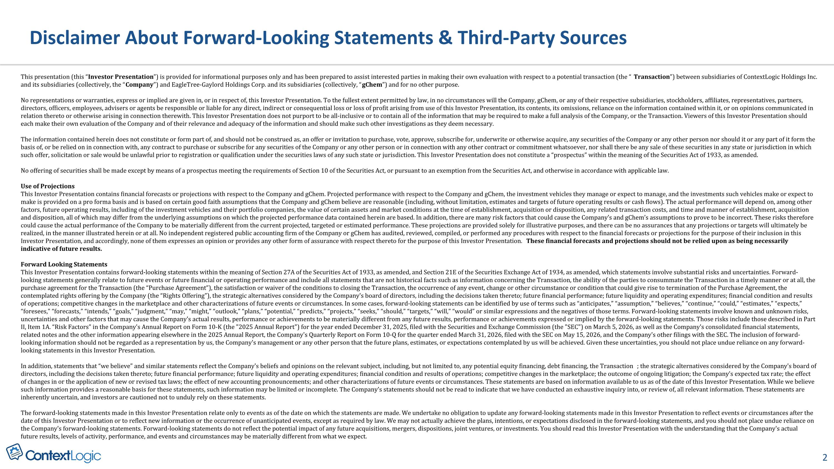
Disclaimer About Forward-Looking Statements & Third-Party Sources 2 This presentation (this “Investor Presentation”) is provided for informational purposes only and has been prepared to assist interested parties in making their own evaluation with respect to a potential transaction (the “Transaction”) between subsidiaries of ContextLogic Holdings Inc. and its subsidiaries (collectively, the “Company”) and EagleTree-Gaylord Holdings Corp. and its subsidiaries (collectively, “gChem”) and for no other purpose. No representations or warranties, express or implied are given in, or in respect of, this Investor Presentation. To the fullest extent permitted by law, in no circumstances will the Company, gChem, or any of their respective subsidiaries, stockholders, affiliates, representatives, partners, directors, officers, employees, advisers or agents be responsible or liable for any direct, indirect or consequential loss or loss of profit arising from use of this Investor Presentation, its contents, its omissions, reliance on the information contained within it, or on opinions communicated in relation thereto or otherwise arising in connection therewith. This Investor Presentation does not purport to be all-inclusive or to contain all of the information that may be required to make a full analysis of the Company, or the Transaction. Viewers of this Investor Presentation should each make their own evaluation of the Company and of their relevance and adequacy of the information and should make such other investigations as they deem necessary. The information contained herein does not constitute or form part of, and should not be construed as, an offer or invitation to purchase, vote, approve, subscribe for, underwrite or otherwise acquire, any securities of the Company or any other person nor should it or any part of it form the basis of, or be relied on in connection with, any contract to purchase or subscribe for any securities of the Company or any other person or in connection with any other contract or commitment whatsoever, nor shall there be any sale of these securities in any state or jurisdiction in which such offer, solicitation or sale would be unlawful prior to registration or qualification under the securities laws of any such state or jurisdiction. This Investor Presentation does not constitute a “prospectus” within the meaning of the Securities Act of 1933, as amended. No offering of securities shall be made except by means of a prospectus meeting the requirements of Section 10 of the Securities Act, or pursuant to an exemption from the Securities Act, and otherwise in accordance with applicable law. Use of Projections This Investor Presentation contains financial forecasts or projections with respect to the Company and gChem. Projected performance with respect to the Company and gChem, the investment vehicles they manage or expect to manage, and the investments such vehicles make or expect to make is provided on a pro forma basis and is based on certain good faith assumptions that the Company and gChem believe are reasonable (including, without limitation, estimates and targets of future operating results or cash flows). The actual performance will depend on, among other factors, future operating results, including of the investment vehicles and their portfolio companies, the value of certain assets and market conditions at the time of establishment, acquisition or disposition, any related transaction costs, and time and manner of establishment, acquisition and disposition, all of which may differ from the underlying assumptions on which the projected performance data contained herein are based. In addition, there are many risk factors that could cause the Company’s and gChem’s assumptions to prove to be incorrect. These risks therefore could cause the actual performance of the Company to be materially different from the current projected, targeted or estimated performance. These projections are provided solely for illustrative purposes, and there can be no assurances that any projections or targets will ultimately be realized, in the manner illustrated herein or at all. No independent registered public accounting firm of the Company or gChem has audited, reviewed, compiled, or performed any procedures with respect to the financial forecasts or projections for the purpose of their inclusion in this Investor Presentation, and accordingly, none of them expresses an opinion or provides any other form of assurance with respect thereto for the purpose of this Investor Presentation. These financial forecasts and projections should not be relied upon as being necessarily indicative of future results. Forward Looking Statements This Investor Presentation contains forward-looking statements within the meaning of Section 27A of the Securities Act of 1933, as amended, and Section 21E of the Securities Exchange Act of 1934, as amended, which statements involve substantial risks and uncertainties. Forward-looking statements generally relate to future events or future financial or operating performance and include all statements that are not historical facts such as information concerning the Transaction, the ability of the parties to consummate the Transaction in a timely manner or at all, the purchase agreement for the Transaction (the “Purchase Agreement”), the satisfaction or waiver of the conditions to closing the Transaction, the occurrence of any event, change or other circumstance or condition that could give rise to termination of the Purchase Agreement, the contemplated rights offering by the Company (the “Rights Offering”), the strategic alternatives considered by the Company's board of directors, including the decisions taken thereto; future financial performance; future liquidity and operating expenditures; financial condition and results of operations; competitive changes in the marketplace and other characterizations of future events or circumstances. In some cases, forward-looking statements can be identified by use of terms such as “anticipates,” “assumption,” “believes,” “continue,” “could,” “estimates,” “expects,” “foresees,” “forecasts,” “intends,” “goals,” “judgment,” “may,” “might,” “outlook,” “plans,” “potential,” “predicts,” “projects,” “seeks,” “should,” “targets,” “will,” “would” or similar expressions and the negatives of those terms. Forward-looking statements involve known and unknown risks, uncertainties and other factors that may cause the Company's actual results, performance or achievements to be materially different from any future results, performance or achievements expressed or implied by the forward-looking statements. Those risks include those described in Part II, Item 1A. “Risk Factors” in the Company's Annual Report on Form 10-K (the "2025 Annual Report") for the year ended December 31, 2025, filed with the Securities and Exchange Commission (the "SEC") on March 5, 2026, as well as the Company's consolidated financial statements, related notes and the other information appearing elsewhere in the 2025 Annual Report, the Company's Quarterly Report on Form 10-Q for the quarter ended March 31, 2026, filed with the SEC on May 15, 2026, and the Company's other filings with the SEC. The inclusion of forward-looking information should not be regarded as a representation by us, the Company's management or any other person that the future plans, estimates, or expectations contemplated by us will be achieved. Given these uncertainties, you should not place undue reliance on any forward-looking statements in this Investor Presentation. In addition, statements that “we believe” and similar statements reflect the Company's beliefs and opinions on the relevant subject, including, but not limited to, any potential equity financing, debt financing, the Transaction; the strategic alternatives considered by the Company's board of directors, including the decisions taken thereto; future financial performance; future liquidity and operating expenditures; financial condition and results of operations; competitive changes in the marketplace; the outcome of ongoing litigation; the Company's expected tax rate; the effect of changes in or the application of new or revised tax laws; the effect of new accounting pronouncements; and other characterizations of future events or circumstances. These statements are based on information available to us as of the date of this Investor Presentation. While we believe such information provides a reasonable basis for these statements, such information may be limited or incomplete. The Company's statements should not be read to indicate that we have conducted an exhaustive inquiry into, or review of, all relevant information. These statements are inherently uncertain, and investors are cautioned not to unduly rely on these statements. The forward-looking statements made in this Investor Presentation relate only to events as of the date on which the statements are made. We undertake no obligation to update any forward-looking statements made in this Investor Presentation to reflect events or circumstances after the date of this Investor Presentation or to reflect new information or the occurrence of unanticipated events, except as required by law. We may not actually achieve the plans, intentions, or expectations disclosed in the forward-looking statements, and you should not place undue reliance on the Company's forward-looking statements. Forward-looking statements do not reflect the potential impact of any future acquisitions, mergers, dispositions, joint ventures, or investments. You should read this Investor Presentation with the understanding that the Company's actual future results, levels of activity, performance, and events and circumstances may be materially different from what we expect.

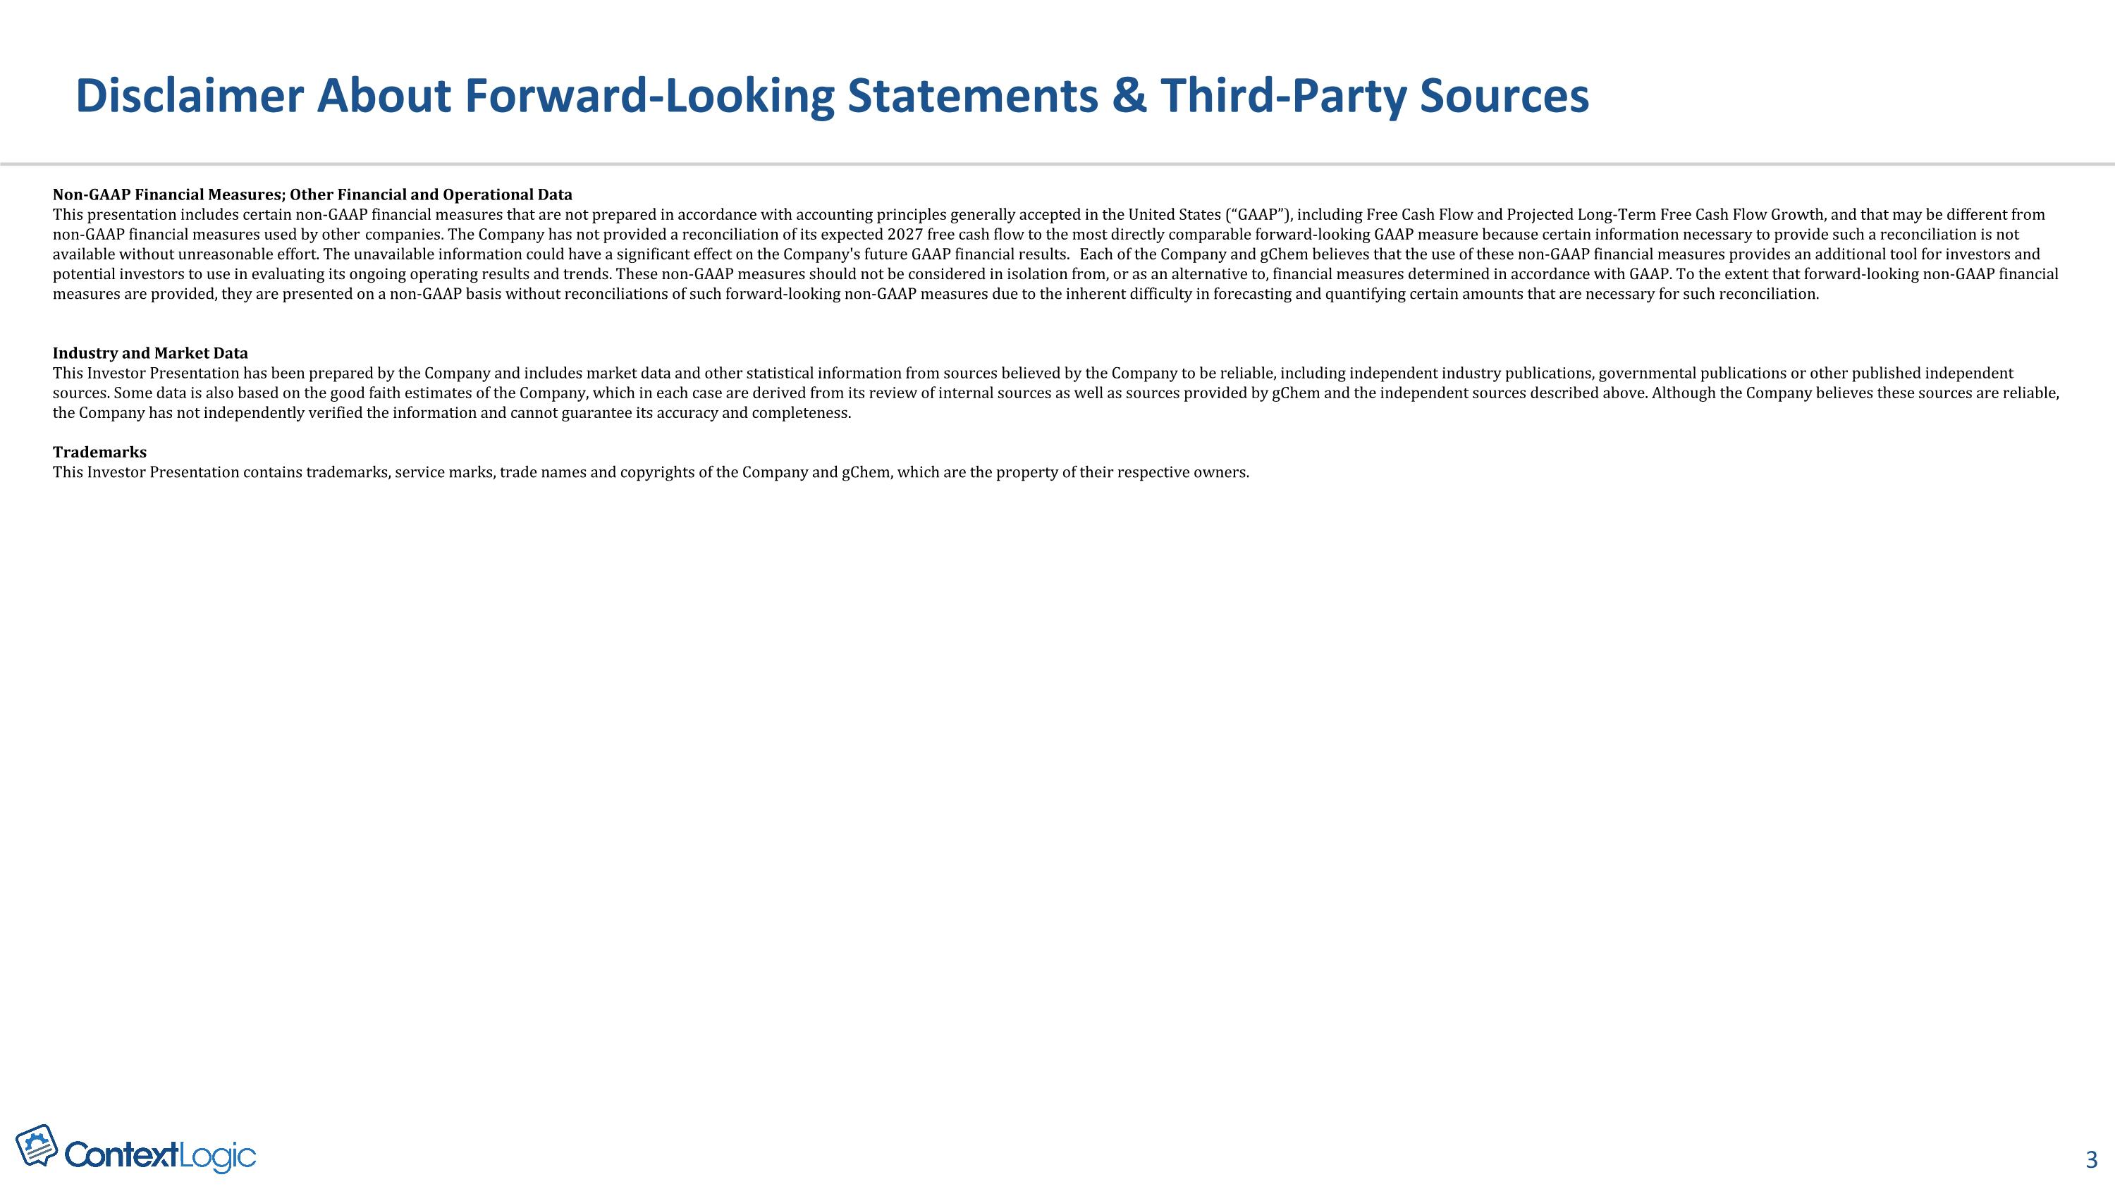
Disclaimer About Forward-Looking Statements & Third-Party Sources 3 Non-GAAP Financial Measures; Other Financial and Operational Data This presentation includes certain non-GAAP financial measures that are not prepared in accordance with accounting principles generally accepted in the United States (“GAAP”), including Free Cash Flow and Projected Long-Term Free Cash Flow Growth, and that may be different from non-GAAP financial measures used by other companies. The Company has not provided a reconciliation of its expected 2027 free cash flow to the most directly comparable forward-looking GAAP measure because certain information necessary to provide such a reconciliation is not available without unreasonable effort. The unavailable information could have a significant effect on the Company's future GAAP financial results. Each of the Company and gChem believes that the use of these non-GAAP financial measures provides an additional tool for investors and potential investors to use in evaluating its ongoing operating results and trends. These non-GAAP measures should not be considered in isolation from, or as an alternative to, financial measures determined in accordance with GAAP. To the extent that forward-looking non-GAAP financial measures are provided, they are presented on a non-GAAP basis without reconciliations of such forward-looking non-GAAP measures due to the inherent difficulty in forecasting and quantifying certain amounts that are necessary for such reconciliation. Industry and Market Data This Investor Presentation has been prepared by the Company and includes market data and other statistical information from sources believed by the Company to be reliable, including independent industry publications, governmental publications or other published independent sources. Some data is also based on the good faith estimates of the Company, which in each case are derived from its review of internal sources as well as sources provided by gChem and the independent sources described above. Although the Company believes these sources are reliable, the Company has not independently verified the information and cannot guarantee its accuracy and completeness. Trademarks This Investor Presentation contains trademarks, service marks, trade names and copyrights of the Company and gChem, which are the property of their respective owners.

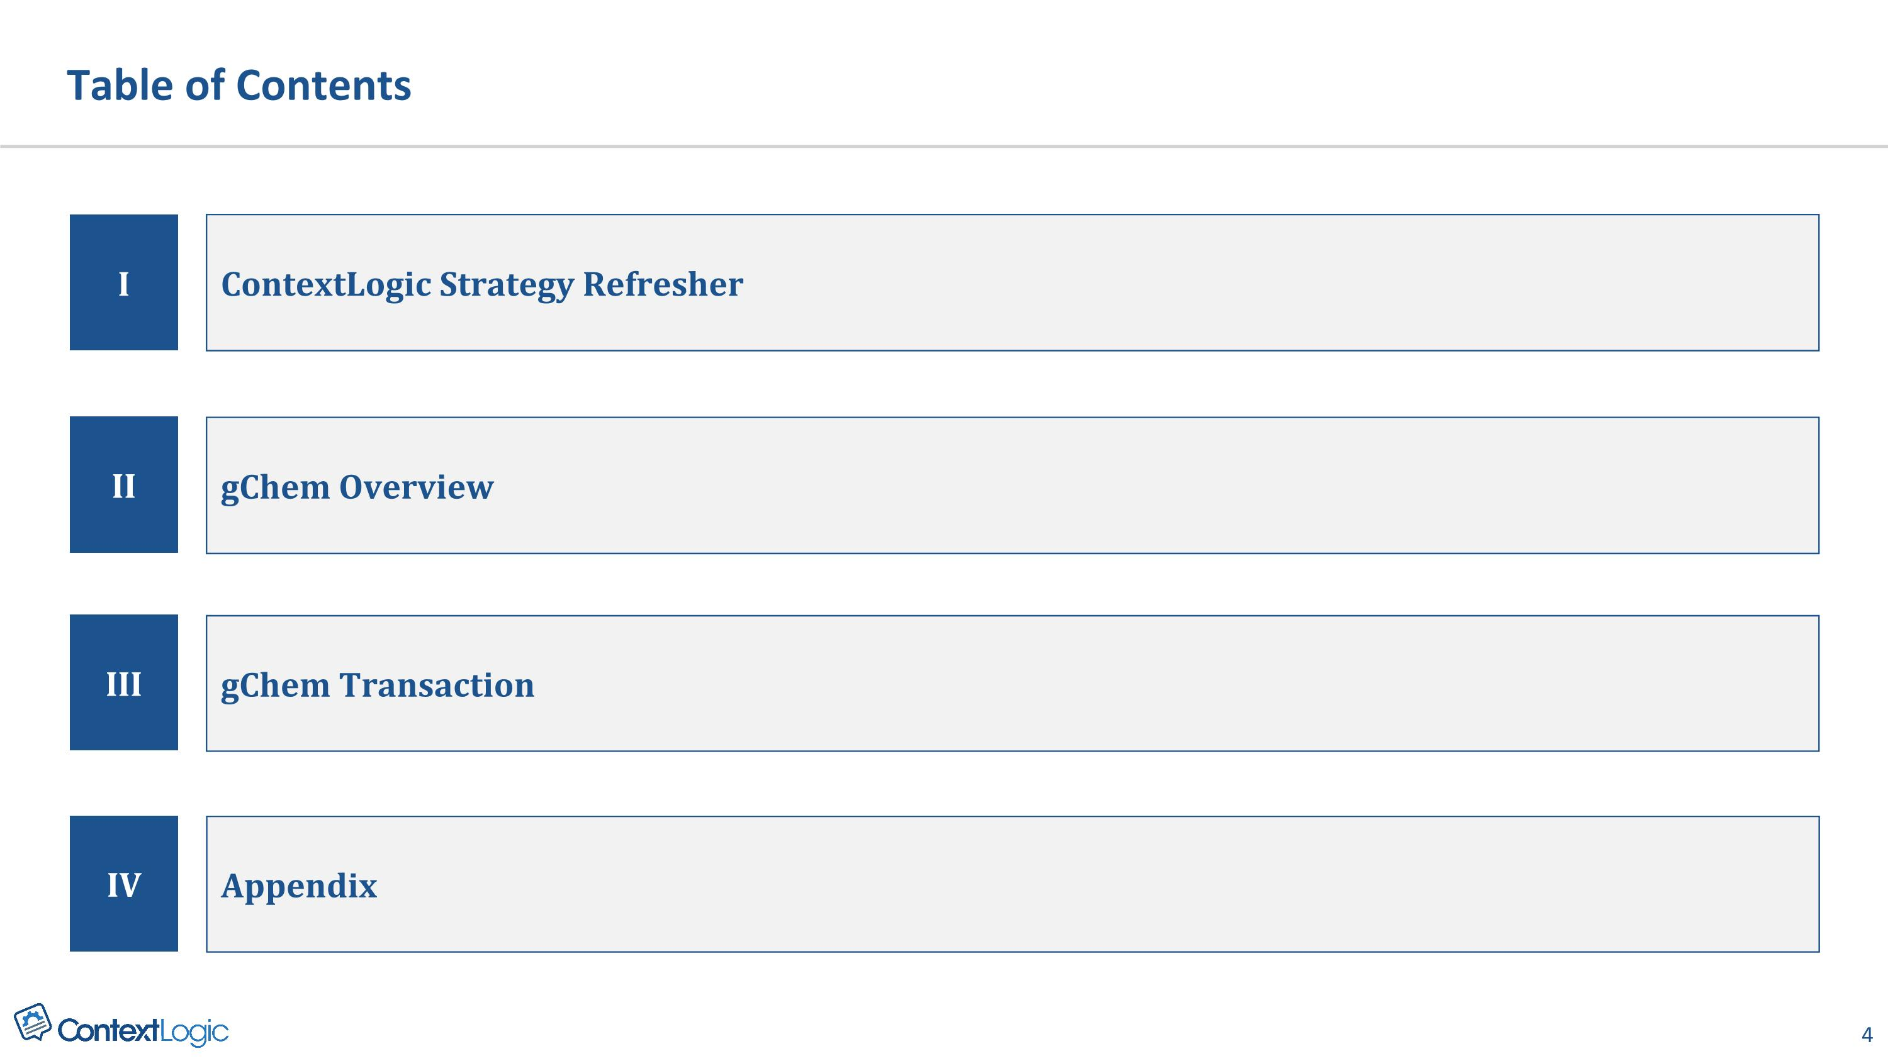
I II ContextLogic Strategy Refresher gChem Overview III gChem Transaction Table of Contents IV Appendix

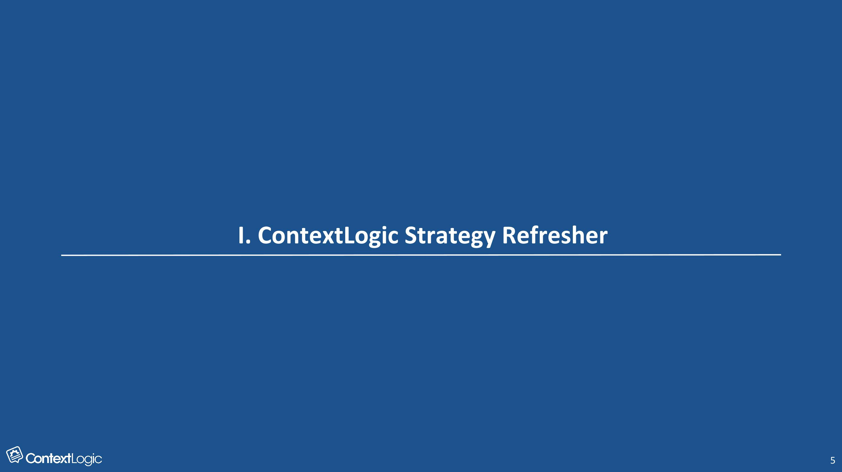
I. ContextLogic Strategy Refresher

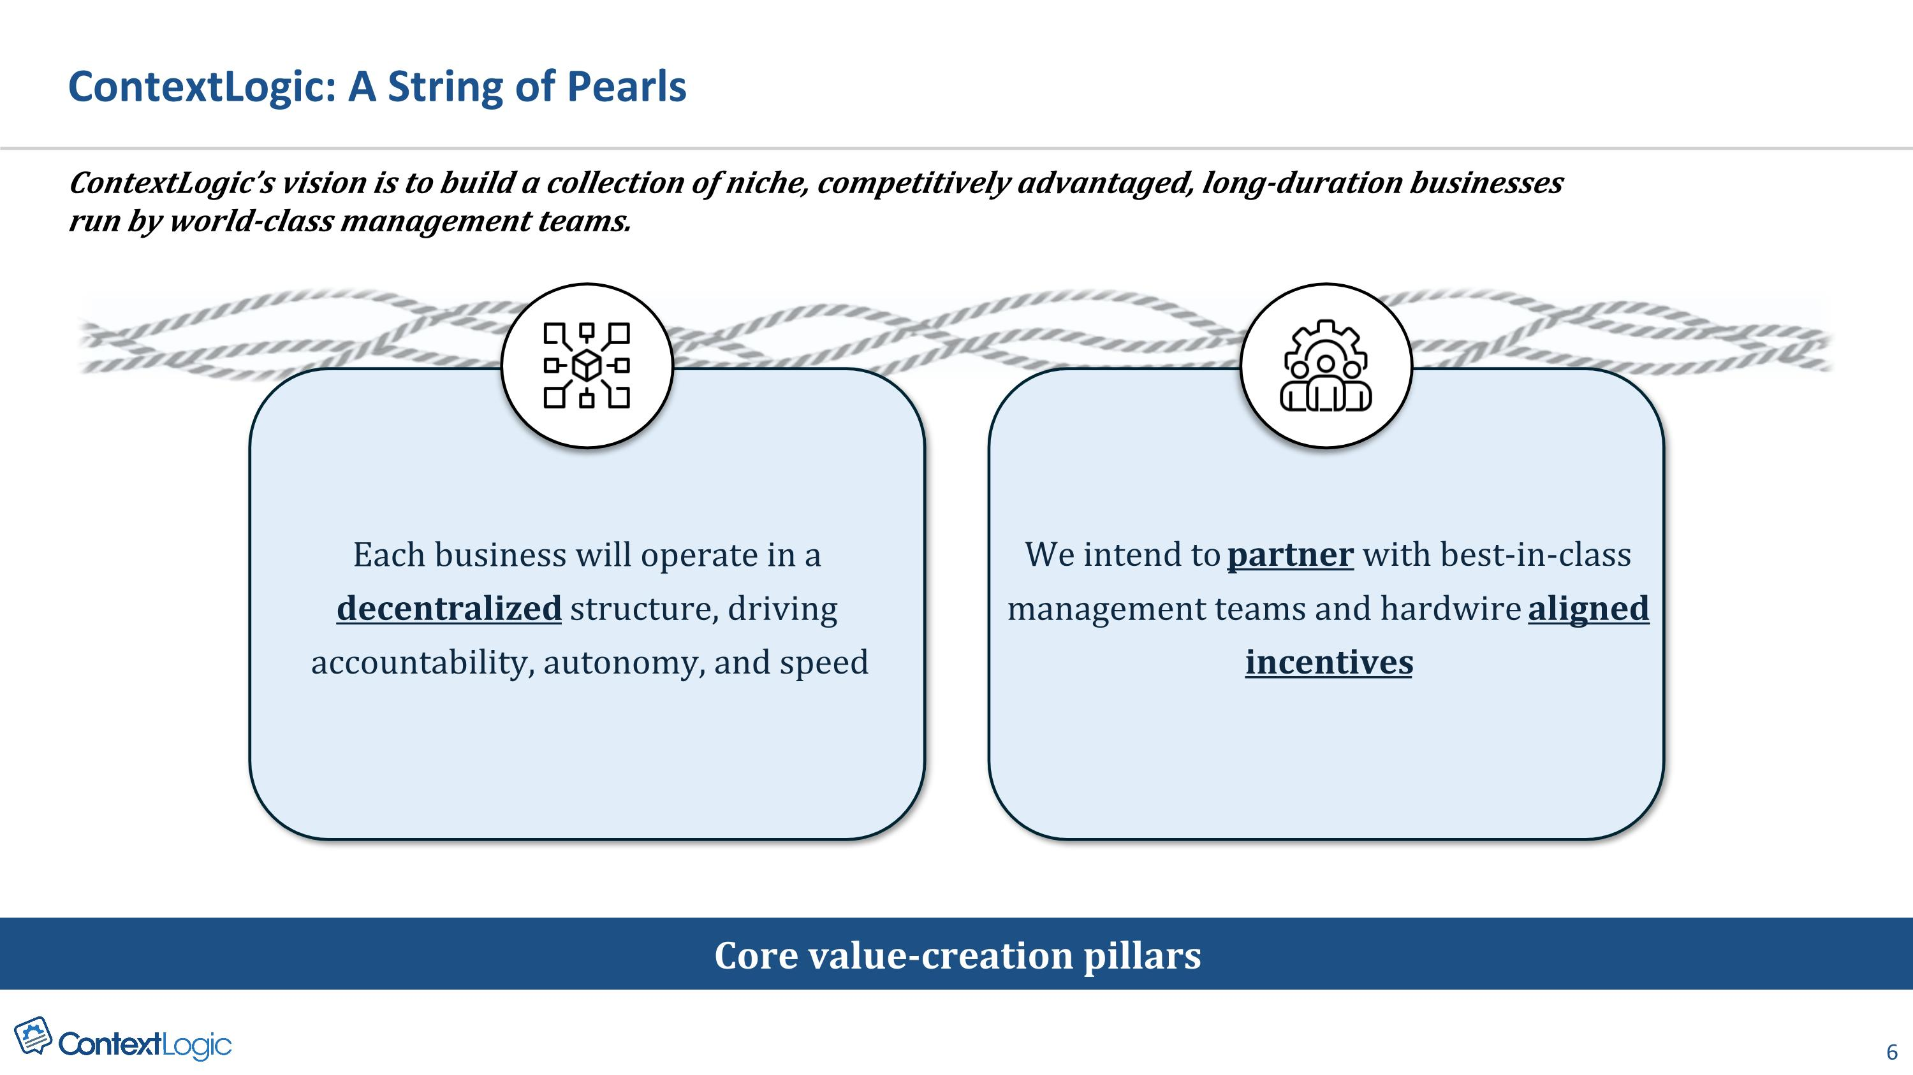
ContextLogic: A String of Pearls ContextLogic’s vision is to build a collection of niche, competitively advantaged, long-duration businesses?run by world-class management teams. Each business will operate in a decentralized structure, driving accountability, autonomy, and speed We intend to partner with best-in-class management teams and hardwire aligned incentives Core value-creation pillars

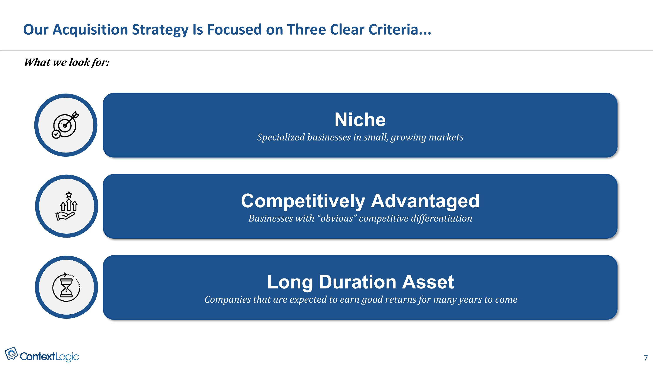
What we look for: Our Acquisition Strategy Is Focused on Three Clear Criteria... Niche Specialized businesses in small, growing markets Competitively Advantaged Businesses with “obvious” competitive differentiation Long Duration Asset Companies that are expected to earn good returns for many years to come

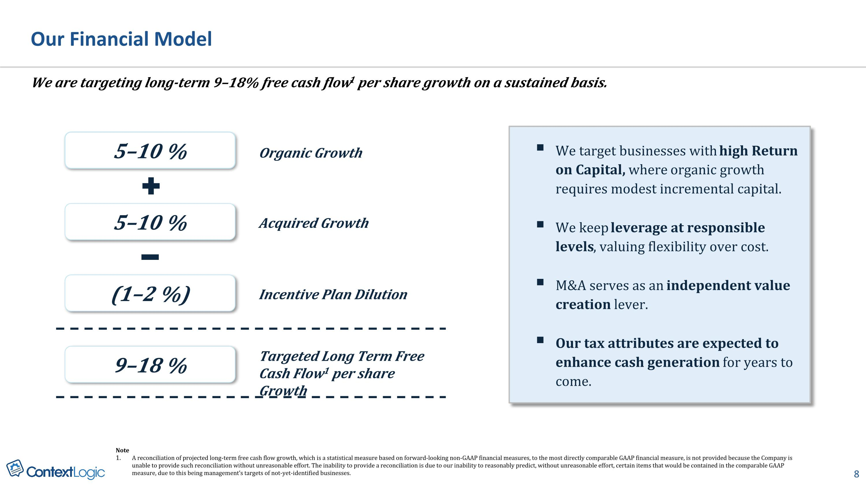
We are targeting long-term 9–18% free cash flow1 per share growth on a sustained basis. Our Financial Model 5–10 % 9–18 % Targeted Long Term Free Cash Flow1 per share Growth 5–10 % Acquired Growth (1–2 %) Incentive Plan Dilution Organic Growth Note A reconciliation of projected long-term free cash flow growth, which is a statistical measure based on forward-looking non-GAAP financial measures, to the most directly comparable GAAP financial measure, is not provided because the Company is unable to provide such reconciliation without unreasonable effort. The inability to provide a reconciliation is due to our inability to reasonably predict, without unreasonable effort, certain items that would be contained in the comparable GAAP measure, due to this being management’s targets of not-yet-identified businesses. We target businesses with high Return on Capital, where organic growth requires modest incremental capital. We keep leverage at responsible levels, valuing flexibility over cost. M&A serves as an independent value creation lever. Our tax attributes are expected to enhance cash generation for years to come.


II. Introducing The Second Pearl

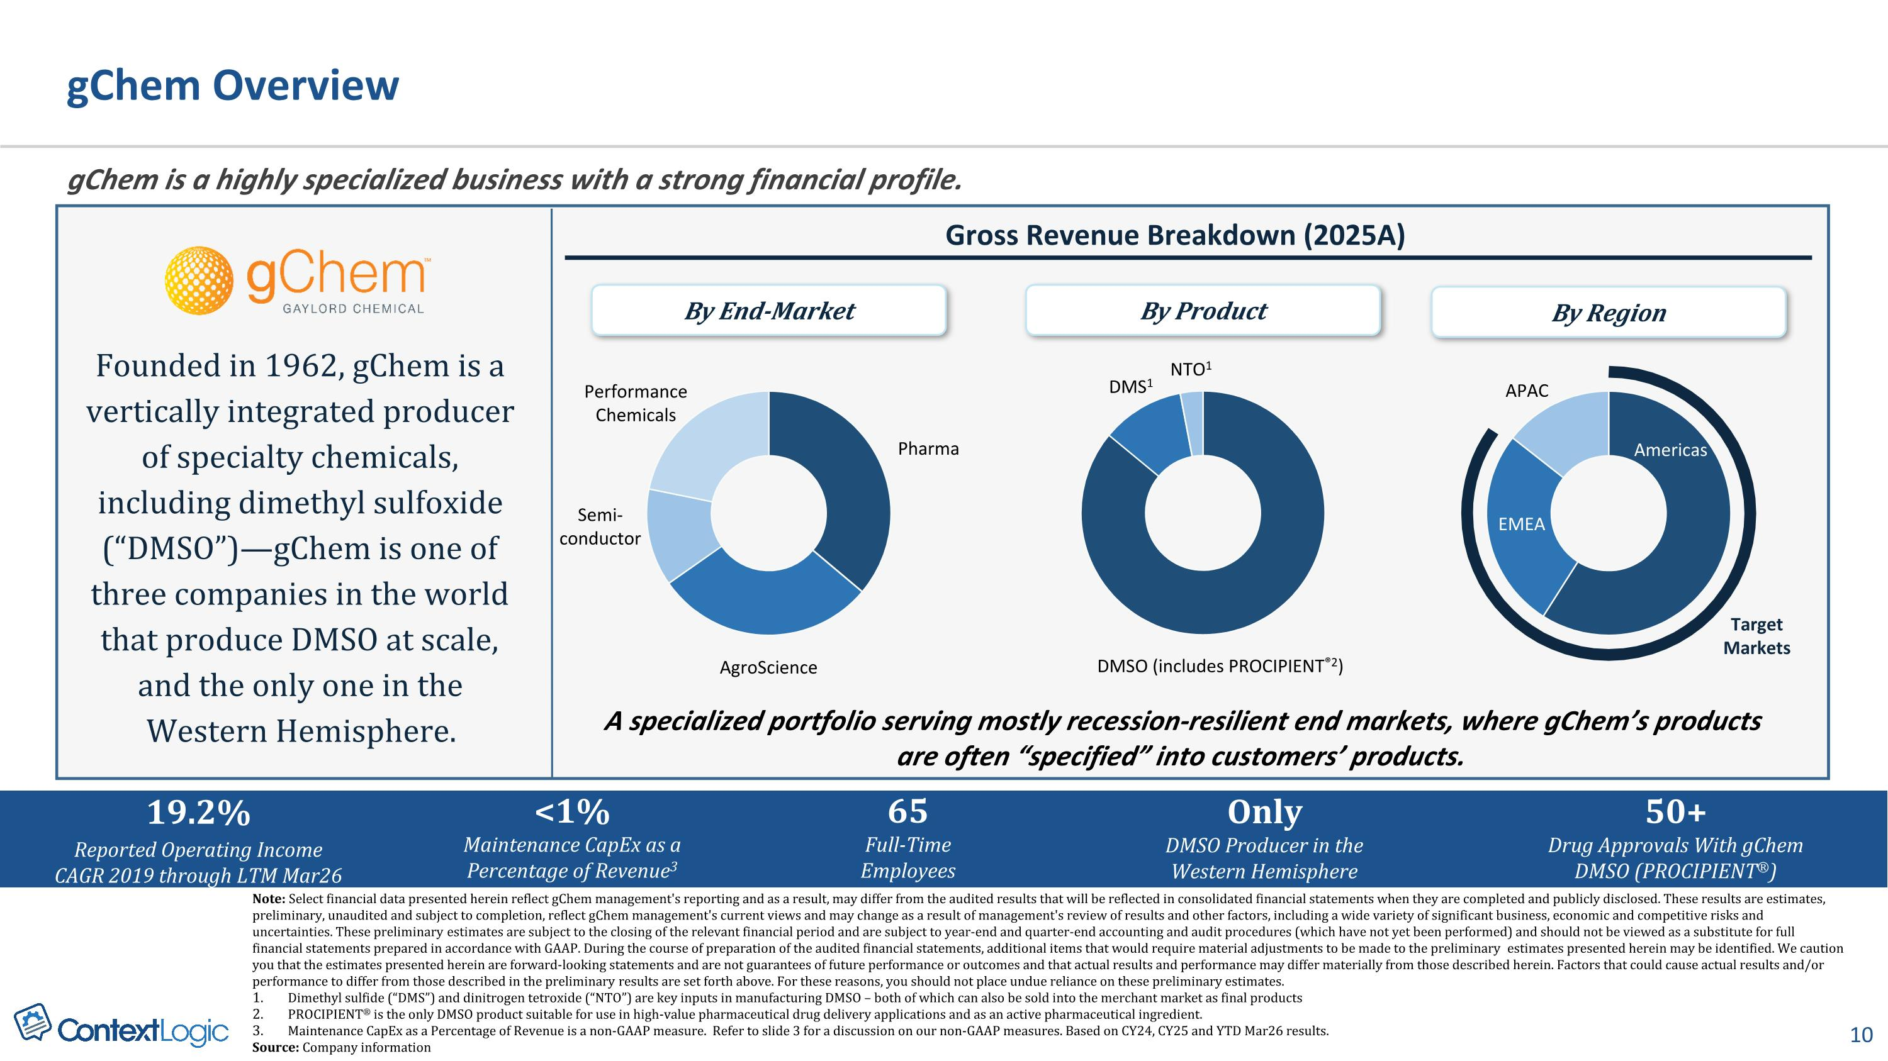
gChem Overview A specialized portfolio serving mostly recession-resilient end markets, where gChem’s products are often “specified” into customers’ products. Gross Revenue Breakdown (2025A) gChem is a highly specialized business with a strong financial profile. Founded in 1962, gChem is a vertically integrated producer of specialty chemicals, including dimethyl sulfoxide (“DMSO”)—gChem is one of three companies in the world that produce DMSO at scale, and the only one in the Western Hemisphere. Only?DMSO Producer in the Western Hemisphere 50+?Drug Approvals With gChem DMSO (PROCIPIENT®) DMSO (includes PROCIPIENT®2) DMS1 NTO1 By Product Pharma AgroScience Semi-conductor Performance Chemicals By End-Market Americas EMEA APAC By Region Target Markets Note: Select financial data presented herein reflect gChem management's reporting and as a result, may differ from the audited results that will be reflected in consolidated financial statements when they are completed and publicly disclosed. These results are estimates, preliminary, unaudited and subject to completion, reflect gChem management's current views and may change as a result of management's review of results and other factors, including a wide variety of significant business, economic and competitive risks and uncertainties. These preliminary estimates are subject to the closing of the relevant financial period and are subject to year-end and quarter-end accounting and audit procedures (which have not yet been performed) and should not be viewed as a substitute for full financial statements prepared in accordance with GAAP. During the course of preparation of the audited financial statements, additional items that would require material adjustments to be made to the preliminary estimates presented herein may be identified. We caution you that the estimates presented herein are forward-looking statements and are not guarantees of future performance or outcomes and that actual results and performance may differ materially from those described herein. Factors that could cause actual results and/or performance to differ from those described in the preliminary results are set forth above. For these reasons, you should not place undue reliance on these preliminary estimates. Dimethyl sulfide (“DMS”) and dinitrogen tetroxide (“NTO”) are key inputs in manufacturing DMSO – both of which can also be sold into the merchant market as final products PROCIPIENT® is the only DMSO product suitable for use in high-value pharmaceutical drug delivery applications and as an active pharmaceutical ingredient. Maintenance CapEx as a Percentage of Revenue is a non-GAAP measure. Refer to slide 3 for a discussion on our non-GAAP measures. Based on CY24, CY25 and YTD Mar26 results. Source: Company information 19.2% Reported Operating Income CAGR 2019 through LTM Mar26 Only?DMSO Producer in the Western Hemisphere <1%?Maintenance CapEx as a Percentage of Revenue3 65 Full-Time Employees 50+?Drug Approvals With gChem DMSO (PROCIPIENT®)

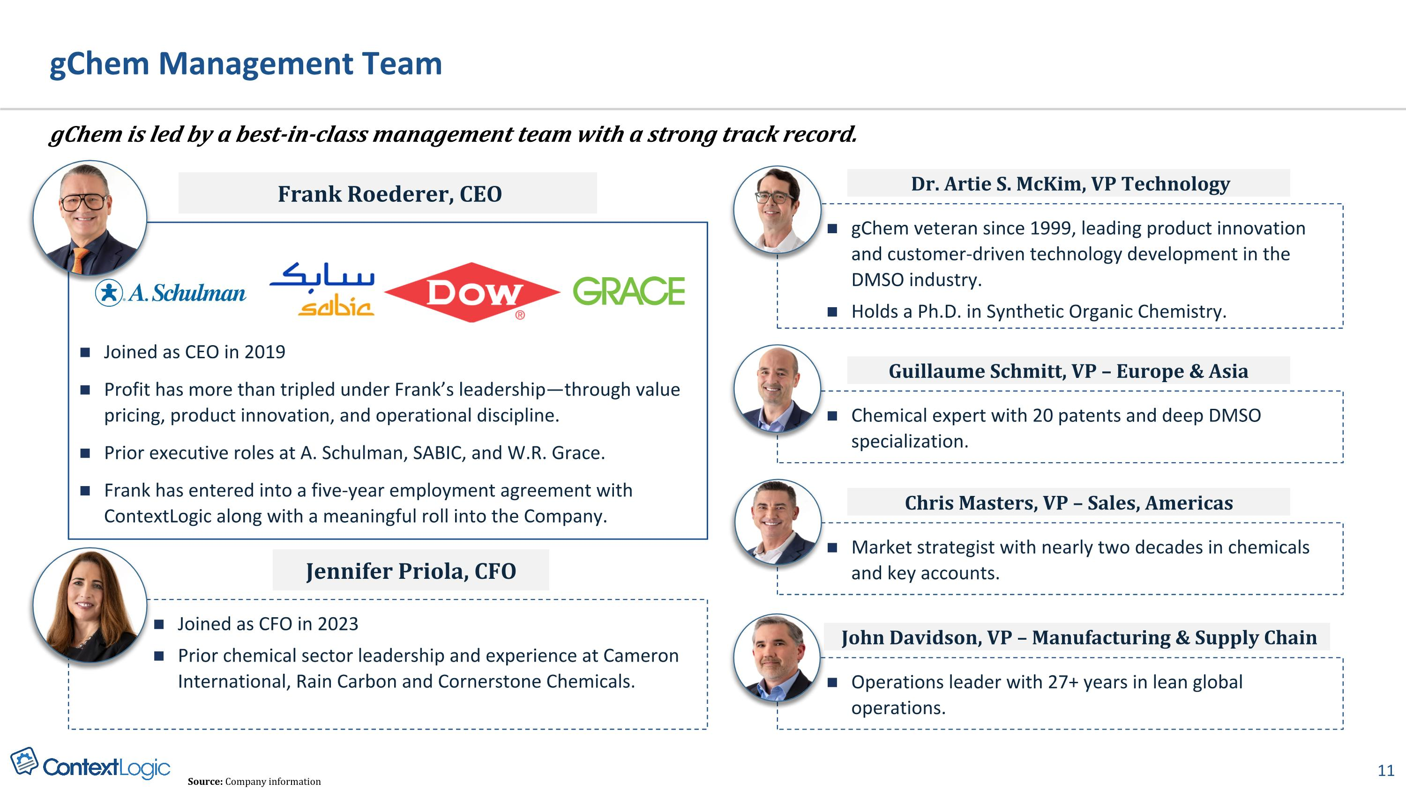
gChem Management Team gChem is led by a best-in-class management team with a strong track record. Source: Company information Joined as CEO in 2019 Profit has more than tripled under Frank’s leadership—through value pricing, product innovation, and operational discipline. Prior executive roles at A. Schulman, SABIC, and W.R. Grace. Frank has entered into a five-year employment agreement with ContextLogic along with a meaningful roll into the Company. Frank Roederer, CEO Joined as CFO in 2023 Prior chemical sector leadership and experience at Cameron International, Rain Carbon and Cornerstone Chemicals. Jennifer Priola, CFO gChem veteran since 1999, leading product innovation and customer-driven technology development in the DMSO industry. Holds a Ph.D. in Synthetic Organic Chemistry. Dr. Artie S. McKim, VP Technology Chemical expert with 20 patents and deep DMSO specialization. Guillaume Schmitt, VP – Europe & Asia Market strategist with nearly two decades in chemicals and key accounts. Chris Masters, VP – Sales, Americas Operations leader with 27+ years in lean global operations. John Davidson, VP – Manufacturing & Supply Chain

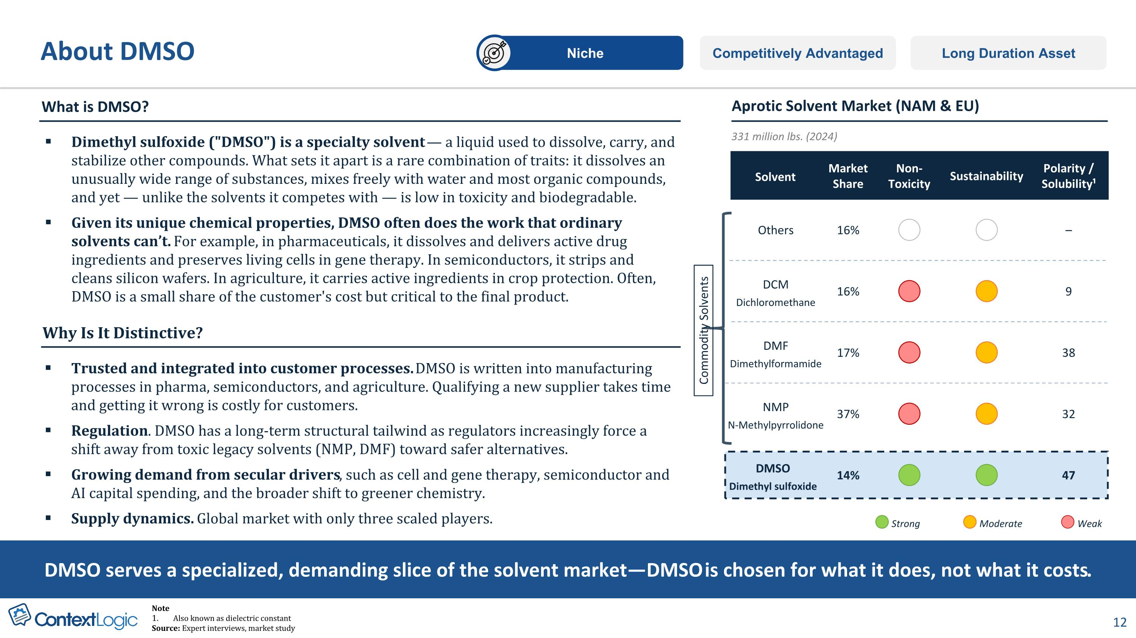
About DMSO Competitively Advantaged Long Duration Asset Niche Solvent Market Share Non- Toxicity Sustainability Polarity / Solubility¹ Strong Moderate Weak DMSO serves a specialized, demanding slice of the solvent market—DMSO is chosen for what it does, not what it costs. 331 million lbs. (2024) Others 16% – DMF Dimethylformamide 17% 38 DCM Dichloromethane 16% 9 NMP N-Methylpyrrolidone 37% 32 DMSO Dimethyl sulfoxide 14% 47 Aprotic Solvent Market (NAM & EU) What is DMSO? Dimethyl sulfoxide ("DMSO") is a specialty solvent — a liquid used to dissolve, carry, and stabilize other compounds. What sets it apart is a rare combination of traits: it dissolves an unusually wide range of substances, mixes freely with water and most organic compounds, and yet — unlike the solvents it competes with — is low in toxicity and biodegradable. Given its unique chemical properties, DMSO often does the work that ordinary solvents can’t. For example, in pharmaceuticals, it dissolves and delivers active drug ingredients and preserves living cells in gene therapy. In semiconductors, it strips and cleans silicon wafers. In agriculture, it carries active ingredients in crop protection. Often, DMSO is a small share of the customer's cost but critical to the final product. Trusted and integrated into customer processes. DMSO is written into manufacturing processes in pharma, semiconductors, and agriculture. Qualifying a new supplier takes time and getting it wrong is costly for customers. Regulation. DMSO has a long-term structural tailwind as regulators increasingly force a shift away from toxic legacy solvents (NMP, DMF) toward safer alternatives. Growing demand from secular drivers, such as cell and gene therapy, semiconductor and AI capital spending, and the broader shift to greener chemistry. Supply dynamics. Global market with only three scaled players. Why Is It Distinctive? Commodity Solvents Note Also known as dielectric constant Source: Expert interviews, market study

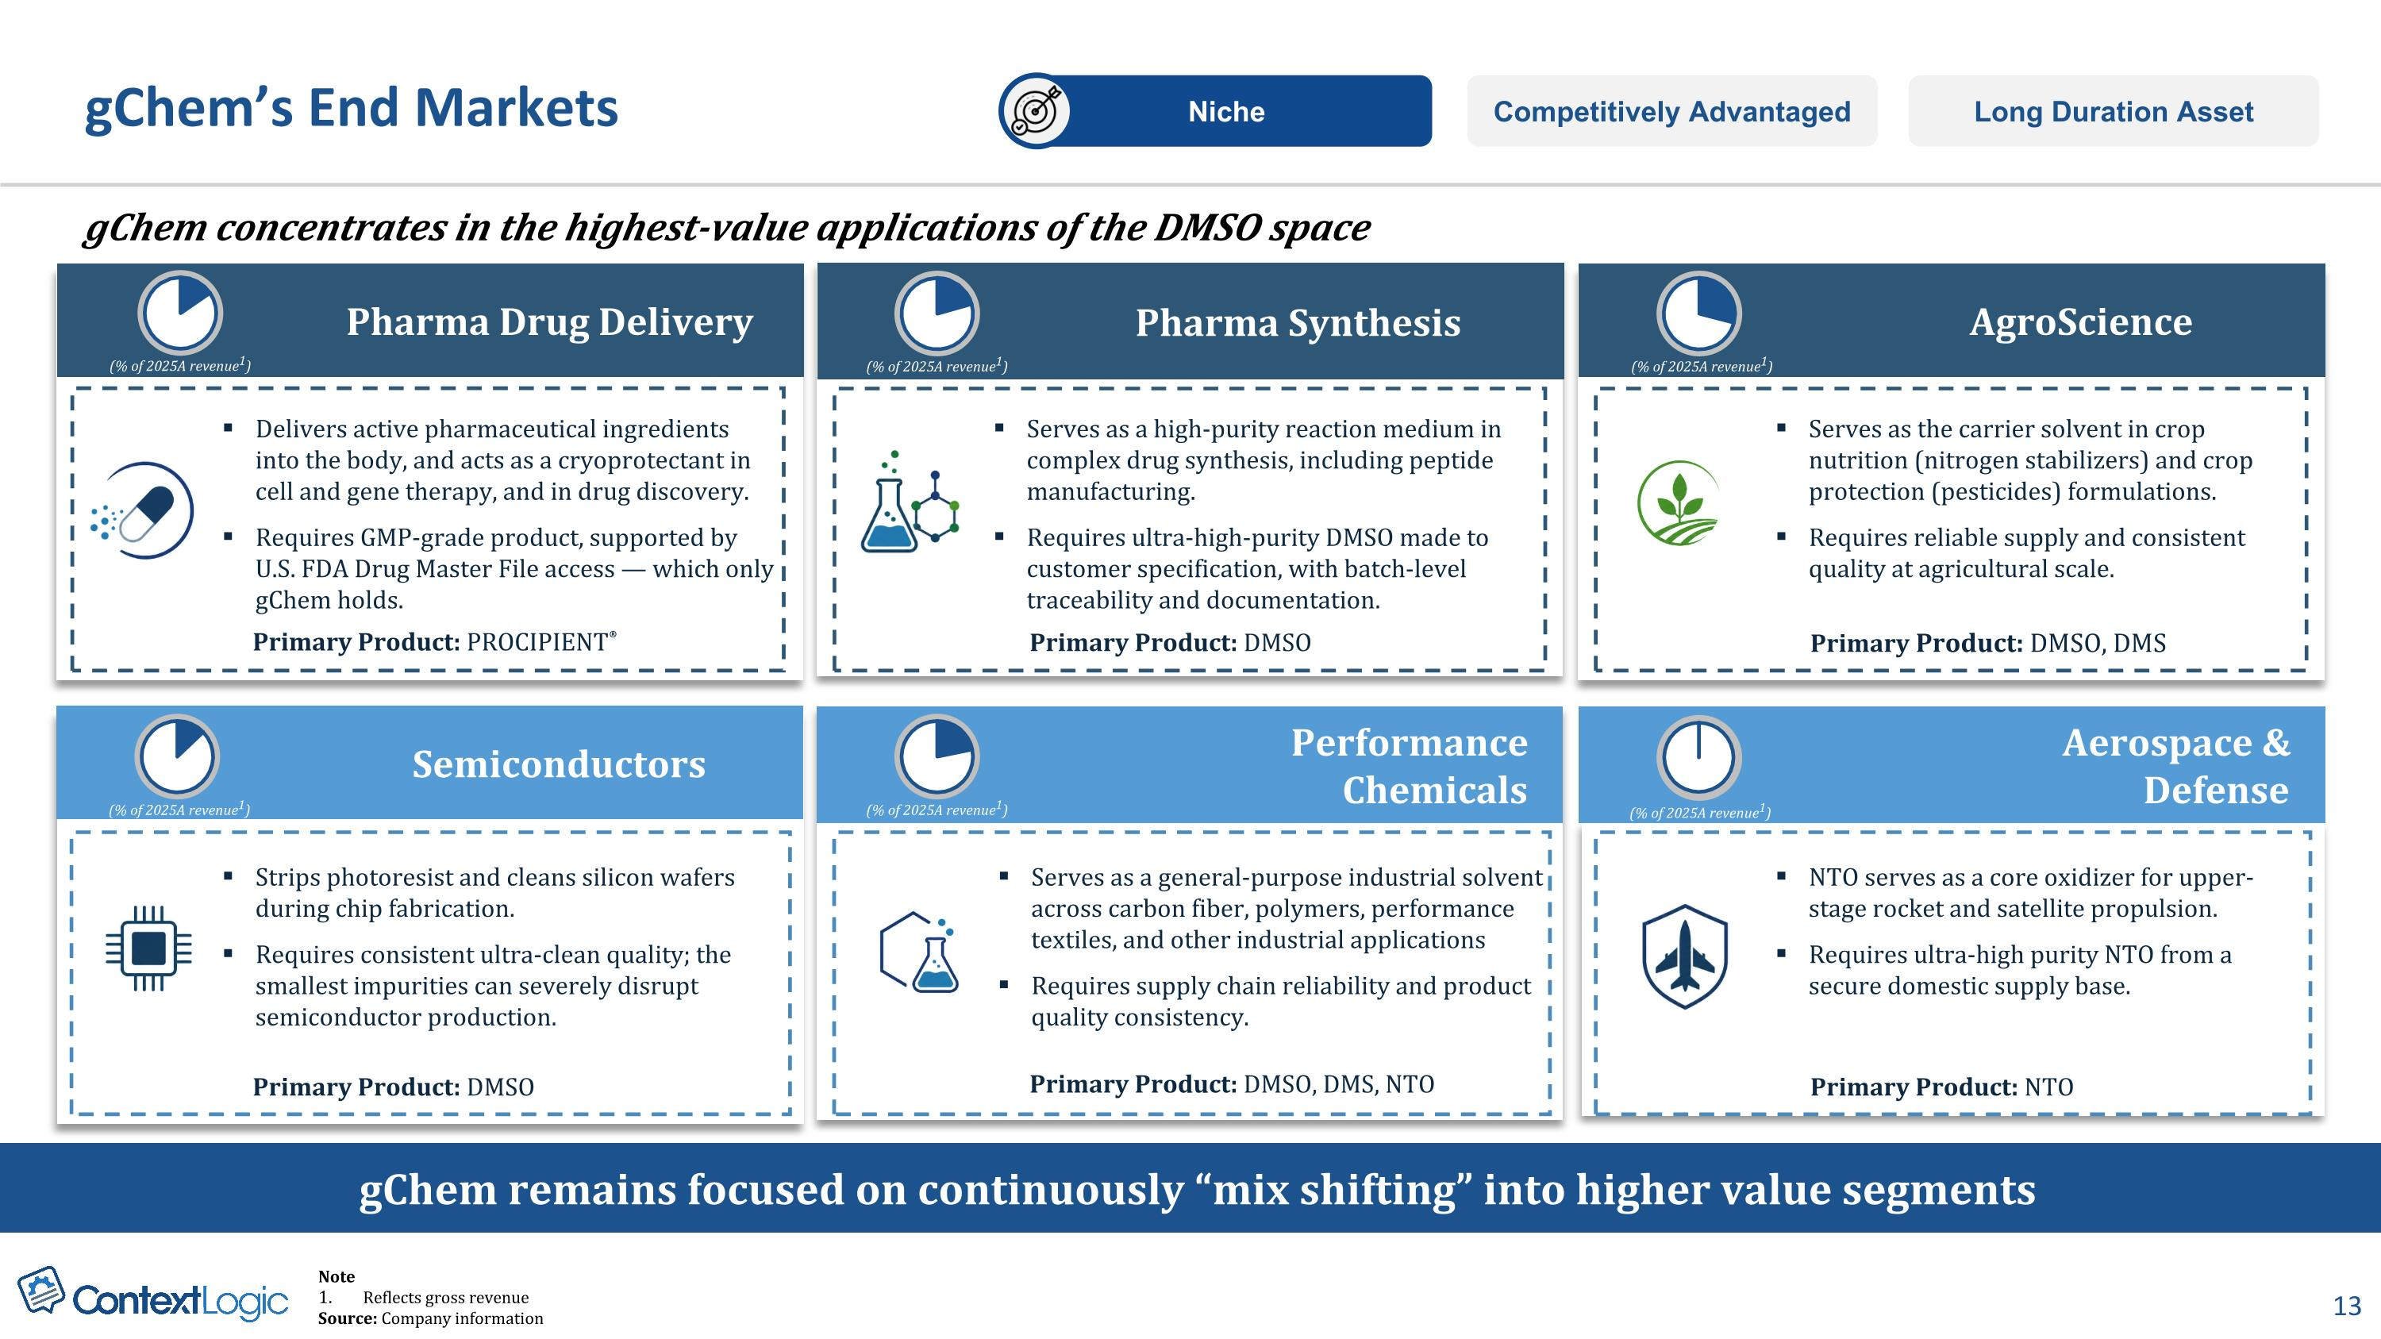
Semiconductors Strips photoresist and cleans silicon wafers during chip fabrication. Requires consistent ultra-clean quality; the smallest impurities can severely disrupt semiconductor production. Delivers active pharmaceutical ingredients into the body, and acts as a cryoprotectant in cell and gene therapy, and in drug discovery. Requires GMP-grade product, supported by U.S. FDA Drug Master File access — which only gChem holds. Serves as the carrier solvent in crop nutrition (nitrogen stabilizers) and crop protection (pesticides) formulations. Requires reliable supply and consistent quality at agricultural scale. Serves as a general-purpose industrial solvent across carbon fiber, polymers, performance textiles, and other industrial applications Requires supply chain reliability and product quality consistency. Serves as a high-purity reaction medium in complex drug synthesis, including peptide manufacturing. Requires ultra-high-purity DMSO made to customer specification, with batch-level traceability and documentation. NTO serves as a core oxidizer for upper-stage rocket and satellite propulsion. Requires ultra-high purity NTO from a secure domestic supply base. (% of 2025A revenue1) (% of 2025A revenue1) (% of 2025A revenue1) gChem concentrates in the highest-value applications of the DMSO space Pharma Drug Delivery Performance Chemicals Aerospace & Defense AgroScience (% of 2025A revenue1) gChem remains focused on continuously “mix shifting” into higher value segments Pharma Synthesis gChem’s End Markets Competitively Advantaged Long Duration Asset Niche Primary Product: PROCIPIENT® Primary Product: DMSO Primary Product: DMSO, DMS Primary Product: DMSO Primary Product: DMSO, DMS, NTO Primary Product: NTO (% of 2025A revenue1) (% of 2025A revenue1) Note Reflects gross revenue Source: Company information

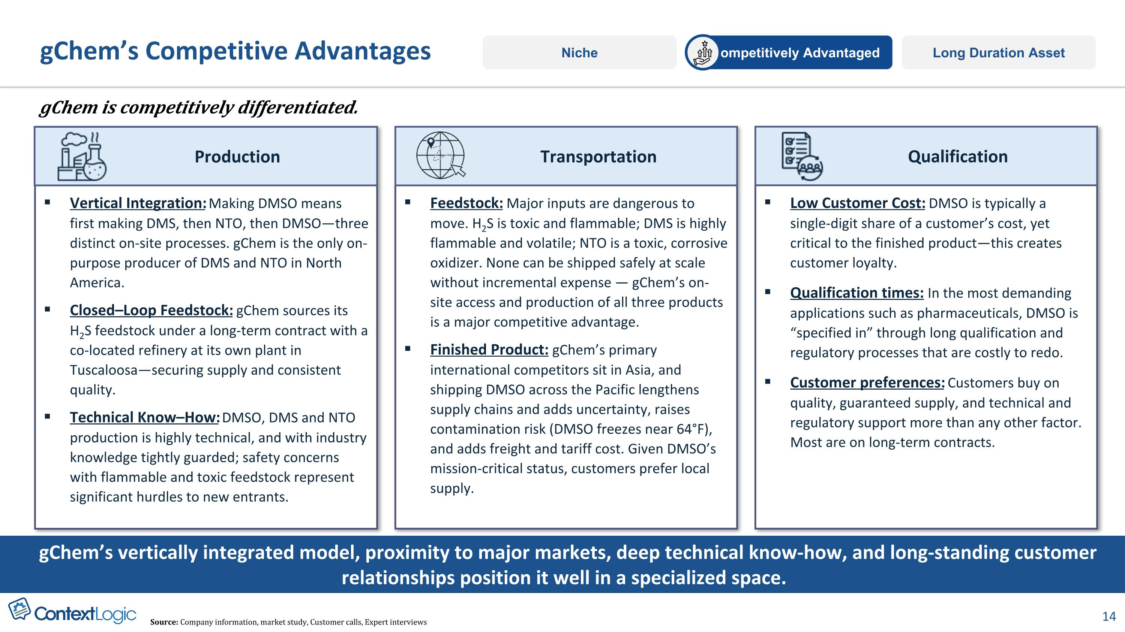
Vertical Integration: Making DMSO means first making DMS, then NTO, then DMSO—three distinct on-site processes. gChem is the only on-purpose producer of DMS and NTO in North America. Closed–Loop Feedstock: gChem sources its H2S feedstock under a long-term contract with a co-located refinery at its own plant in Tuscaloosa—securing supply and consistent quality. Technical Know–How: DMSO, DMS and NTO production is highly technical, and with industry knowledge tightly guarded; safety concerns with flammable and toxic feedstock represent significant hurdles to new entrants. Production gChem’s Competitive Advantages Long Duration Asset Competitively Advantaged Niche gChem is competitively differentiated. Feedstock: Major inputs are dangerous to move. H2S is toxic and flammable; DMS is highly flammable and volatile; NTO is a toxic, corrosive oxidizer. None can be shipped safely at scale without incremental expense — gChem’s on-site access and production of all three products is a major competitive advantage. Finished Product: gChem’s primary international competitors sit in Asia, and shipping DMSO across the Pacific lengthens supply chains and adds uncertainty, raises contamination risk (DMSO freezes near 64°F), and adds freight and tariff cost. Given DMSO’s mission-critical status, customers prefer local supply. Low Customer Cost: DMSO is typically a single-digit share of a customer’s cost, yet critical to the finished product—this creates customer loyalty. Qualification times: In the most demanding applications such as pharmaceuticals, DMSO is “specified in” through long qualification and regulatory processes that are costly to redo. Customer preferences: Customers buy on quality, guaranteed supply, and technical and regulatory support more than any other factor. Most are on long-term contracts. gChem’s vertically integrated model, proximity to major markets, deep technical know-how, and long-standing customer relationships position it well in a specialized space. Transportation Qualification Source: Company information, market study, Customer calls, Expert interviews

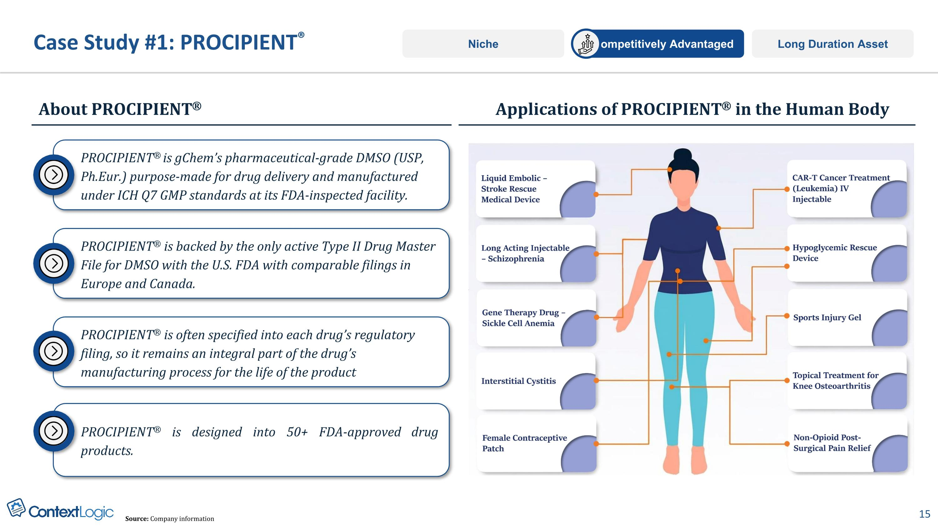
Case Study #1: PROCIPIENT® About PROCIPIENT® Applications of PROCIPIENT® in the Human Body Long Duration Asset Competitively Advantaged Niche PROCIPIENT® is backed by the only active Type II Drug Master File for DMSO with the U.S. FDA with comparable filings in Europe and Canada. PROCIPIENT® is gChem’s pharmaceutical-grade DMSO (USP, Ph.Eur.) purpose-made for drug delivery and manufactured under ICH Q7 GMP standards at its FDA-inspected facility. PROCIPIENT® is often specified into each drug’s regulatory filing, so it remains an integral part of the drug’s manufacturing process for the life of the product PROCIPIENT® is designed into 50+ FDA-approved drug products. Source: Company information

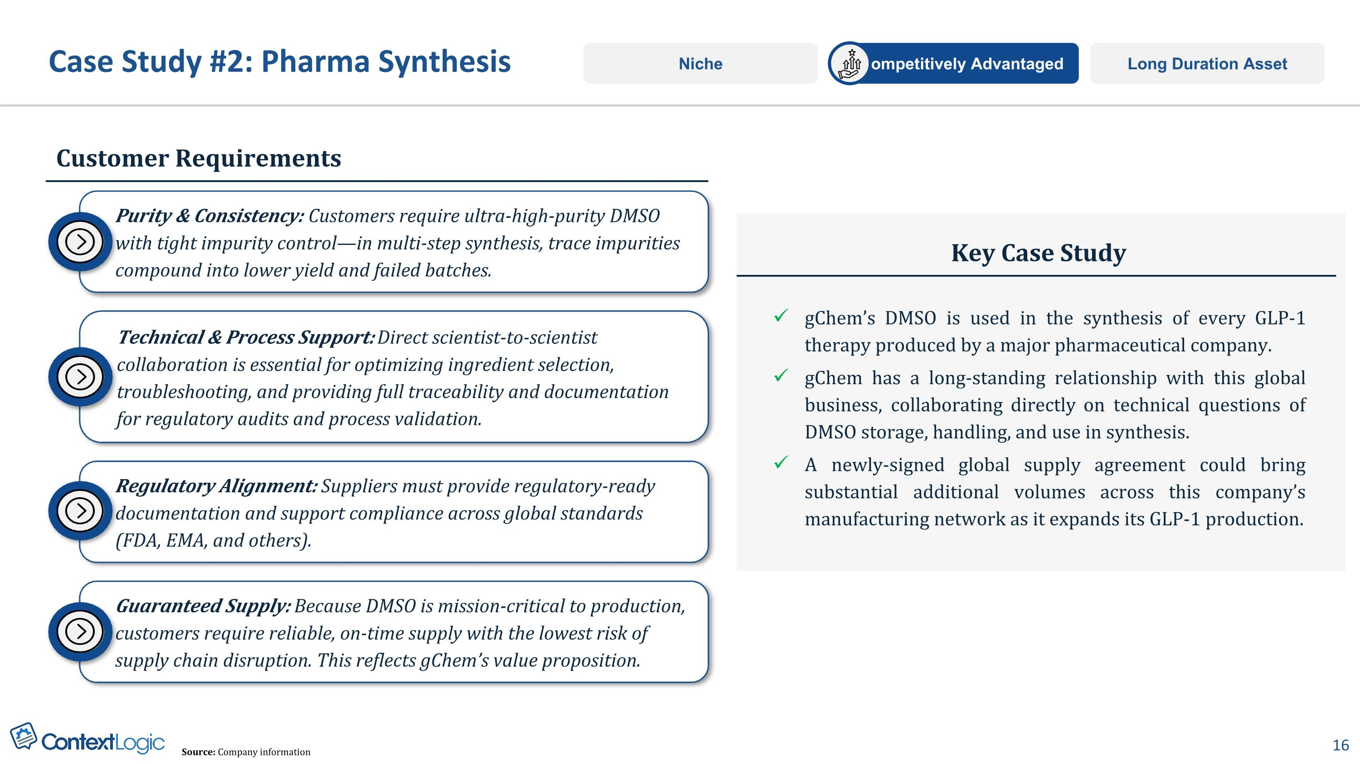
Case Study #2: Pharma Synthesis Customer Requirements Key Case Study gChem’s DMSO is used in the synthesis of every GLP-1 therapy produced by a major pharmaceutical company. gChem has a long-standing relationship with this global business, collaborating directly on technical questions of DMSO storage, handling, and use in synthesis. A newly-signed global supply agreement could bring substantial additional volumes across this company’s manufacturing network as it expands its GLP-1 production. Long Duration Asset Competitively Advantaged Niche Technical & Process Support: Direct scientist-to-scientist collaboration is essential for optimizing ingredient selection, troubleshooting, and providing full traceability and documentation for regulatory audits and process validation. Purity & Consistency: Customers require ultra-high-purity DMSO with tight impurity control—in multi-step synthesis, trace impurities compound into lower yield and failed batches. Regulatory Alignment: Suppliers must provide regulatory-ready documentation and support compliance across global standards (FDA, EMA, and others). Guaranteed Supply: Because DMSO is mission-critical to production, customers require reliable, on-time supply with the lowest risk of supply chain disruption. This reflects gChem’s value proposition. Source: Company information

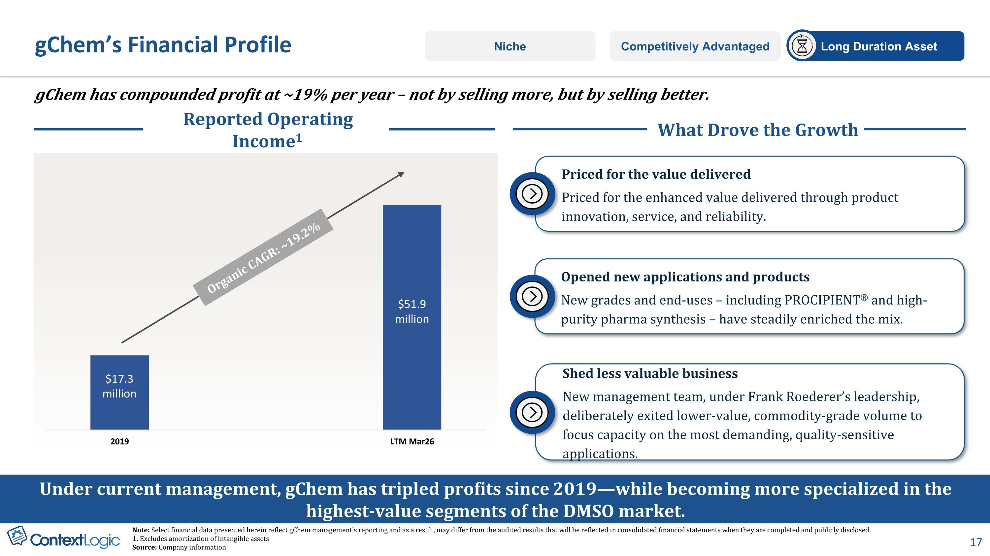
Reported Operating Income1 gChem has compounded profit at ~19% per year – not by selling more, but by selling better. gChem’s Financial Profile Organic CAGR: ~19.2% Competitively Advantaged Long Duration Asset Niche Under current management, gChem has tripled profits since 2019—while becoming more specialized in the highest-value segments of the DMSO market. What Drove the Growth Shed less valuable business New management team, under Frank Roederer’s leadership, deliberately exited lower-value, commodity-grade volume to focus capacity on the most demanding, quality-sensitive applications. Opened new applications and products New grades and end-uses – including PROCIPIENT® and high-purity pharma synthesis – have steadily enriched the mix. Priced for the value delivered Priced for the enhanced value delivered through product innovation, service, and reliability. $17.3 million $51.9 million Note: Select financial data presented herein reflect gChem management's reporting and as a result, may differ from the audited results that will be reflected in consolidated financial statements when they are completed and publicly disclosed. 1. Excludes amortization of intangible assets Source: Company information

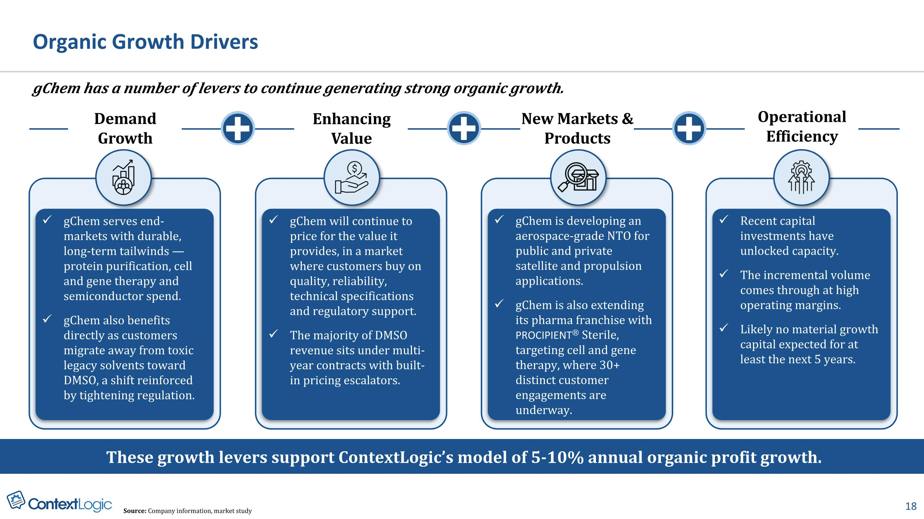
Organic Growth Drivers gChem serves end-markets with durable, long-term tailwinds — protein purification, cell and gene therapy and semiconductor spend. gChem also benefits directly as customers migrate away from toxic legacy solvents toward DMSO, a shift reinforced by tightening regulation. gChem will continue to price for the value it provides, in a market where customers buy on quality, reliability, technical specifications and regulatory support. The majority of DMSO revenue sits under multi-year contracts with built-in pricing escalators. gChem is developing an aerospace-grade NTO for public and private satellite and propulsion applications. gChem is also extending its pharma franchise with PROCIPIENT® Sterile, targeting cell and gene therapy, where 30+ distinct customer engagements are underway. Demand Growth New Markets & Products Enhancing Value + gChem has a number of levers to continue generating strong organic growth. Recent capital investments have unlocked capacity. The incremental volume comes through at high operating margins. Likely no material growth capital expected for at least the next 5 years. These growth levers support ContextLogic’s model of 5-10% annual organic profit growth. + Operational Efficiency + Source: Company information, market study

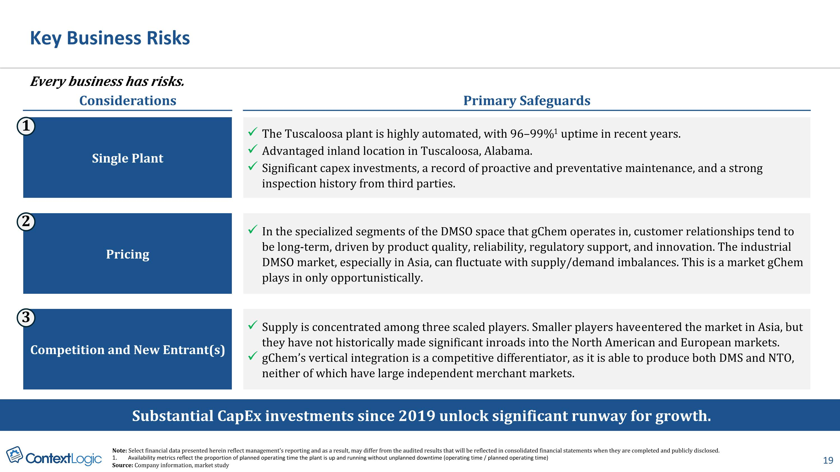
Key Business Risks Considerations Primary Safeguards Single Plant The Tuscaloosa plant is highly automated, with 96–99%1 uptime in recent years. Advantaged inland location in Tuscaloosa, Alabama. Significant capex investments, a record of proactive and preventative maintenance, and a strong inspection history from third parties. 1 Pricing In the specialized segments of the DMSO space that gChem operates in, customer relationships tend to be long-term, driven by product quality, reliability, regulatory support, and innovation. The industrial DMSO market, especially in Asia, can fluctuate with supply/demand imbalances. This is a market gChem plays in only opportunistically. 2 Competition and New Entrant(s) Supply is concentrated among three scaled players. Smaller players have entered the market in Asia, but they have not historically made significant inroads into the North American and European markets. gChem’s vertical integration is a competitive differentiator, as it is able to produce both DMS and NTO, neither of which have large independent merchant markets. 3 Substantial CapEx investments since 2019 unlock significant runway for growth. Every business has risks. Note: Select financial data presented herein reflect management's reporting and as a result, may differ from the audited results that will be reflected in consolidated financial statements when they are completed and publicly disclosed. Availability metrics reflect the proportion of planned operating time the plant is up and running without unplanned downtime (operating time / planned operating time) Source: Company information, market study

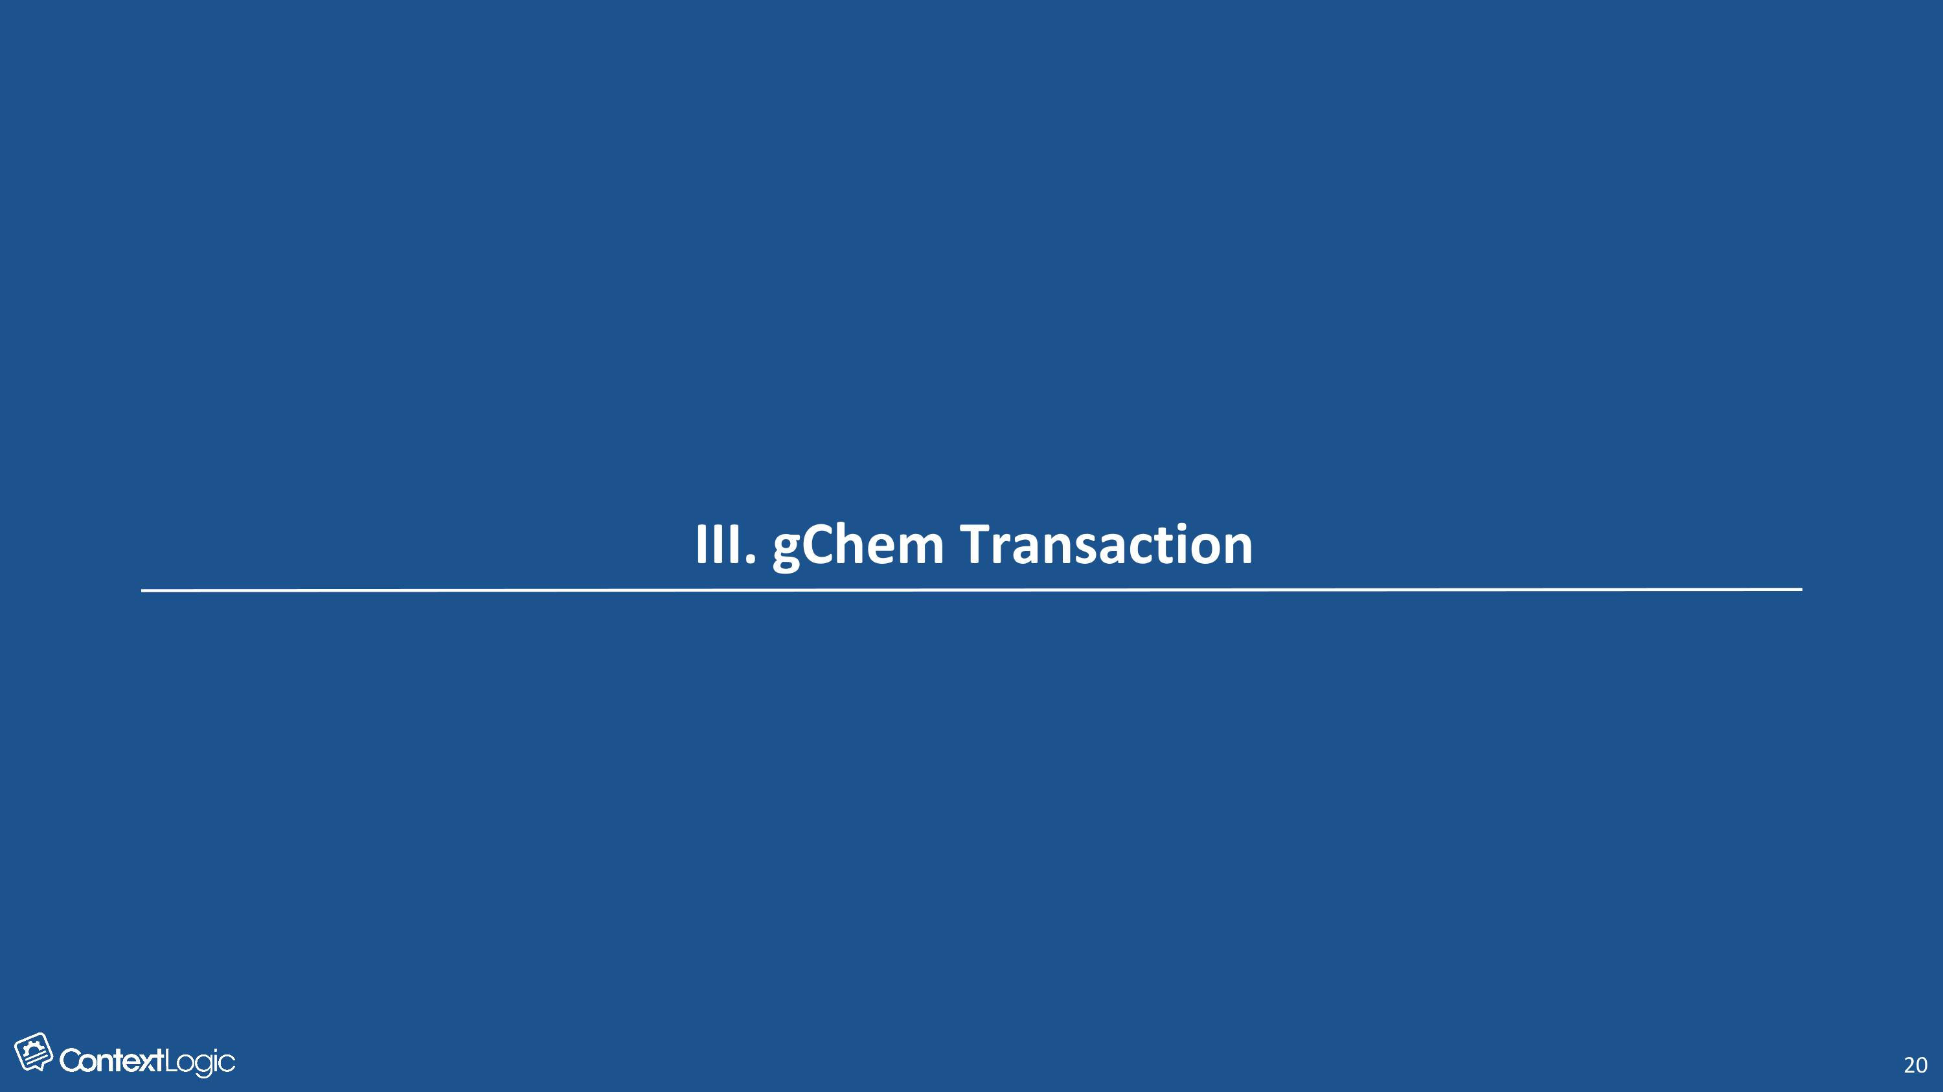
III. gChem Transaction

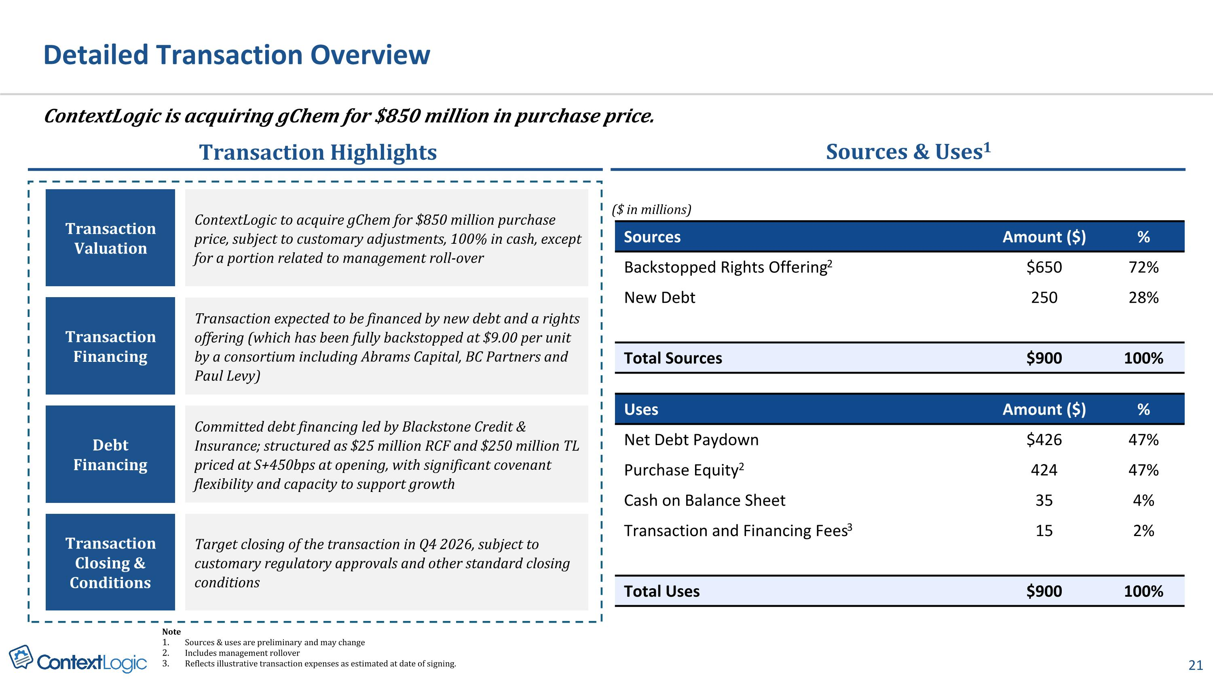
ContextLogic is acquiring gChem for $850 million in purchase price. Detailed Transaction Overview Note Sources & uses are preliminary and may change Includes management rollover Reflects illustrative transaction expenses as estimated at date of signing. Transaction Highlights Transaction Valuation ContextLogic to acquire gChem for $850 million purchase price, subject to customary adjustments, 100% in cash, except for a portion related to management roll-over Transaction Financing Transaction expected to be financed by new debt and a rights offering (which has been fully backstopped at $9.00 per unit by a consortium including Abrams Capital, BC Partners and?Paul Levy) Sources & Uses1 ($ in millions) Debt Financing Committed debt financing led by Blackstone Credit & Insurance; structured as $25 million RCF and $250 million TL priced at S+450bps at opening, with significant covenant flexibility and capacity to support growth Transaction Closing & Conditions Target closing of the transaction in Q4 2026, subject to customary regulatory approvals and other standard closing conditions Sources Amount ($) % Backstopped Rights Offering2 $650 72% New Debt 250 28% Total Sources $900 100% Uses Amount ($) % Net Debt Paydown $426 47% Purchase Equity2 424 47% Cash on Balance Sheet 35 4% Transaction and Financing Fees3 15 2% Total Uses $900 100%

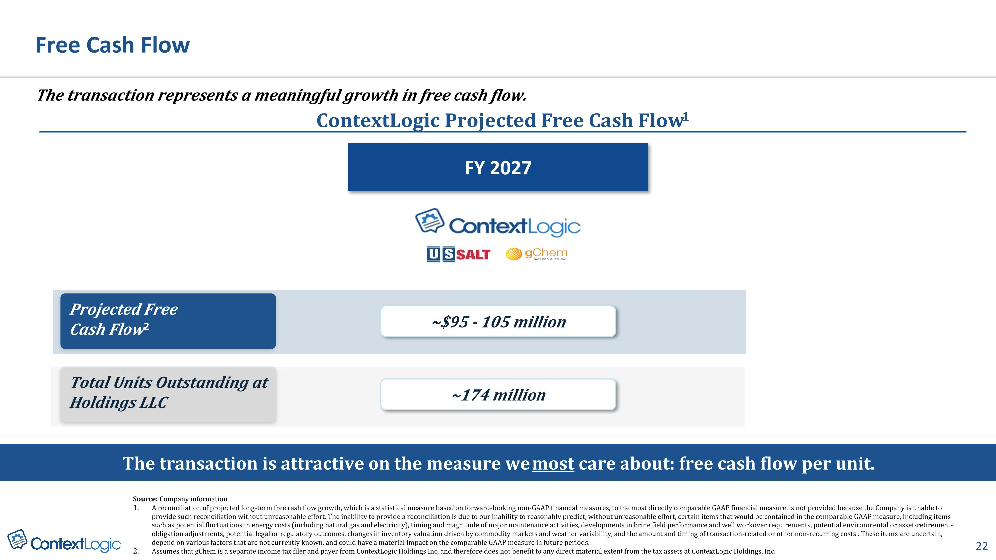
ContextLogic Projected Free Cash Flow1 Free Cash Flow The transaction represents a meaningful growth in free cash flow. The transaction is attractive on the measure we most care about: free cash flow per unit. ~$95 - 105 million ~174 million Projected Free?Cash Flow2 Total Units Outstanding at Holdings LLC FY 2027 Source: Company information A reconciliation of projected long-term free cash flow growth, which is a statistical measure based on forward-looking non-GAAP financial measures, to the most directly comparable GAAP financial measure, is not provided because the Company is unable to provide such reconciliation without unreasonable effort. The inability to provide a reconciliation is due to our inability to reasonably predict, without unreasonable effort, certain items that would be contained in the comparable GAAP measure, including items such as potential fluctuations in energy costs (including natural gas and electricity), timing and magnitude of major maintenance activities, developments in brine field performance and well workover requirements, potential environmental or asset-retirement-obligation adjustments, potential legal or regulatory outcomes, changes in inventory valuation driven by commodity markets and weather variability, and the amount and timing of transaction-related or other non-recurring costs. These items are uncertain, depend on various factors that are not currently known, and could have a material impact on the comparable GAAP measure in future periods. Assumes that gChem is a separate income tax filer and payer from ContextLogic Holdings Inc, and therefore does not benefit to any direct material extent from the tax assets at ContextLogic Holdings, Inc.

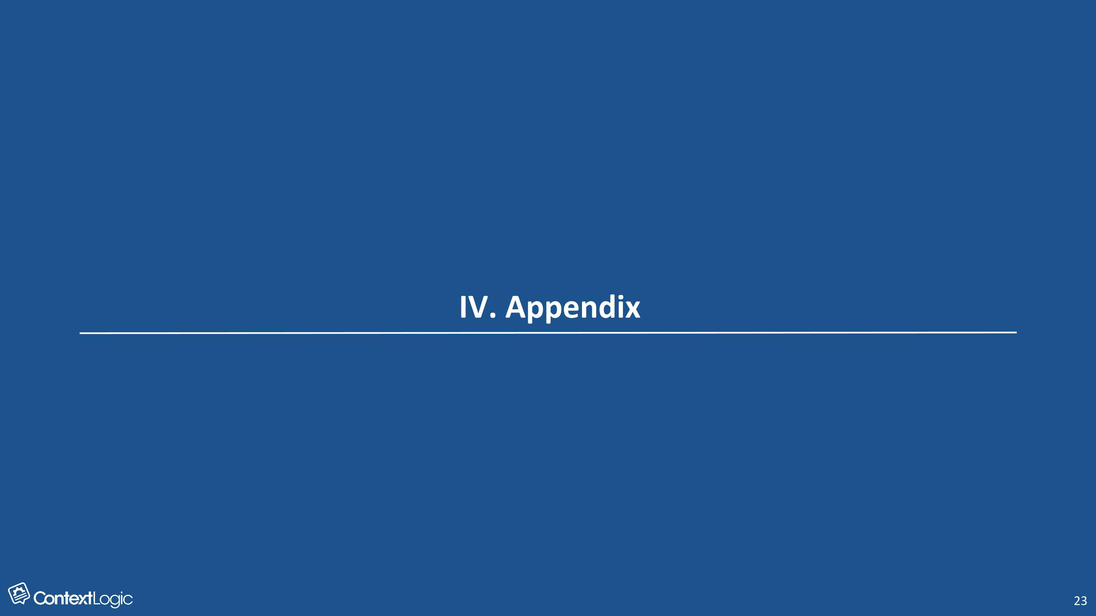
IV. Appendix

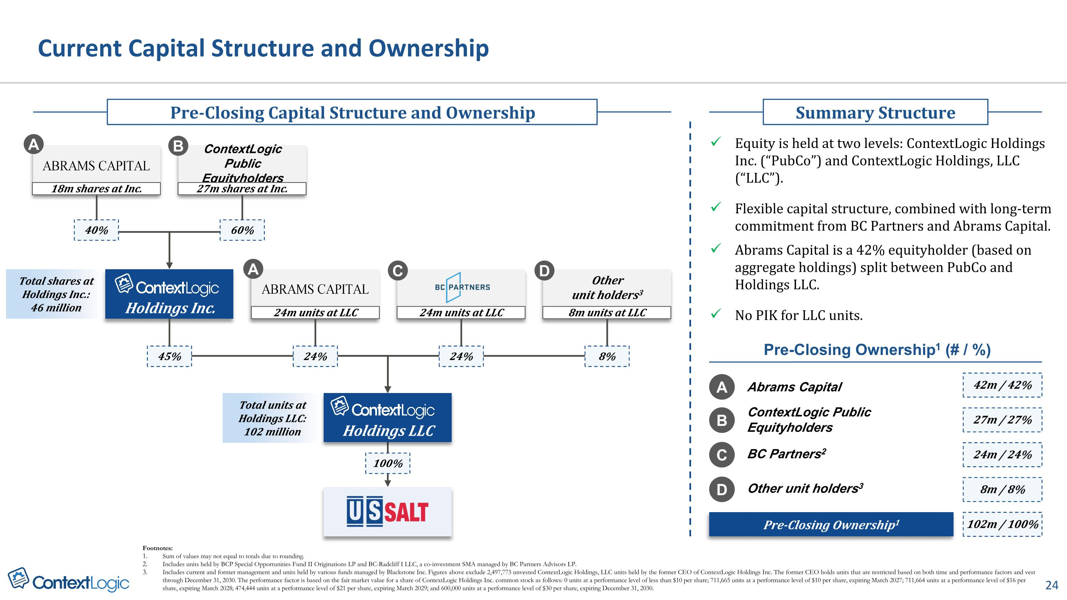
Pre-Closing Capital Structure and Ownership Summary Structure Equity is held at two levels: ContextLogic Holdings Inc. (“PubCo”) and ContextLogic Holdings, LLC (“LLC”). Flexible capital structure, combined with long-term commitment from BC Partners and Abrams Capital. Abrams Capital is a 42% equityholder (based on aggregate holdings) split between PubCo and Holdings LLC. No PIK for LLC units. Other?unit holders3 ContextLogic?Public Equityholders Holdings LLC Holdings Inc. 18m shares at Inc. 27m shares at Inc. Total shares at Holdings Inc.:?46 million 40% 60% 8m units at LLC 24m units at LLC 24m units at LLC Total units at?Holdings LLC:?102 million 45% 24% 24% 8% 100% A B A C D A Abrams Capital 42m / 42% Pre-Closing Ownership1 (# / %) B ContextLogic Public Equityholders 27m / 27% C BC Partners2 24m / 24% D Other unit holders3 8m / 8% Pre-Closing Ownership1 102m / 100% Current Capital Structure and Ownership Footnotes: Sum of values may not equal to totals due to rounding. Includes units held by BCP Special Opportunities Fund II Originations LP and BC-Radcliff I LLC, a co-investment SMA managed by BC Partners Advisors LP. Includes current and former management and units held by various funds managed by Blackstone Inc. Figures above exclude 2,497,773 unvested ContextLogic Holdings, LLC units held by the former CEO of ContextLogic Holdings Inc. The former CEO holds units that are restricted based on both time and performance factors and vest through December 31, 2030. The performance factor is based on the fair market value for a share of ContextLogic Holdings Inc. common stock as follows: 0 units at a performance level of less than $10 per share; 711,665 units at a performance level of $10 per share, expiring March 2027; 711,664 units at a performance level of $16 per share, expiring March 2028; 474,444 units at a performance level of $21 per share, expiring March 2029; and 600,000 units at a performance level of $30 per share, expiring December 31, 2030.

